What is Procurement or Sourcing Intelligence?

Procurement or Sourcing intelligence supplies knowledge on the right product, pricing and place (supplier credentials). It ensures that a business has relevant and up-to-date information to aid in purchasing decision-making. It is really just about finding the right information on commercials and suppliers, and then being able to come up with strategies to utilize the data in a positive manner. An oft-neglected, but extremely vital, part of intelligence is willingness to try things in a different way. Having a purchasing or procurement process is a crucial requirement of procurement organization. Procure-to-pay software alone will not drive procurement intelligence - it will only give access to the historical data. To make it effective, organizations need access to both current (real-time) and historical data on spending and budgets, thereby becoming better informed when making important decisions to drive future action.

Procurement software solutions do exist that make operational processes more efficient, however there are no sourcing software tools to help improve the sourcing function effective. Beyond collecting and analyzing data, an organization should be prepared to think strategically on cost reduction and optimization. Unfortunately, many organizations are not set up with a system that promotes strategic thinking and are therefore unaware of the values of procurement intelligence.

About Teckost.com

The proposition

- The one and only online IT Procurement Intelligence software tool
- Quick TAT leads to Increased Productivity, Revenue, Customer Experience & Cost Optimization
- Help save Internet & Energy Expenses as our software tool is lightning quick
- Help improves IT Asset Life
- Supports ‘Sustainability’
A snapshot of our product

- Helps conduct effective negotiation to effect a savings of xx %
- Helps identify risks on IT supplier network & helps choose right IT Supplier
- Helps make informed sourcing decisions

Teckost.com is an exclusive search engine for IT Hardware and Software, IT Cost discovery and IT Procurement Intelligence software for IT Professionals. It’s a domain specific tool cutting across industry lines.

According to Gartner, the overall annual Global IT Spend is $3.8 Trillion and a tool like teckost.com would certainly help reduce the sourcing cycle time and the IT Cost for organizations. Our product would act as a negotiation tool for the buyers & decision makers by providing the insights on the right or best Global IT Cost for various IT Products.

For example, If somebody wants to procure a laptop for their personal use, they would hunt for the best product and more importantly the best price by browsing Amazon, Flipkart, Alibaba or ebay to figure out the best prices offered by them. However, there are no etailers, portals or products like teckost.com to find out the best possible prices for corporates or real time right price for a laptop or any IT product for that matter. Organizations are in desperate need of such data as it could help their CPO and CIO offices be well prepared, before they invite their IT Suppliers for a price negotiation discussion. Example: A mid-sized organization which spends $100 Million on IT Hardware, IT Software and IT Services, annually. Whether the ‘special prices or discounts’ offered to this organization by the IT Suppliers are indeed the right(best) prices or not can be determined by using our software tool.

IT Sourcing Intelligence from Teckost.com provides insight into IT Sourcing category (one of the most difficult purchasing categories) and markets to enable effective sourcing decisions. The disruption & volatility in the IT Industry causes significant challenges to procurement managers and it is very critical to have (i) insights into current IT Cost, technology advancements & Obsolescence and (ii) potential risks involved due to incorrect decisions taken by the CIO and/or CPO office to deliver true value to the organisation. Teckost.com rapidly filters out the relevant data from the multiple sources of data that are reliable enough to support effective decision making with competitive insights. It is necessary to consistently integrate both global and regional Global IT Intelligence to sustain the competitive advantage.

How are corporates handling Procurement Intelligence today?

There are a few management consulting firms such as IDC, Gartner, Beroe, big fours, GEP and others who provide Offline Procurement Intelligence services based on their customers’ needs – this process is an effort intensive & time-consuming one as it is offline. As opposed to this method, an exclusive service provider like teckost.com, which serves only one domain, IT, would prove highly effective & efficient. The following table contrasts the two models.

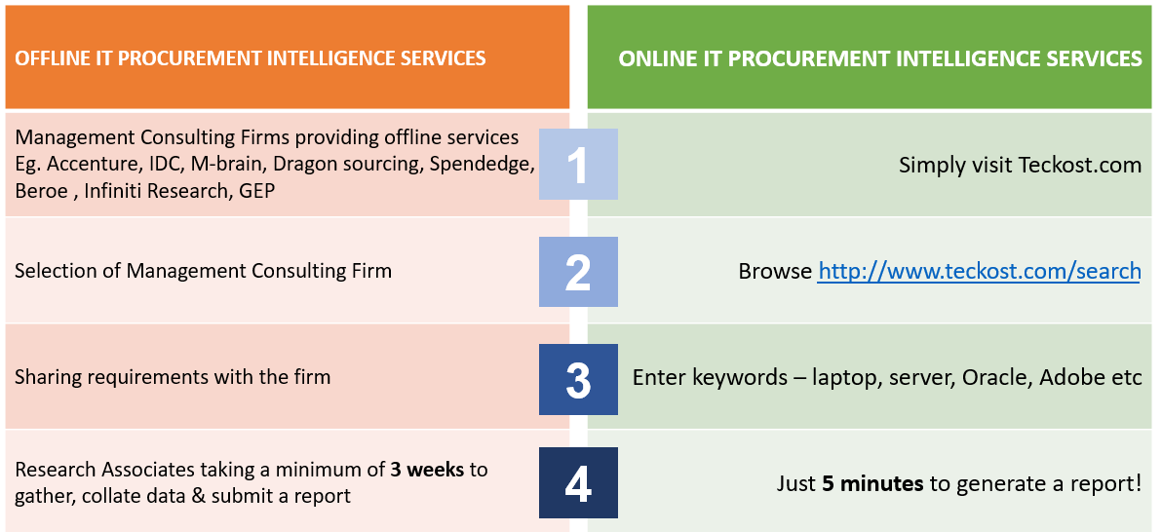

The User Journey

Teckost.com is a user-friendly product for IT Professionals to pull out the right or best IT pricing for IT Hardware and Software. The registered user has to use their login credentials and to access the product.

Simple steps to use the product:
- User logs in with credentials on www.teckost.com
- Enters keywords such as laptop, desktop, server, Oracle, Dell, Adobe in the search bar on the home page
- teckost.com would display the pricing of products for the chosen keywords
- Users may choose more than keyword at a time and get the pricing for the specific keywords that were chosen with crisp specifications

For example, let's say the user wanted to know the prices for two IT Hardware products - laptop and server, the user would type these two keywords in the search bar and teckost.com would pull out the necessary data from its database and display it. Further search refinement is also possible, by typing specific keywords like i5 processor and teckost.com would filter and produce the results for i5 processor based laptop ignoring other specifications like i7 processor. The items chosen by the users can be saved as a project, retrieved, modified as and when required, as it is stored on the cloud and powered by AWS. The users need not use a spreadsheet for IT Project cost estimation and simulation, as teckost.com has an inbuilt price calculator as a substitute to cumbersome spreadsheets.

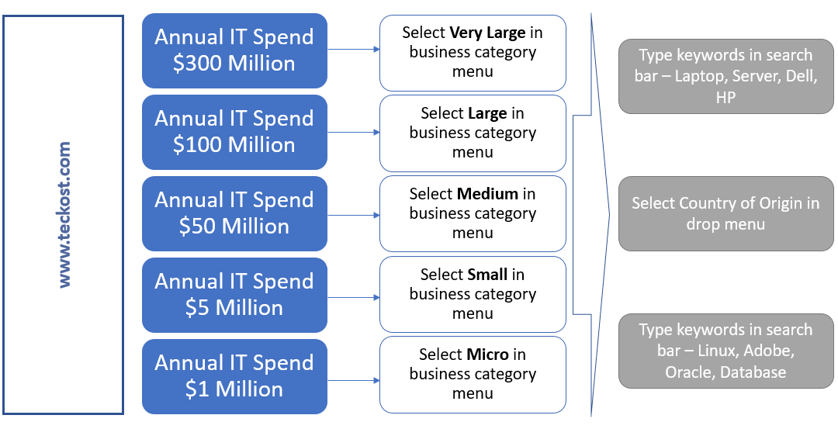

How accurate are the prices provided by teckost.com.?

While it is practically infeasible for anyone including the actual IT suppliers (OEMs) to discover the costs before the deal is signed off between two parties, prices indicated by teckost.com would have a variance of plus or minus 5%.

