For Immediate Release March 26, 2019

The Joy of Job Named Gold Medal Winner in Theology
2019 Illumination Book Awards
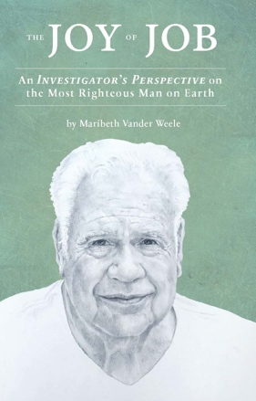
Chicago, Illinois – The Joy of Job, An Investigator’s Perspective on the Most Righteous Man on Earth, has been named a Gold Medal winner in the 2019 Illumination Book Awards.
The award was given in the category of Theology.
The Illumination Book Awards recognizes the very best Christian books in the fast-growing segment of publishing and bookselling. It recognizes books that illuminate Scripture and explore aspects of faith in a complicated world.
Drawing on more than 350 Biblical Scriptures, The Joy of Job, An Investigator’s Perspective on the Most Righteous Man on Earth, presents what Bible scholars say is a remarkable case for reinterpreting the ancient mystery. Kirkus Reviews describes the book’s thesis “as challenging as it is rigorous” and calls the painstaking interrogation of the Biblical text “delightfully unrelenting.” It commends the book for its “profound, moral meaning.” Publishers Weekly Booklife recognizes ​The Joy of Job for its "excellent exegesis" and "refreshing insight.
About the Author
A former investigative journalist and government inspector general, Maribeth is an American author and business owner. Her life’s work revolves around unearthing obscure but significant information to discern deception. An astute and painstaking fact-finder, she communicates complicated subjects with clarity. Maribeth founded the Vander Weele Group, a Chicago-based firm that provides investigative and grant oversight services, domestically and abroad. She was an award-winning investigative reporter for the Chicago Sun-Times before joining the Chicago Public Schools as a key member of the 1995 turnaround team and serving subsequently as its Inspector General. In 1994, she authored, Reclaiming Our Schools, The Struggle for Chicago School Reform, published by Loyola University Press. Maribeth has appeared in the Wall Street Journal, New York Times, Washington Monthly, Christianity Today, Teacher Magazine, Extraordinary Ordinary Women Making a Difference, American School Board Journal, and elsewhere. She has lectured nationally. Maribeth is a graduate of Wheaton College in Wheaton, Illinois, and a member of Christ Church in Oak Brook, Illinois.
Read what Bible scholars say
about The Joy of Job.
Download an excerpt.
Visit JoyofJob.com.

About the Cover
The cover portrait depicts the author’s late father, from whom she learned the value of the throwaway line, a key to unlocking the mysteries of Job. Her father’s expression, captured in his eighties, conveys living with joy in one’s old age. Like Job, his journey ended well. The portrait was drawn by Susan Vander Wey of Tweed, Ontario, Canada.

For more information, see http://www.illuminationawards.com/13/2019-medalists

