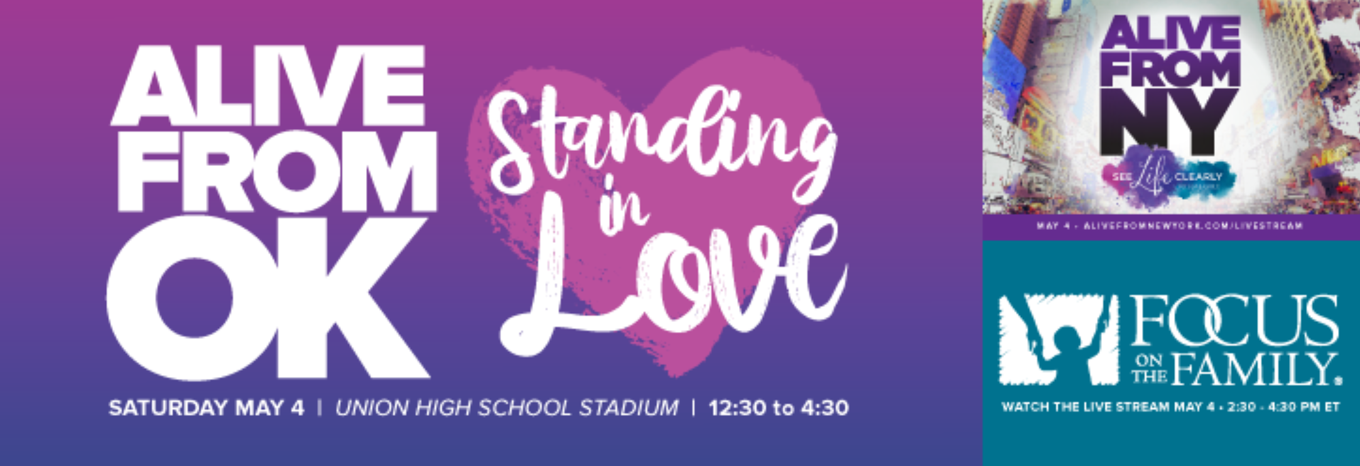

For Immediate Release: Contact: Teresa Goodnight,
Community Spirit Magazine
Phone: 918.956.0700
Email: teresa@communityspiritmagazine.com

Alive from Oklahoma. Standing in Love.
The BIG, FUN, People-Loving Event

Tulsa, OK April 30, 2019: Pregnancy resource centers, adoption/fostering support groups, mobile medical clinics for the uninsured and more will gather with Congressman Kevin Hern 12:30 Saturday, May 4th in Union High School Stadium (UMAC) to showcase free resources available to Tulsa and surrounding communities. They will simulcast "Alive from New York" with Focus on the Family from 1:30-3:30 celebrating life. “We started the ball rolling in a meeting with the Pregnancy Resource Centers sharing details about the Focus on the Family event in Times Square as they do a 4-D late term ultrasound celebrating life. We wanted to go, but quickly realized most people in Oklahoma couldn't get there with us. We have incredible groups pouring love all over Oklahomans. So, we thought--'We should do something here to highlight all the ways people can get help from these generous non-profits as we celebrate life.’ We wanted to share ways these groups support a better life right here in the Tulsa and surrounding areas.'" said Ryan and Teresa Goodnight, owners of Community Spirit Magazine. “We were so thrilled when Congressman Hern wanted to be a part of the celebration. We know he is a proponent of helping citizens with so many programs, but like us, he believes the non-profits and the “C”hurch can interject locally. The “C”hurch, which largely supports these non-profits with volunteers and financial support, has the ability to make a radical impact with generosity and love, taking the burden off of government programs and loving people right here in our own backyard with real, genuine care.”
The Goodnights said, "We get a lot of people asking how THEY can help people--and these groups right here are the best we know at what they do. They love on women in unplanned pregnancy situations, offering a host of free services. There are groups working with DHS to provide support for families needing adoption or fostering assistance. Others dedicated to specialty services many of us might not think about--like healing after abortion will be there. We highlighted most of the groups at communityspiritmagazine.com so that anyone needing help can hop online and look at the list of these amazing groups." the Goodnights added, "It's a big deal to have so many groups helping women and families in with unplanned pregnancies or just in a tough spot right here where we live. For women, men and families needing help, these groups want you to know they exist and are here for you. For those who want to get involved, they have the simplest volunteer positions to some that require a little training. Whatever you have to offer--they can get you plugged in making a difference in our neighbor's lives.” The Goodnights emphasized, “We serve a God, who loved this whole world so much that He gave His son as ransom for it—so, we kinda have a really good ‘people-loving example’ to follow.”
There will be bouncy houses, obstacle courses, a giant 6-foot soccer ball field, games and more for kids to enjoy. Josh's Sno Shack will be present with yummy snow cones available. Plus, Hayden Burlingame (also of MidLife Crisis) has put together a great band to play at the event before and after the simulcast.
In addition to the event, Whistler Media has donated 1 minute of digital billboard airtime across the Tulsa area Saturday, 5/4, to show a 3-D ultrasound to celebrate all of life even in its tiniest form.
Mend Medical Clinic, Crisis Pregnancy Outreach, GoLife Mobile Medical, Nightlight Christian Adoptions, Birthright of Tulsa, Northeast Oklahoma Hope Resources, Compassion Women’s Center, have provided financial support to make the event happen. All of these groups are uniting together generating awareness for what they do so that more people can get help.
Come out and join us to find out how to be loved on or to give some love! It’s going to be a super fun day in the sun!

Focus on the Family “Alive from NY” Info:
Stand up for life!
Join Focus on the Family on May 4th for a FREE live stream event, “Alive from New York.” With live music, inspirational speeches, and abortion survivor stories, we will unite as one voice to celebrate the sanctity of human life and encourage the support of women facing unplanned pregnancies. Then, to help the world #SeeLifeClearly, we will light up Times Square with a live 4D ultrasound broadcast on massive digital screens!

Community Spirit Magazine is a northeastern Oklahoma Christian magazine challenging the “Body of Christ” to #GoDoBe Christ in our community. With new ownership, under Ryan and Teresa Goodnight, relaunching the magazine January 1st, 2019, the continued focus is on uniting the churches, as we come together to impact our community. The magazine speaks directly to Christians--pushing them out of the pews and into the streets with the truth of God’s word and his directive to love our neighbors.
###

If you would like more information about this topic, please call Teresa Goodnight at 918.956.0700 or email info@communityspiritmagazine.com. Teresa can get you any contact information for any of the other sponsoring organizations. The original organization list is attached hereafter. However, more groups have joined including DHS.

Pregnancy Resource Centers in Eastern Oklahoma
PRCs provide free confidential pregnancy testing, support, some provide limited ultrasounds, parenting classes and clothing for moms and babies.
Birthright Phone 918-481-4884 www.birthright.org/tulsa
www.birthright.org/Stillwater www.birthright.org/Bartlesville
Free services: pregnancy tests, diapers, maternity and infant clothing to toddler 2, pregnancy resources, community referrals, select financial aid and parenting classes.
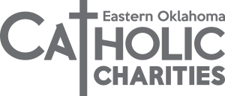
www.cceok.org
Catholic Charities Blessed Mother Teresa Women’s Health Center – OB care 918-508-7199
Madonna House maternity home for pregnant women 918-508-7140 Food, clothing & NFP
Compassion Women’s Center www.mightbepregnant.org Claremore
918-923-7388 Pregnancy Resources/ Post Abortive Care
The Cottage www.cottageforlife.com
Bartlesville OK 918-214-8854 Pregnancy Testing, Ultrasound, Community Resources, Maternity Home and Abortion Recovery
Go Life Mobile Medical https://golife.org/ Tulsa OK 918-518-0648
FREE pregnancy tests FREE limited ultrasounds FREE resources and information in multiple locations
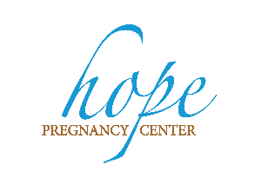
Hope Pregnancy Center www.obhc.org/hope 918-622-3325 Karen Alley, Director
Free pregnancy tests, limited ultrasounds, educational groups and maternity and newborn/toddler clothes
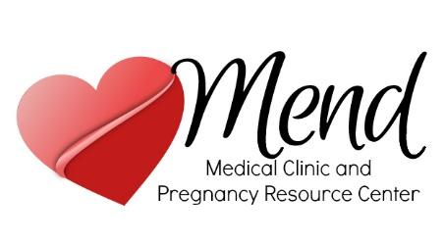
Mend Medical Clinic and Pregnancy Resource Center
www.mendpregnancy.org 918 745 6000 Text 539 777 1426 Free and confidential

24/7 HELPLINE: (877) 558-0333 Abortion Pill Rescue
Pregnancy tests, Option Information, Limited Ultrasound, Educational programs, Post Abortion Healing, Sexual Integrity Program and Ongoing Support to help navigate life issues. Abortion Pill Rescue services.
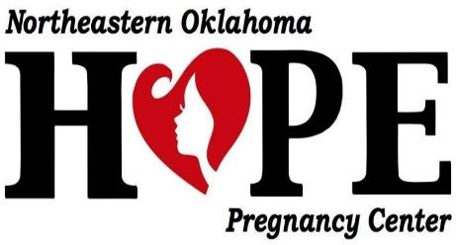
Northeastern Oklahoma Hope Pregnancy Center. Pryor, Ok https://maybepregnant.org/ 918-825-8258 Abortion Information, Adoption Agency Referrals, Maternity & Infant Supplies, Medical Referrals, Parenting Education, Post-Abortion Support, Pregnancy Options Information, Pregnancy Tests, STD/STI Information, Support for Men, Ultrasound (Onsite)
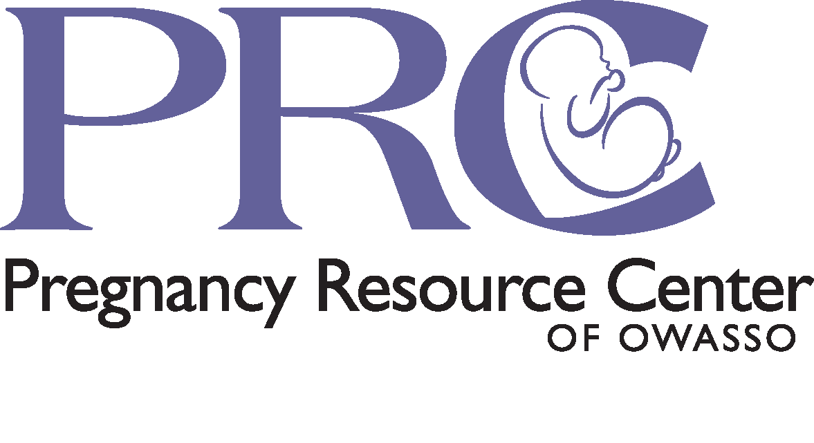
Pregnancy Resource Center of Owasso www.prcowasso.org
Free pregnancy testing, STD testing, limited ultrasound, Education and mentoring program, Dad-Men education and mentoring program, diapers, clothing, formula and an Emergency Help program.
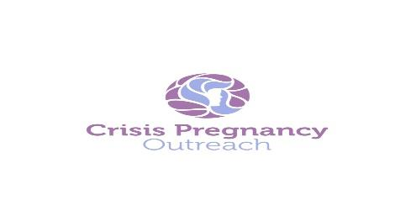
Crisis Pregnancy Outreach https://www.crisispregnancyoutreach.org/ 918.296.3377 Tulsa
Pregnancy testing and limited ultrasounds. Weekly support groups for Parenting Moms and Birth Moms. Weekly counseling by Licensed Professionals. Mentors. Childbirth classes and Doulas. Maternity and baby clothing. Transitional Home. Transportation to appointments. Arrangements for private medical care. Open Adoption Services.

Abortion Healing Programs in Eastern Oklahoma
The trauma of abortion can impact the woman and anyone close to her including her significant other, parents, siblings and friends.
Rachel’s Vineyard https://cceok.org/healing-after-abortion
918-978-4673 call or text
Rachel’s Vineyard National http://www.rachelsvineyard.org/
For English call Mary Lee 918-508-7142 or marylee@cceok.org
For Spanish call Martha 918-508-7134 mstanton@cceok.org
Individual counseling for trauma after abortion and abortion healing retreats One need not be Catholic to receive services
Compassion Women’s Center Claremore Ok 74017 https://inolacwc.wixsite.com/cwcok
918-923-7388 Forgiven and Set Free Bible Study
Forgiven and Set Free Book Study guides suffering and hurting women to bring their emotional scars from abortion “out of the dark past and into his holy light,” where true and lasting healing can take place. Scriptures help to deal with issues such as relief, denial, anger, forgiveness, depression, letting go, and acceptance.”
Hope Pregnancy Center Tulsa 918-622-3325
https://thinkimpregnant.org/ orgiven & Set Free Bible Study No cost
Contact Karen @ kalley@obhc.org
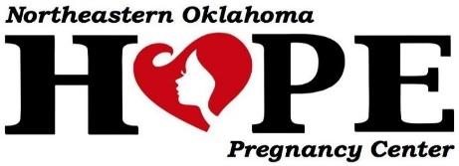
Northeastern Oklahoma Hope Pregnancy Center. Pryor, Ok https://maybepregnant.org/ 918-825-8258 Forgiven and Set Free bible study
Mend Medical Clinic & Pregnancy Resource Center https://www.mendpregnancy.org/ Tulsa “Healing Hearts” Ministries International Book Study www.healinghearts.org
Contact Karen McKewon 918.520.5919 and at karenlm@healinghearts.org
The Church of Battlecreek Tulsa
Beyond her Choice– book study Contact Danielle beyondherchoice@theChurch.at.

Want to leave the abortion industry?
And then there were none www.abortionworker.com 888-570-5501

ADOPTION in Eastern Oklahoma
Oklahoma Adoption Coalition – Identifies all Licensed Adoption Agencies in Oklahoma
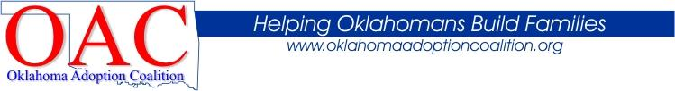
https://www.oklahomaadoptioncoalition.org/
Catholic Charities https://cceok.org/adoption 918-508-7131
Birth mother and adoptive parent support

Crisis Pregnancy Outreach https://www.crisispregnancyoutreach.org/ 918.296.3377 Tulsa
Parenting support and open adoptions
Pregnancy Care Co-op Individuals and organizations who collaborate for the protection of life, nurturing the mother and baby, provide healing and counseling after abortion and serve for the common good and the glory to God. Volunteers and donations welcome to any of these programs. More info: Karen@golifemobilemedical.com

