Isis, an 18 year old, defeating optic nerve damage with a revolutionary low vision aids
“I spent my childhood going to a lot of doctors and they wouldn’t know what was wrong with me”, says Isis, an 18 year old high school student.
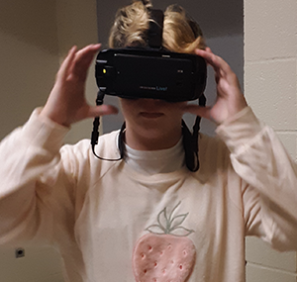
This was 13 years ago, when she was 5 years old and got diagnosed with Craniofringioma brain tumor. The good thing was her diagnosis, that finally somebody identified what was wrong with her but the bad thing – The tumor destroyed most of her optic nerves, leaving her with a 13 year( and counting) battle with low vision!
IrisVision is a California based company, leveraging the power of Virtual Reality (VR) technology to help people see clearly and live fully. We created IrisVision to be able to cater to vision that may change or deteriorate, because that’s what most of the people coming at IrisVision are fighting with. A deteriorating vision with multiple vision problems!
Conventional glasses or contact lenses don’t help. Patients have to adjust with hectic routines, multiple visual aids and have to deal with a lot of pain points, to live a very dependent life.
Thats was the story of Isis, who after finding IrisVision, felt that she had a great chance at a normal life after all.
“I used to try to keep up with everyone else, now my mom tires to keep up with me! And that’s all because of IrisVision. My favorite feature is the IrisReader! I just point and zoom at things I want to read, and it reads everything to me, even at a good distance, and that makes it even more exciting. “
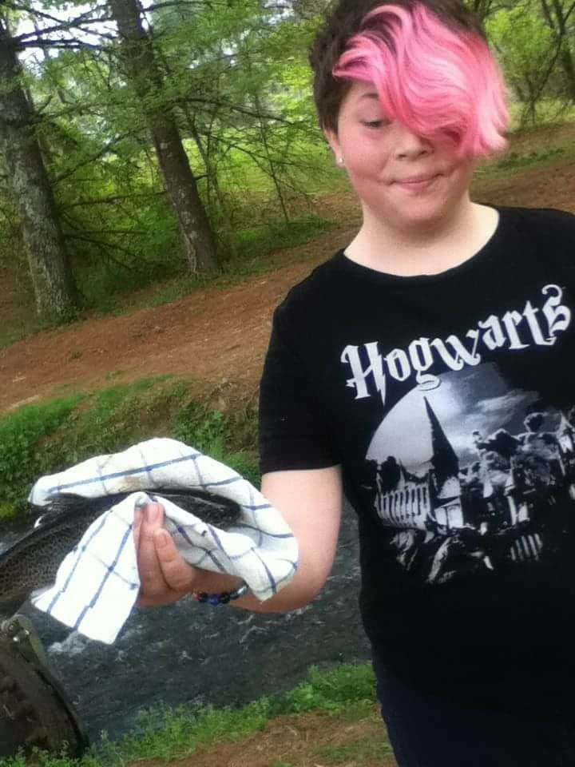

Just like her, IrisVision has changed the lives of countless visually impaired people by providing an affordable yet powerful vision enhancement system that does not constrict them in any way.
In an interview with Samsung, Ammad Khan, the CEO of IrisVision said, “We found that there was a huge gap with how technology was serving vision-impaired individuals,” He said. “Given what virtual reality is capable of, we started working on the idea to enhance the reality of these people by combining what we understand about the visual process and taking advantage of what VR coupled with Smartphone can offer. And the results were just mind blowing.
Everytime I see someone putting IrisVision on for the first time, it’s their reaction that reminds me of the importance of what we are doing and the reason we need to keep doing it!”
IrisVision isn’t just a technology gadget. It is a product of research, innovation and more research by some of the top scientists and industry veterans such as Dr. Frank Werblin and his fellow scientists at Johns Hopkins, The Chicago Lighthouse for the Blind, and UC Berkeley. The software is a clinically validated-VR platform with the capability to adjust to the visual impairment of the person and enhance what they see – giving them a crisp, clear and colorful view of reality, just like someone with a good eye would see.
The Smartphone comes preloaded with the IrisVision software and attaches onto the VR headset, making a fully covered headgear. This design is great because it blocks light leaking in/out which most people with extensive central vision loss find trouble coping with.
You would be surprised what the biggest problem, after not being able to see the faces of their loved ones, is for patients with visual impairments. It’s not being able to read!
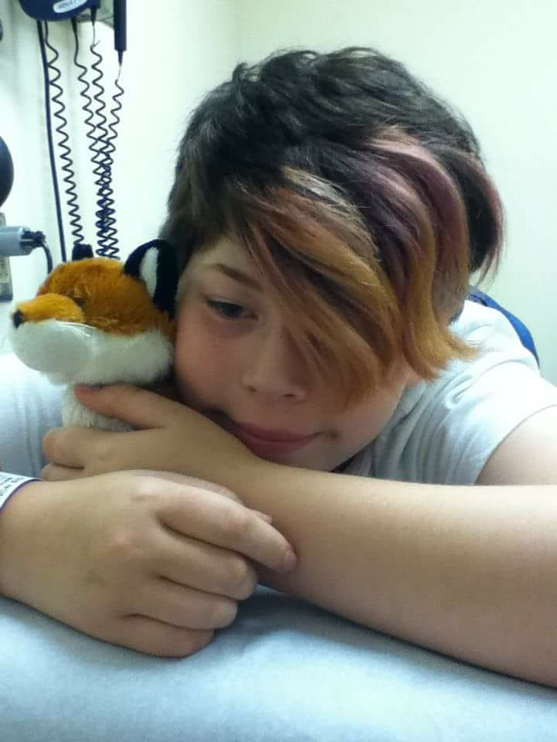
We took that from Isis’s experience of using IrisVision. She and her mom were looking for an alternate to esight, another low vision aid better for people with more peripheral vision, when they stumbled upon IrisVision. After using it for more than three months, Isis exclaimed with joy she uses this low vision aids for everything. For reading, shopping, reading signs, menus everything. One of her pain points were not being able to keep up with everyone else. With IrisVision, that completely changed. She said, “When I am shopping I use it to read signs. All I do is aim at the sign (even from a distance) and the device reads it to me. It has made shopping at Walmart incredibly successful. Even at school, I use it every day and it really helps me keep up in my classes. I am able to read everything clearly, especially in Geometry and History. We got a Harry Potter recipe book and as soon as I got it, I read the whole thing using the IrisVision and I loved it! ”
With our patent zoom feature, the IrisBubble working in conjecture with other zooming features, IrisVision gives patients the ability to zoom in on things unclear to them unlike anything ever before. Reading becomes incredibly easy for patients with different kinds of eye diseases like macular degeneration, retinitis pigmentosa (there is a full mode dedicated to this eye disease), diabetic retinopathy, glaucoma and other similar eye diseases.
This is the story of just one visually impaired kid making the most of her life with IrisVision, there are countless others. If you know someone who is coping with vision loss be sure to check IrisVision out.
Who knows, you might be able to help someone get their gift of sight

