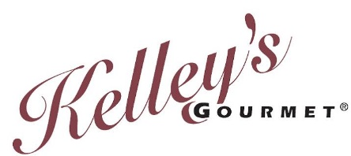
For Immediate Release** For Immediate Release** For Immediate Release
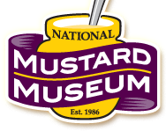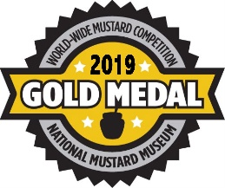
Manteno IL, - -Kelley’s Gourmet is proud to announce that it has been awarded a Gold Medal for their Kelley’s Gourmet Stone Ground Mustard in the 2019 Worldwide Mustard Competition!
Held under the direction of the National Mustard Museum in Middleton, Wisconsin, the 2019 World-Wide Mustard Competition drew more than 300 entries in eighteen flavor categories from as far away as Sweden, Greece, and Japan. Judges tasted the mustards “blind,” not knowing if they were tasting international brands or small boutique mustards. Judging took place over a period of several weeks at the Mustard Museum in Middleton WI, where chefs, food writers, restaurateurs, and mustard aficionados gathered to pick the medal winners.
This Six-TIME award winning mustard by Kelley’s Gourmet is called “the perfect accompaniment to your favorite corned beef sandwich, artisan creation, or backyard brat.”
Kelley’s Gourmet is currently located in Manteno, Illinois, and was founded in 1997 in Bloomington, Illinois. It's not surprising to hear Kelley’s proclaim “You don’t have to like mustard to love our Stone Ground Gourmet Mustard,” with the awards echoing his words.
Kelley’s Gourmet was first recognized with a Gold Medal Award in the 2013 Worldwide Mustard Competition for their Stone Ground Mustard.
You can taste their award winning products at the ¡SALUTE! To the Winners taking place Memorial Day weekend at the National Mustard Museum located at 7477 Hubbard Ave., Middleton, WI 53562 from 10 A.M – 5 P.M... Kelley’s Gourmet Stone Ground Mustard is also available for purchase online at www.greatmustard.com or at your local grocer. They encourage you to post your pictures and your recipes on their Facebook page here: Kelley's Gourmet www.facebook.com/greatmustard
For more information, including a list of where to purchase. Contact HK Foods- Kelley’s Gourmet at 800-500-3675 or Susan@greatmustard.com

