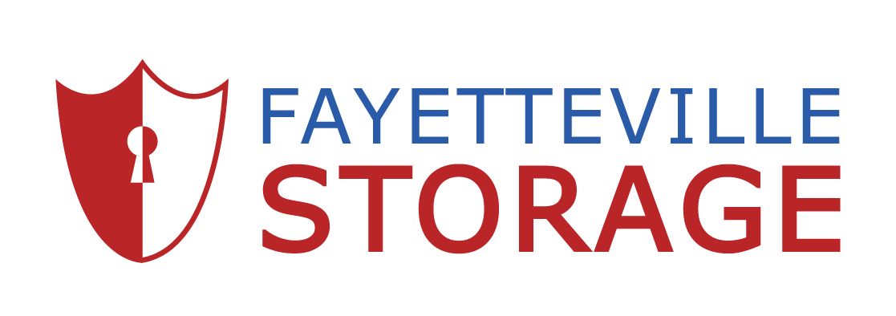
Fayetteville Storage on Yadkin Road
4610 Yadkin Road
Fayetteville, NC 28303
910-864-6686
StorageOnYadkin.com

FOR IMMEDIATE RELEASE May 28, 2019
NEW MANAGEMENT FOR LOCAL SELF STORAGE FACILITY
New Management in Fayetteville, NC

FAYETTEVILLE, NC. – Local acquisition of Fayetteville Storage on Yadkin Road is bringing professional self-storage management to city of Fayetteville, NC. Remote owners, Absolute Storage Investment, purchased this facility for an undisclosed price. Fayetteville Storage provides highly secure self-storage options to the local community serving residents near the Glensford Commons Shopping center. Conveniently located off U.S. Route 401 this storage facility sits on Yadkin Road with the nearest cross street of Castle Hayne Rd. Less than a mile from well-known establishments such as Waffle House, Logan's Roadhouse and Red Lobster. Fayetteville Storage on Yadkin Road is comprised of 425 units totaling 53,750 rentable square feet. Fayetteville Storage on Yadkin Road was previously referred to as A Storage Place.

Absolute Storage Investments have contracted with Absolute Storage Management (ASM) to provide professional self-storage management. Fayetteville Storage is officially under new management as of February 2019.

If you would like to speak to the local manager, please stop by the location at 4610 Yadkin Road
Fayetteville, NC 28303 or call local manager Shannon Rivera at 910-864-6686.

Absolute Storage Management
Absolute Storage Management (ASM) is one of the largest private, third-party self-storage management company in the United States. Founded in 2002, ASM holds its headquarters in Memphis, TN with regional offices in Atlanta, GA; Charlotte, NC; Nashville, TN; and Jackson, MS. The company operates 100 properties in Alabama, Arkansas, Florida, Georgia, Illinois, Kentucky, Louisiana, Mississippi, Missouri, North Carolina, Ohio, South Carolina, and Tennessee.

For further information and news about Absolute Storage Management, please go to the ASM website at www.absolutemgmt.com or contact Jasmin Jones at jasmin.jones@absolutemgmt.com or call her at (678) 779-1978.

###

