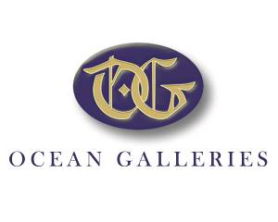
Making Homes Beautiful Since 1986
9618 Third Avenue, Stone Harbor, NJ 08247 | 609.368.7777
www.OceanGalleries.com

FOR IMMEDIATE RELEASE CONTACT: Julie Hayles Page 1 of 4 609.576.3717/PR@OceanGalleries.com

OCEAN GALLERIES WELCOMES JANE SEYMOUR TO STONE HARBOR
OVER LABOR DAY WEEKEND
Award winning actress, designer, and artist showcases her latest watercolors and oil paintings

STONE HARBOR, NJ – July 24, 2019 – She is as charming and beautiful as she is talented. Ocean Galleries is delighted to welcome back award-winning actress, designer, and artist, Jane Seymour, over Labor Day weekend with an all new collection of her gorgeous artwork.

The “Jane Seymour: California Colorist” exhibition opens at Ocean Galleries (9618 Third Avenue, Stone Harbor, NJ/609.368.7777) on Friday, August 30, 2019. Ms. Seymour will appear at the gallery for intimate receptions from 7:00 PM to 10:00 PM on Friday, August 30 and Saturday, August 31, and from 1:00 PM until 4:00 PM on Sunday, September 1.

The multi-talented Jane Seymour returns to Ocean Galleries Labor Day weekend

These days, it seems many actors dabble in businesses outside of their primary vocation, but few have proven their talent in such a wide range as Ms. Seymour. A multiple Emmy® and Golden Globe® winning actress, Jane Seymour has enjoyed a successful acting career on Broadway, as well as in motion pictures, and television. In addition, she has written over 10 books and launched Jane Seymour Designs, a national lifestyle brand inspired by her homes, art, and family-centered lifestyle.

A recipient of the Officer of the Order of the British Empire (OBE), Ms. Seymour began painting nearly three decades ago. Prompted by a period of personal challenge, her art became the expression of a very private healing process from which she emerged as an accomplished, passionate painter. Seymour sketches and paints at her Malibu studio, on movie sets, and on her travels. She has created an intimate world of delicate watercolors, colorful vibrant oil paintings, and stunning bronze sculptures, and has exhibited in many North American galleries.

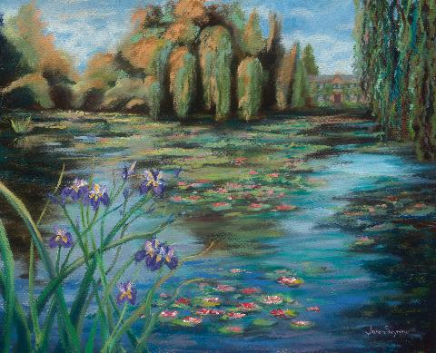
Water Lily Landscape, Copyright Jane Seymour 2019

At an early age, Jane Seymour developed a passion for art in England, where family gifts were typically created, rather than purchased, as a form of self-expression. She enjoyed many museum visits and was profoundly influenced by Matisse’s motifs, Chagall’s palette, and Raoul Dufy’s vibrant watercolors.
Often described as a California colorist, Ms. Seymour believes that her art reflects the essence of who she is. Her expressive art often mirrors her passions in life, such as flower gardening, which is evident in her colorful flower arrangements, detailed landscapes, and lush garden paintings and watercolors. An inspirational trip to paint in Monet’s Garden (Giverny, France) became Seymour’s personal tribute to the Impressionists, resulting in an elaborate series of paintings and watercolors depicting the famed gardens. She also has painted many seascapes from her Malibu coastal home, as well as paintings of her beloved grandchildren.
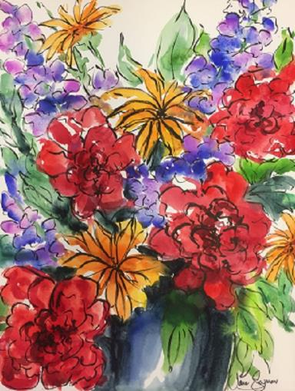
Along with her fine artwork, Jane’s love of art and color led her into the world of design with a variety of projects, ranging from her “Open Hearts by Jane Seymour®” jewelry collection, to fine furniture with Michael Amini, home accessories, and botanicals, as well as a signature line of picture frame mouldings, Fotiou Fine Moulding by Design™. With jewelry and her successful enterprises in related design fields, she has taken her Jane Seymour brand to the position of being in the top one hundred of Licensing Global Magazine’s list of the world’s top brands, something no other actor or actress has accomplished.
Spring Fling Bouquet, Copyright Jane Seymour 2019

Ocean Galleries, which has been providing creative custom framing for over 30 years, was one of the first galleries to carry Ms. Seymour’s picture frame mouldings line. Gallery owner Kim Miller is a fan of the popular line, as well as the artist herself. “We are so happy to welcome back Jane this summer. She is hard-working and kind, and her grace is felt by all who meet her. We invite everyone to join us Labor Day weekend to enjoy her art and feel her message in each piece of art she creates.”

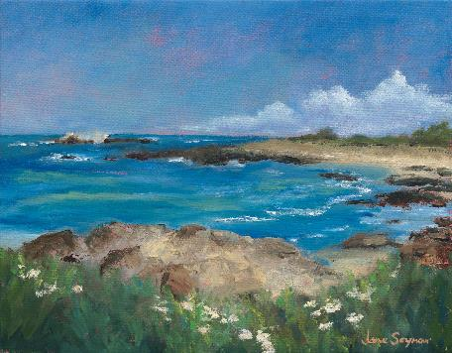
Pacific Grove View II, Copyright Jane Seymour 2019

The “Jane Seymour – California Colorist” exhibition will be at Ocean Galleries in Stone Harbor Friday, August 30 through Sunday, September 1, and will include numerous beachscapes and figurative paintings, many of which were inspired by recent visits to the East Coast. Ms. Seymour will be at the gallery to meet guests and sign purchased artwork from 7:00 PM to 10:00 PM on Friday, August 30 and Saturday, August 31, and from 1:00 PM to 4:00 PM on Sunday, September 1. The exhibition is free and open daily 10:00 AM to 10:00 PM with all artwork available for acquisition.

In addition to an extraordinary collection of artwork and custom-framing, Ocean Galleries also offers a variety of hand-made crafts from local, regional, and national artists in America, such as glass, pottery, jewelry, and furniture. All summer exhibitions take place at the Stone Harbor location of Ocean Galleries (9618 Third Avenue). Ocean Galleries also has an Avalon, NJ location at 2199 Ocean Drive. For seasonal hours at both gallery locations, call 609-368-7777 or visit oceangalleries.com
# # #
Established in 1986, Ocean Galleries is a distinguished fine art gallery and custom-framing retailer with locations in Avalon and Stone Harbor, New Jersey. We represent national and local artists, originals and fine art reproductions; with a mission of personally introducing our clientele to the fine artists and their coveted artwork. Ocean Galleries is considered one of the best custom framing operations in the industry for quality and design, with all framing done in-house. Ocean Galleries also offers a wide variety of hand-crafted items such as glass, jewelry, and furniture. Over the years, the gallery has become nationally known for hosting renowned artists such as Peter Max, Josef Kote, Autumn de Forest, Romero Britto, Charles Fazzino, Graham Nash, Ringo Starr, Hessam, Aldo Luongo, Jane Seymour, Don Hatfield, Howard Behrens, Jiang, Wyland, Viktor Shvaiko, Sam Park, and many others. As a regional and national dealer to individuals and corporate collectors, Ocean Galleries promotes artists with extraordinary abilities and established value, while practicing the highest standards of credibility and integrity in a comfortable and unpretentious atmosphere. For more information and store hours, visit OceanGalleries.com

