BUSINESS NEWS PRESS RELEASE

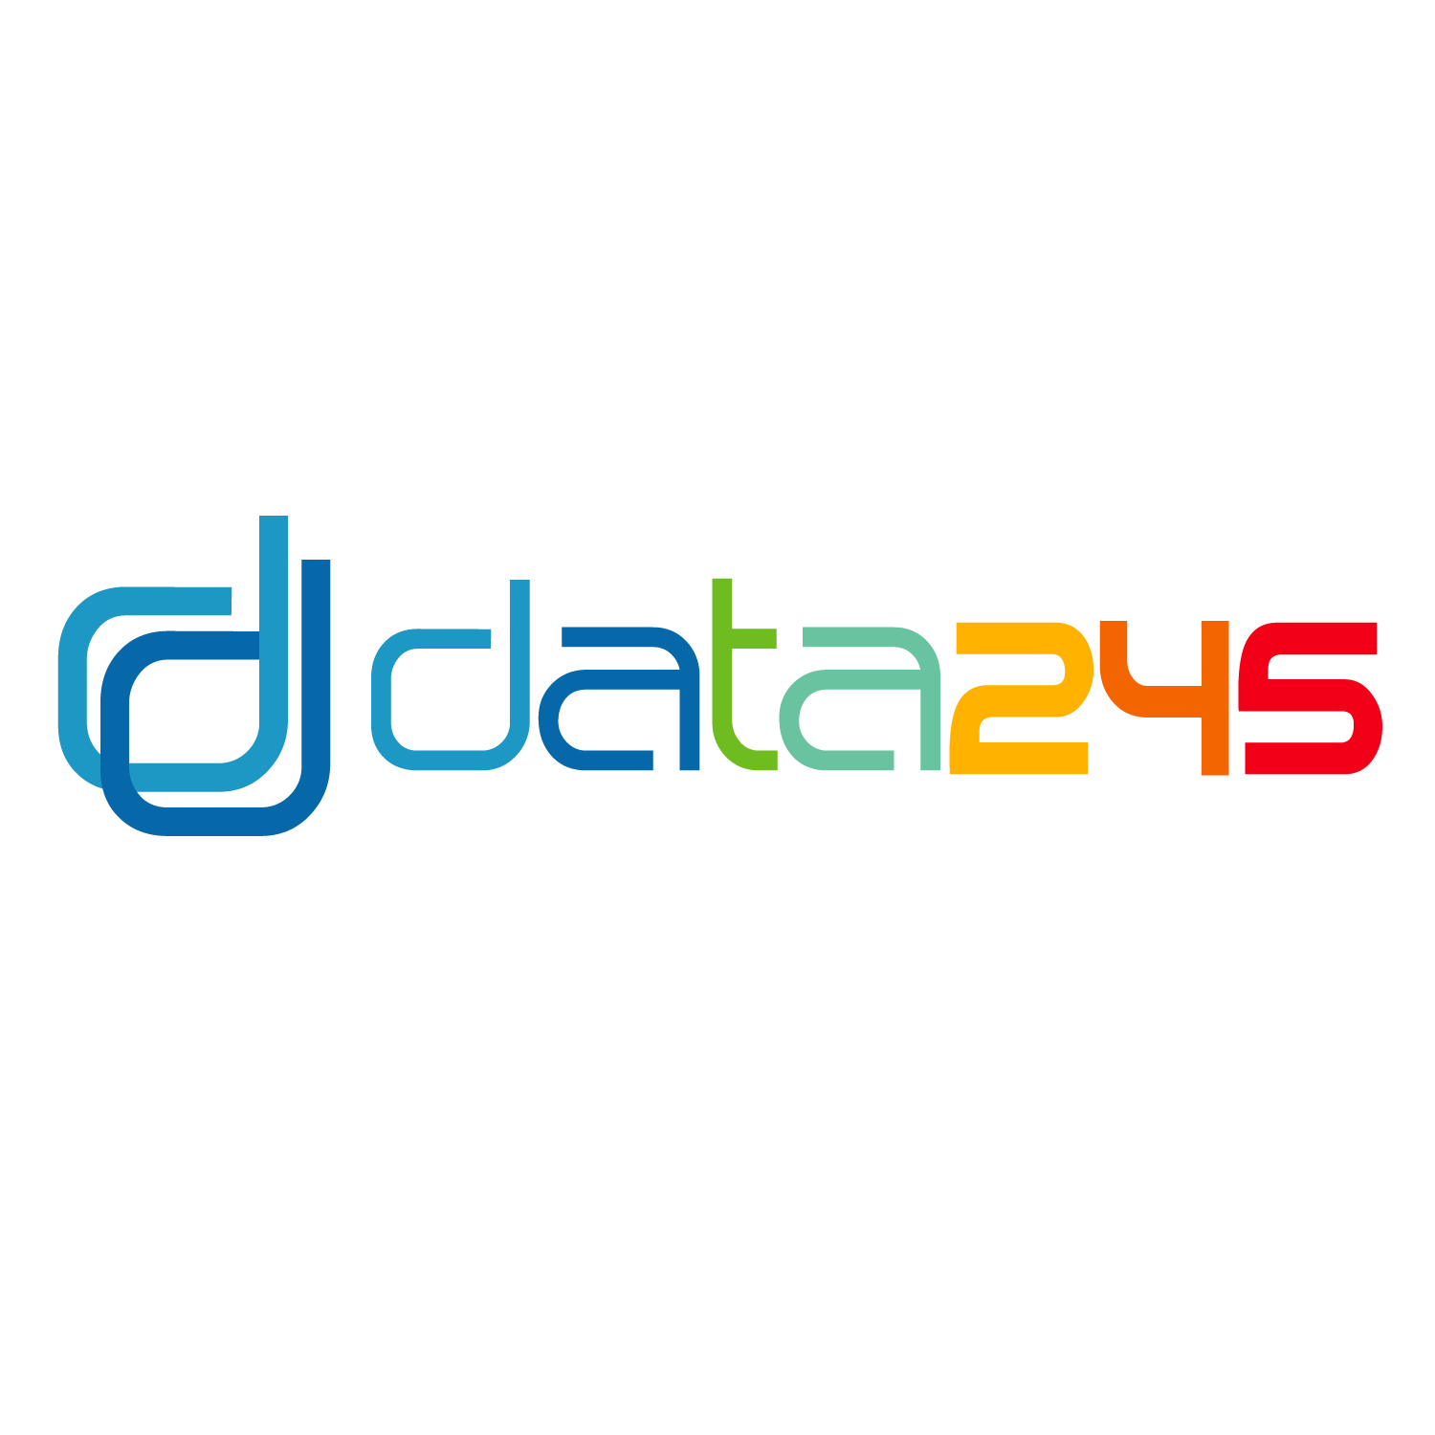

CONTACT INFORMATION:
data245
Paul J Burt
847-894-5700 cell
info@data245.com

FOR IMMEDIATE RELEASE

Startup data245 utilizes machine learning to predict and reduce employee benefit healthcare spend

{Bannockburn, IL, 8-19-19} – data245, the country's first machine learning company dedicated to employee benefits and employer health plans released a series of algorithmic reports that predict the future of employer health care expenses.

Paul J. Burt, data245’s founder, explains: “One of reports is available, at no cost, to groups in excess of 1,000 full-time employees, to demonstrate the value of data science”.

“Our reports have produced surprising results, thus far.” “Initially, we focus on mortality, morbidity and prescription drug use and abuse. Surprisingly, we are finding that our millennial population may be getting sicker, quicker”, says Burt.

“The reports reveal that there are specific areas of concern for each client revealed by the data and we are able to predict future claims and conditions that will likely produce substantial claims.”

“In the case of mental health conditions, as an example, an employee who is prescribed SSRI drugs can cost three times more in health claims than an employee with no anxiety or depressive conditions. These costs have yet been accounted for in current claims dollars.”

data245 was founded in 2017 and is located in Bannockburn, IL.

Paul Burt reiterates “Machine learning is new to the employee benefit space but has already proved to be a game changer, leveling the playing field with medical carriers that are already employing data science and machine learning to produce their annual renewals”.

Paul J. Burt founded data245 and is also the Founder/President of WL Benefits Group, an employee benefits brokerage and consulting firm, founded in 1991.

###

DISCLAIMER

Any articles, templates, or information provided by Smartsheet on the website are for reference only. While we strive to keep the information up to date and correct, we make no representations or warranties of any kind, express or implied, about the completeness, accuracy, reliability, suitability, or availability with respect to the website or the information, articles, templates, or related graphics contained on the website. Any reliance you place on such information is therefore strictly at your own risk.

