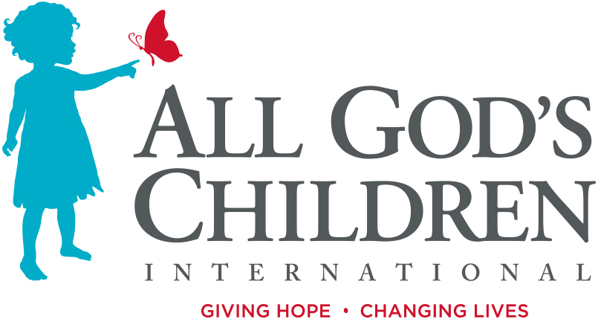
1400 NE 136th Ave #201
Vancouver, WA 98684
Media Contact: Angela Hood
503-705-5931

JEP ROBERTSON JOINS ALL GOD’S CHILDREN INTERNATIONAL
Jep Roberston of Duck Dynasty Fame Joins AGCI

Sept. 18, 2019 (Vancouver, WA, USA) –U.S. based orphan care ministry, All God’s Children International (AGCI), is thrilled to welcome Jep Roberston as their National Advancement Officer. Jep officially joined the team on September 3rd, 2019, and will be fulfilling his new role from his home in Austin, Texas. AGCI seeks to leverage Jep's many unique national connections to introduce new donors to AGCI while also advancing church engagement. Jep was first introduced to AGCI at their annual dinner and auction in Austin, Texas in February 2019.

“I was invited to the auction by a buddy of mine, and I was blown away,” said Jep Roberston. “There was a girl who spoke that grew up in an orphanage in Colombia. She was now in college and doing amazing things thanks to the support of All God’s Children. I was crying like a baby hearing all that she had been through and what she was able to accomplish now. I really like how AGCI comes at the orphan crisis from all angles. They are adaptive and adjust their programs when needed so that they are able to have biggest impact possible for kids and families.”

Jep and his wife Jessica adopted their youngest son, Gus, through a domestic adoption four years ago. Intervening for orphans is something that the Robertsons felt God laid on their heart with the adoption of their son. In July, Jep also traveled to Ethiopia with AGCI President, Hollen Frazier, to see AGCI’s work for orphans and vulnerable families first hand. After seeing the immense need and getting to know Hollen, Jep was on board.

“We’re so grateful to be partnering with Jep and to have him as a member of our team,” said AGCI President, Hollen Frazier. “We feel very blessed to be entering a new season as an organization. We’re looking forward to sharing AGCI’s mission and vision with an entirely new group of individuals, thanks in large part to Jep’s help. I think when people hear about the need and the opportunities there are to make a difference for vulnerable children and families, there’s this excitement and drive to be a part of something.”

For additional information, please contact Angela Hood.
About All God’s Children International
All God’s Children International has over 28 years of experience changing lives for orphans around the world. AGCI is an orphan care ministry answering God’s call to provide the love and care that every child deserves. Our vision is to empower local leaders to intervene for the 8 million children currently living in institutions and create more pathways to family and independence. AGCI currently serves in Bulgaria, Burundi, China, Colombia, Ethiopia, Guatemala, Haiti, the Philippines, South Africa, and the United States. AGCI is located at 1400 NE 136th Ave #201, Vancouver, Washington. For more information on AGCI, visit their website.
# # #

