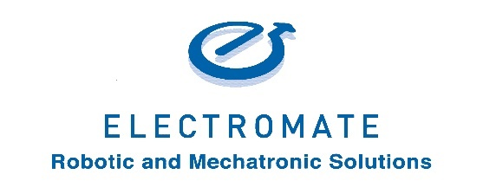
Electromate Inc. made it to the 2019 List of Best Workplaces™ for Millennials

For Release: October 1, 2019 11:00am EST

Electromate is proud to announce that our organization has been named on the 2019 list of Best Workplaces™ for Millennials.
Electromate received this honour after a thorough and independent analysis conducted by Great Place to Work®.
This list is based on direct feedback from employees of the hundreds of organizations that were surveyed by Great Place to Work®. The data has a 90% confidence and a plus or minus 5% margin of error. To be eligible for this list, organizations must be Great Place to Work Certified™ in the past year, and…
- 30% of their employees must fit the Millennial demographic (born between 1981 and 1996)
- They must have minimum 90% positive response to the statement "I am treated fairly regardless of my age"
- The organization must meet a minimum consistency index among the different age demographics

"Electromate is honored to be named on the 2019 list of Best Workplaces™ for Millennials. Creating a ‘Great Place to Work’ has been pivotal in driving employee satisfaction and engagement”, says Warren Osak Founder and President of Electromate. “Numerous empirical studies have shown that highly engaged employees are more productive and deliver a higher level of customer satisfaction than unengaged employees, and much of our competitive advantage stems from the positivity in our workplace. Electromate prides itself on its commitment to the principles of Kaizen, or continuous improvement. This holds true for the professional and personal development of its employees which has greatly contributed to the creation of our company culture embodying the Core Values of Integrity, Innovation, Enthusiasm, Continuous Learning and Customer Advocacy.”
About Electromate Inc:
Electromate’s Core Purpose is to help Manufacturers compete globally by building better machines using differentiated Automation Technology. They specialize in Robotic and Mechatronic Solutions for the Industrial Automation marketplace. Respected by customers as a premiere source for High Performance Automation and Motion Control Components & Systems, Electromate® specializes in AC & DC Servo and Stepper Motors & Drives, Motion & Automation Controllers, Positioning Systems & Actuators, Feedback Devices, Gearing Products and HMI's & Operator Displays, all supported via extensive product selection, just-in-time delivery, dedicated customer service and technical engineering support.
You can follow Electromate® on…
Website: www.electromate.com
LinkedIn: https://www.linkedin.com/company/electromate/
Twitter: @Electromate
Facebook: www.facebook.com/electromateindustrial/
YouTube: www.youtube.com/user/electromate
Blog: electromate.wordpress.com/

About Great Place to Work®:

Great Place to Work® is the global authority on high-trust, high-performance workplace cultures. Conducting the world’s largest workplace study, surveying over 8,000 organizations representing more than 10 million employees in more than 60 countries, GPTW provides tremendous understanding of effective business cultures and the increasingly complex marketplace. Through proprietary assessment tools and services, GPTW recognizes the world's Best Workplaces™ in a series of national lists including those published by The Globe & Mail (Canada) and Fortune magazine (USA). GPTW provides the benchmarks and expertise needed to create, sustain, and recognize outstanding workplaces, and it supports clients as this accelerating pace of change compels organizations to continuously adapt, innovate and thrive.

Media contacts:

Electromate Inc.
Toll Free Phone: 877-737-8698
www.electromate.com
sales@electromate.com
Attention: Warren Osak

