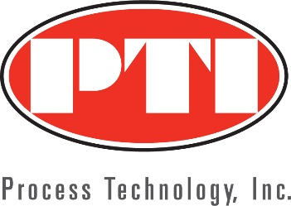
Process Technology, Inc. Expands Turck USA Coverage into Colorado, Montana and Wyoming
Salt Lake City, January 14, 2020 - Process Technology, Inc (PTI) along with Turck USA announces an expansion of territory to include Colorado, Montana and Wyoming.
Process Technology, Inc. (PTI) has expanded its presence into Colorado, Montana and Wyoming by representing Turck USA. For over 30 years, PTI ‘s expertise has identified and solved some of the toughest challenges in industry throughout the Rocky Mountain region.
“Our Front Range team will offer industry of all sizes the opportunity to strengthen their automated processes with the durability, functionality, and performance of Turck’s distributed I/O and connectivity solutions,” says PTI CEO Chris Wheat. “We are ready to provide the Colorado, Montana and Wyoming territories the most up-to-date processes and customer service that Turck USA products bring.”
PTI has an established team in the Front Range. Sales Engineers, Aaron Mooney, Rich Robins, Steve Pitkin, Buddy Alford and Applications Engineer, Brian Waslo have the technical industry expertise that have enabled our customers to prosper. Based in the PTI Denver office, Brian states, “With the addition of Turck’s products and solutions, we have an opportunity to pair industry-specific knowledge with custom electronics development, guaranteeing optimal solutions for automation challenges.”
The PTI territory expansion of Turck products, specializing in high quality sensors, fieldbus, and connectivity - as well as interface technology and RFID systems will give customers in the Colorado, Montana and Wyoming territories cost efficient, effective solutions across industries. The Front Range Sales and Support team, the “Experts at the Heart of Industry” will configure, quote and order Turck products with reliability and outstanding customer service.
About Process Technology, Inc. (PTI)
Process Technology, Inc., located in Salt Lake City, Utah, has been solving process control and factory automation challenges since 1986. With branch offices located in Arizona and Colorado, serving industrial B2B customers in Utah, Wyoming, Southern Idaho, Northern Nevada, Arizona, New Mexico, Colorado, and Montana.
The PTI Team are factory trained, experienced professionals that are experts in process control and factory automation. The “PTI People” have a deep commitment and dedication to customers and vendors.

