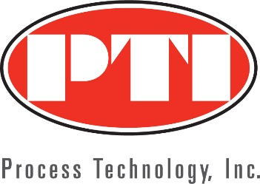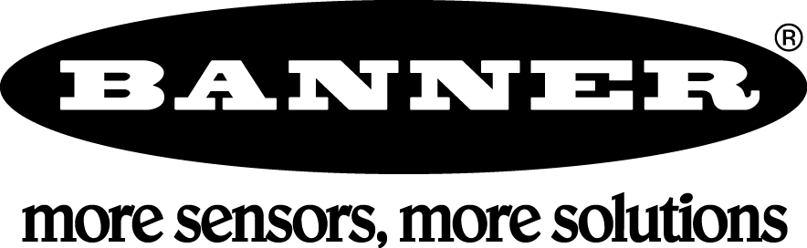

Process Technology, Inc. Expands Banner Engineering Coverage into Colorado, Montana and Wyoming
Salt Lake City, February 1, 2020 - Process Technology, Inc (PTI) along with Banner Engineering announces an expansion of territory to include Colorado, Montana and Wyoming.
Process Technology, Inc. (PTI) has expanded its presence into Colorado, Montana and Wyoming by representing Banner Engineering. For over 30 years, PTI ‘s expertise has identified and solved some of the toughest automation challenges in industry throughout the Rocky Mountain region.
“Our Front Range team will offer large and small companies the opportunity to strengthen their automated processes with the quality and excellence of Banner’s IIOT and Smart Factory solutions,” says PTI CEO Chris Wheat. “We are ready to provide the Colorado, Montana and Wyoming territories the benefits of Banner Engineering’s well-built products, innovative processes and customer service.”
PTI has an established team in the Front Range. Sales Engineers, Aaron Mooney, Rich Robins, Steve Pitkin, Buddy Alford and Applications Engineer, Brian Waslo have the industry knowledge that have enabled our customers to achieve their automation goals. Based in the PTI Denver office, Brian states, “With the addition of Banner’s products and custom solutions, we have an opportunity to satisfy our customer’s requirements by analyzing all the necessary elements of an application and identifying the essential products, features and components to increase productivity.”
The PTI territory expansion of Banner Engineering products, specializing in sensors and vision sensors, LED lights and indicators, wireless and safety products - will give customers in the Colorado, Montana and Wyoming territories a broad selection of superior quality products to solve application challenges. The Front Range Sales and Support team, the “Experts at the Heart of Industry” will configure, quote and order Banner products with reliability and outstanding customer service.
About Process Technology, Inc. (PTI)
Process Technology, Inc., located in Salt Lake City, Utah, has been solving process control and factory automation challenges since 1986. With branch offices located in Arizona and Colorado, serving industrial B2B customers in Utah, Wyoming, Southern Idaho, Northern Nevada, Arizona, New Mexico, Colorado, and Montana.
The PTI Team are factory trained, experienced professionals that are experts in process control and factory automation. The “PTI People” have a deep commitment and dedication to customers and vendors.

