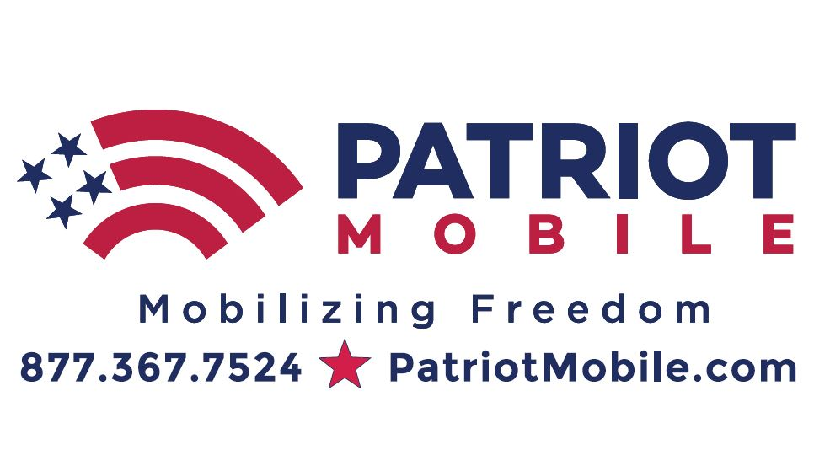
Patriot Mobile revs up support of Veterans at NASCAR Race
FOR IMMEDIATE RELEASE
Fort Worth, TX, February 18, 2020 - Patriot Mobile has once again partnered with Texas Motor Speedway (TMS) to honor our nation’s heroes at the upcoming NASCAR Cup Series race March 27-29, 2020. All veterans, military and first responders can benefit from 25% off regularly priced tickets for the NASCAR Cup Series race on Sunday, March 29th when they use promo code: PatriotMobile and present their military credentials at the gate. Call or text the ticket office at 817-255-6163 for details.
All discounted military ticket holders are invited to join Patriot Mobile in the Military Appreciation Pit Lane Walk prior to the start of the race. Visit the Patriot Mobile’s booth in the Fan Zone near Gate 6, before 10 am on race day, show your military discounted race ticket and pick up your infield wristband to participate in the walk. Sunday March 29th is nationally recognized as Vietnam Veteran Appreciation Day. Patriot Mobile and TMS will honor Vietnam War Veterans in a special way at the O’Reilly Auto Parts 500.
In addition to supporting Veterans at the Texas Motor Speedway NASCAR race, Patriot Mobile is increasing their military discount to 25%. All active military, vets and first responders can take advantage of this promotional, limited time offer on all Patriot Mobile cell phone service plans. Patriot Mobile allows active duty military members to keep their accounts and phone numbers intact while deployed overseas for only $3 a month. As military members reactivate their service, they don’t pay any service charges or reactivation fees on their Patriot Mobile nationwide cell phone service.
Patriot Mobile is giving away two (2) Pre-Race concert passes and cold pit passes for Sunday’s event to anyone signing up for new service with Patriot Mobile through March 26th (Value $158), while supplies last. Click here for concert details.
Visit Patriot Mobile’s booth in the Fan Zone near Gate 6 for a chance to win several prizes: Two tickets to the June Truck Race and a ride for one in the Grand Marshal’s car, Texas Gun Experience (value $500), Cold Pit Passes, Saturday, March 28th NASCAR race tickets, Patriot Mobile cell phone service discounts and much more. No purchase necessary.
Ron Montgomery, CEO of Patriot Mobile said, “Patriot Mobile believes that we must care for the service men and women who sacrifice to keep us safe and free. While we can never fully repay those who give so much to protect our way of life, we are offering these special discounts and supporting our veterans and active military as a token of our appreciation. We will continue to support veterans throughout the year and at each NASCAR and Indycar series weekends at TMS in 2020.”
About Patriot Mobile
Patriot Mobile, a DFW-based company offering nationwide cellular phone service since 2013, is America’s only conservative cell phone company. With reliable nationwide coverage available on Android and Apple devices, Patriot Mobile offers competitive prices and exceptional customer service through its US-based customer service team. Patriotic employees proudly serve Conservative Americans. Patriot Mobile contributes a portion of every cell phone bill to organizations that support the Constitution, religious freedom, First and Second Amendment rights, veterans, and the sanctity of life. For more information about Patriot Mobile, visit PatriotMobile.com or call 877-367-7524. You can also visit us on Facebook, Twitter, YouTube, Parler and Instagram.
Press Contact – Lisa Bennett at lisa.bennett@patriotmobile.com

