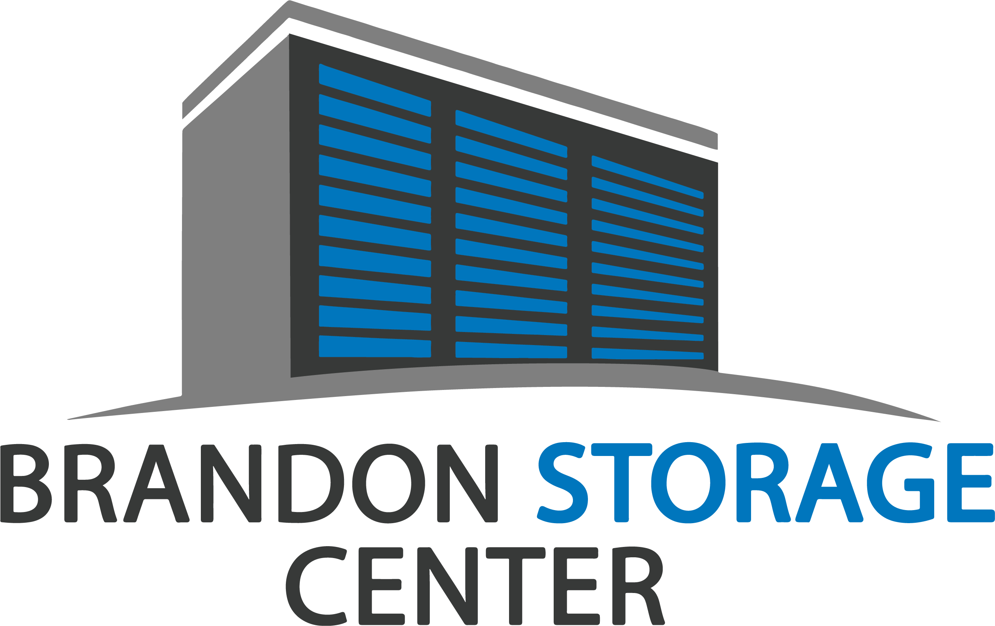
Brandon Storage Center
2711 Broadway Center Boulevard
Brandon, FL 33510
813-570-6800
BrandonStorageCenter.com
_____________________________________________________________________________________
FOR IMMEDIATE RELEASE February 26, 2020
NEW SELF STORAGE FACILITY OPENED
in Brandon, FL

Brandon, FL.- Local real estate development company, Brandon Storage Center, LLC has opened a new location named Brandon Storage Center in Brandon, FL. The newly constructed facility, at 2711 Broadway Center Boulevard, comprises 66,375 square feet of rentable storage space in 682 units. Brandon Storage Center provides a secure facility that offers interior climate controlled units to the local community of Broadway Centre, in Hillsborough County. This brand-new facility sits on the cross street of Broadway Center Boulevard and William Rd. which is next to Ashley Furniture’s distribution center. This state-of-the-art facility provides storage services to the patrons of Lakewood Village, Hillsborough Community College and Retreat at Bermuda Lake by Cortland. Brandon Storage Center is also close in proximity to neighborhoods such as Kensington and Williams Crossing.

Brandon Storage Center, LLC is partnering with Absolute Storage Management (ASM) to provide professional self storage management. Brandon Storage Center opened December 26, 2019. For details on the property, or information on move-in specials and availability please call 813-570-6800, visit their website at BrandonStorageCenter.com.
A ribbon-cutting ceremony will be held on-site on Thursday, March 19, 2020, from 10am to 4pm. Members from the Chamber of Commerce will be in attendance. This event is open to the public and will include property tours, music, games and prizes. Please RSVP by email at BrandonStorage@absolutemgmt.com

Absolute Storage Management
Absolute Storage Management (ASM) is one of the largest private, third-party self-storage management company in the United States. Founded in 2002, with headquarters in Memphis, TN and regional offices in Atlanta, GA; Charlotte, NC; Nashville, TN; and Jackson, MS, the company operates over 100 properties in Alabama, Arkansas, Florida, Georgia, Illinois, Kentucky, Louisiana, Mississippi, Missouri, North Carolina, Ohio, South Carolina, and Tennessee.

For further information and news about Absolute Storage Management, please go to the ASM website at www.absolutemgmt.com or contact Jasmin Jones at jasmin.jones@absolutemgmt.com or call her at (678) 779-1978.

###

