-MEDIA RELEASE-
For more information, contact Kevan Goff-Parker
Director of Corporate Communications, ATS World Wide LLC
405.514.3972, contact@aircrafttowingsystems.com
https://www.aircrafttowingsystems.com

‘Regents Business Partnership Excellence Award’ to honor Aircraft Towing Systems World Wide LLC on March 12
Oklahoma State University’s New Product Development Center and ATS World Wide LLC to Test Revolutionary Prototype this Summer
By Kevan Goff-Parker
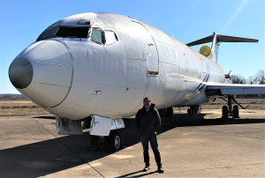Aircraft Towing Systems World Wide LLC CEO/Vice President Vince Howie stands before a Boeing 727 at Ardmore Industrial Airpark in Ardmore, Oklahoma. The plane will be used to test and demonstrate how ATS moves aircraft autonomously using a rail system located in a channel just below the surface of select portions of the airport’s taxiways.
EDMOND, OK (3/3/2020) — Aircraft Towing Systems World Wide LLC (ATS) has transformed from an inventor’s dream into an exciting ongoing creative venture with Oklahoma State University’s New Product Development Center (NPDC).
Oklahoma State University New Product Design Center recently nominated ATS World Wide LLC for a special honor and the company will be recognized with an Oklahoma State Regents for Higher Education’s “Business Partnership Excellence Award” at 11 a.m. on March 12 at the University of Central Oklahoma in Edmond, OK.
The NPDC ATS team’s innovative research, development and design for ATS’ revolutionary aircraft transportation system is resulting in the construction of a prototype to move aircraft to and from airport taxiways and gates without the use of a jet’s main engines.
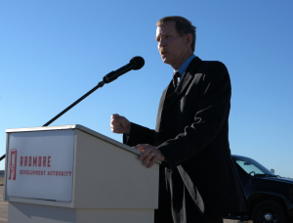Oklahoma State University’s New Product Development Center’s (NPDC) director, Robert Taylor, Ph.D., leads the NPDC’s Aircraft Towing Systems team that performs innovative research, development and design for ATS World Wide LLC. Here, Taylor and other state dignitaries spoke during a groundbreaking ceremony in November 2019 at the Ardmore Industrial Airpark.in Ardmore, Oklahoma. ATS is now constructing a site at the airpark to test a prototype of ATS’ electric-powered railway system. The aircraft towing system is designed move aircraft to and from airport taxiways and gates without the use of a jet’s main engines.
Led by OSU’s NPDC Director Robert Taylor, Ph.D., the center began working on the project in November 2016 and is currently developing a prototype testing system. The OSU team also nominated ATS for a special honor and the company will be recognized with an Oklahoma State Regents for Higher Education’s “Business Partnership Excellence Award” at 11 a.m. on March 12 at the University of Central Oklahoma in Edmond, OK.
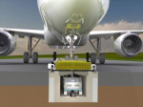
This rendering demonstrates how the Aircraft Towing System will work once completed sometime this fall. ATS is fully automated, powered by an electric motor and moves aircraft autonomously using a rail system located in a channel just below the surface of select portions of the airport taxiways and gate areas.
The award is designed to highlight successful partnerships and to further cultivate the higher learning environment through the Oklahoma State Regent’s Economic Development Grants. Taylor said he is grateful to the state regents for supporting OSU’s business partnerships and the quality that often results when it comes to new product development.
“The unique ATS concept originated with Polish businessman and entrepreneur, Stan Malicki, along with the help of his hand-picked international engineers,” Taylor said.
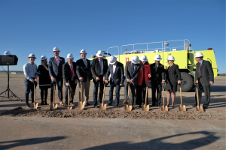Numerous Oklahoma dignitaries attended a groundbreaking ceremony in November 2019 at the Ardmore Industrial Airpark in Ardmore, Oklahoma.
He said Malicki likes Oklahoma’s pro-business environment and friendly workforce and is now the president of the company. Incorporated in Oklahoma in 2016, ATS is an Oklahoma and internationally based company. ATS World Wide LLC CEO/Vice President Vince Howie is a partial owner of the company and meets weekly with the NPDC ATS team as they fulfill the research, development and design on the contract.
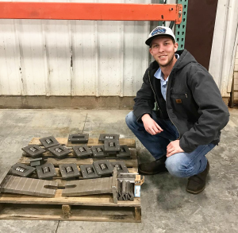
Production Machine and Tool (PMT) is a veteran-owned small business offering extensive machining and manufacturing expertise out of its production facility in Wichita Falls, Texas. Here, Luke McNullen, displays wheel bearings to be used on the Aircraft Towing Systems’ prototype. He manages the production side of PMT’s work, including scheduling and purchasing. He says nearly everyone in the PMT shop, approximately 70 employees, have worked on some aspect of the prototype.
“When we started working on the project in 2016, we basically had a package and pretty much a blank slate before we created a team out of converged departments, professors and mechanical, aerospace, civil, electrical and computer engineering undergraduate and graduate students, including five Ph.Ds.,” Taylor said. “Our research and development of ATS provides our students with real world experience and that’s what our center is wrapped around – the commercialization of new product development and contributing to economic development in Oklahoma.”
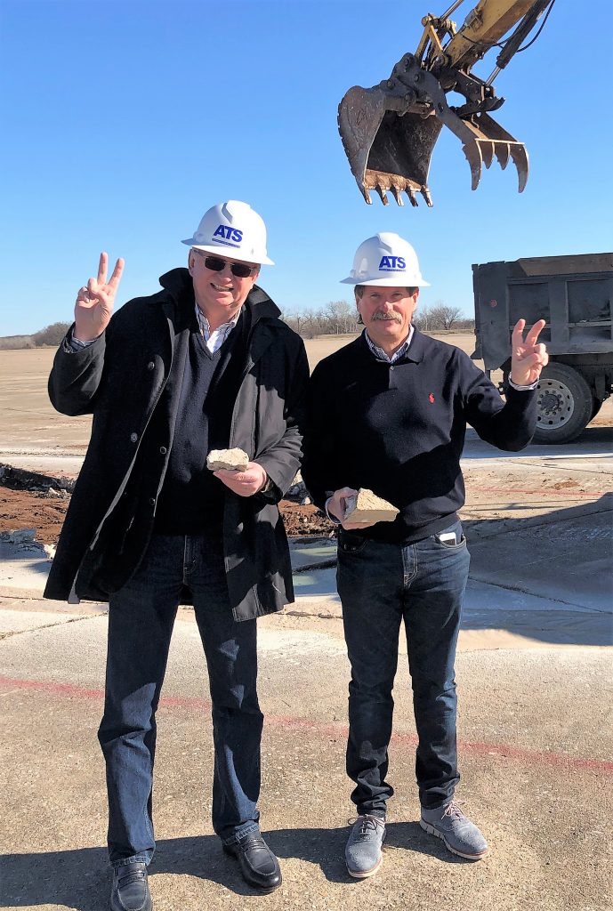
(L-R) Aircraft Towing Systems World Wide LLC President Stan Malicki is the Polish businessman and entrepreneur who created the ATS concept, along with the help of his hand-picked international engineers. Here, he and ATS CEO/Vice President Vince Howie flash the “V for Victory” signs during a recent visit at the Ardmore Industrial Airpark in Ardmore, Oklahoma.
ATS held a groundbreaking celebration at the Ardmore Industrial Airpark in November 2019 and installation of the underground channel for ATS’ electric-powered railway system should be complete by this summer.
“I suspect there are small bits and pieces we’ll need to adjust, which is common when you introduce a prototype and test the system, but we’re excited,” Taylor said. “Some of the benefits of ATS will be a reduction of fuel emissions and it should improve efficiency, as well as an increase in safety because ATS will be run by ground control, so there should few if any aircraft accidents on the ground. With a fully installed ATS system, a pilot can land on a runway and move onto the taxiway, where he or she can align the aircraft’s nose wheel into an ATS pull car.
“Once the nose wheel is secured, a pilot can turn off the main engine and ATS safely moves the aircraft using its channel system to the appropriate gate. The reverse process is used when pilots are ready to takeoff. Pilots will then turn on their engines and drive off the pull car, move into position and takeoff.”
Howie, former director of aerospace and defense for the Oklahoma Department of Commerce, said Taylor and the OSU NPDC team is doing great work that may revolutionize the way airports run in the future.
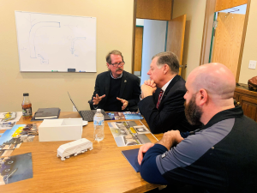Aircraft Towing Systems World Wide LLC CEO/ Vice President Vince Howie discusses ATS with Oklahoma Congressman Tom Cole and Citadel Construction President Michael Shoemaker. Howie explained how ATS should revolutionize the way airports operate. Some of the benefits of ATS will be a reduction of fuel emissions and improved efficiency, as well as an increase in safety. It will be run by ground control, so there should few if any aircraft accidents on the ground. ATS is fully automated, powered by an electric motor and moves aircraft autonomously using a rail system located in a channel just below the surface of select portions of the airport taxiways and gate areas.
“ATS is fully automated, powered by an electric motor and moves aircraft autonomously using a rail system located in a channel just below the surface of select portions of the airport taxiways and gate areas,” Howie said. “ATS will negate the need for tug-and-cart equipment and associated personnel. We do foresee increased operational efficiencies, including the potential to increase the speed of airport gate turnover, as well as environmental and safety benefits.”
He said ATS has the potential to provide solutions to the challenges of wasted aircraft fuel because fuel will be saved when the main engine is shutoff.
“We believe ATS will reduce harmful fuel emissions, decrease noise around airports and potentially extend jet-engine life, all while reducing aircraft collisions,” Howie said. “This will create an overall safer and more efficient takeoff and landing system.”
He said ATS has been pleased with the OSU NPDC team’s performance.
“The kind of work they do has really been outstanding, so we’re really thrilled,” Howie said. “It has been a marvelous relationship. People are excited to see the prototype operational.
“We believe there’s a super bright future for this opportunity, not just for OSU, but because we believe it is the next phase of automation for airports worldwide.”
For more information about ATS, click https://www.aircrafttowingsystems.com. For photos compatible with 300 DPI, click https://drive.google.com/file/d/1970Q360KBIfYB8N0o2Ma1j4GsRhMdRcI/view?usp=sharing.
For more information, contact Kevan Goff-Parker
Director of Corporate Communications, ATS World Wide LLC
405.514.3972, contact@aircrafttowingsystems.com
https://www.aircrafttowingsystems.com.

