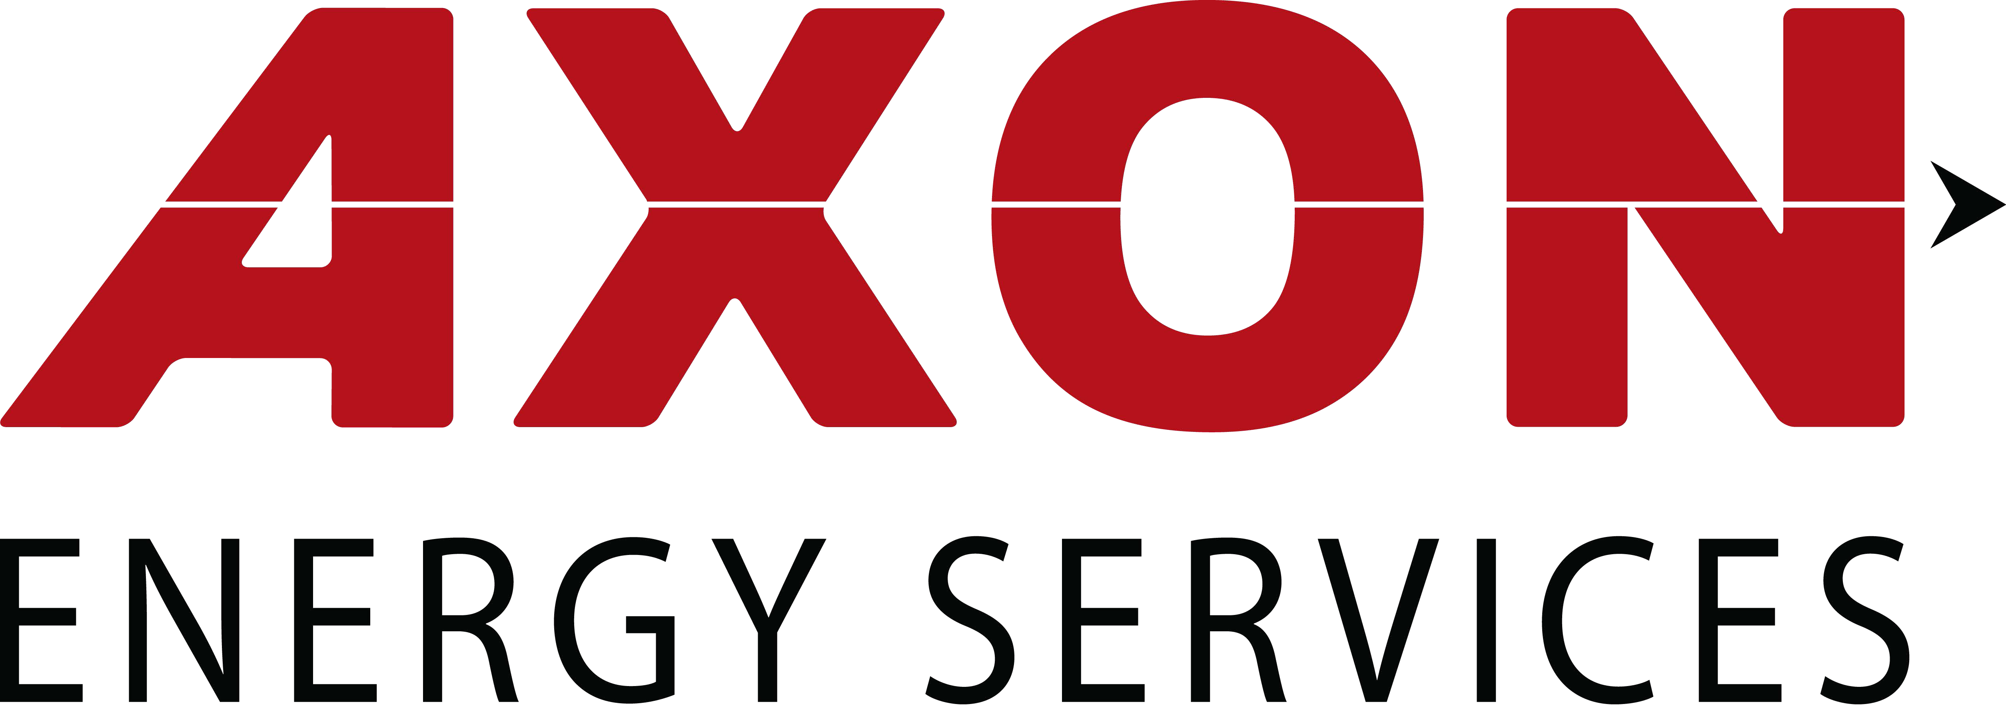

HOUST ON, T X – March 5, 2020 – AXON Energy Services (AES) is pleased to announce it has signed a Service and Maintenance agreement for the Permian Basin Region with Performance Wellhead and Frac Components, LLC (PWC), a Pelican Energy Partners company. This facility will be a full-service shop with the capabilities of performing Reseal and Testing of BOP equipment, valves and control units. AES will be stocking all necessary OEM BOP rubber goods, valve parts and basic control unit spares.

According to Jeff Hunter, Vice President of Business Development for AES, “We will be consistently evolving this venture so that it is geared toward our customer’s specific needs. AES and PWC have been very successful in the Permian this year and we will build upon this achievement with essential stock. PWC is a known entity in the Permian Basin and is a key distribution facility that provides ancillary support to the area. This strategic move will enhance both businesses.”

For further information or details about this service facility please contact Jeff Hunter at JeffreyHunter@axon-es.com

The facility is located: 11200 W. I-20 East
Odessa, Texas 79765
(432) 385-7690

A bout A X ON E nergy S ervices

Headquartered in Houston, Texas, AXON Energy Services is a leading OEM specializing in a wide range of API Certified pressure products for surface and subsea applications including BOPs, BOP Controls, Choke & Kill Manifolds, Connectors, Diverters, Tandem boosters, Elastomers and Aftermarket Services. AXON products are manufactured in the U.S.A. www.axon-es.com

A bout Pe r forma nc e W e l lhe a d a nd Fra c C ompone nts , LLC

Headquartered in Houston, Texas, Performance Wellhead & Frac is a leading oil and gas service company specializing in surface well-control equipment and related field services utilized in all

phases of drilling, well-stimulation, production, and intervention operations.

###
www.pwfrac.com

