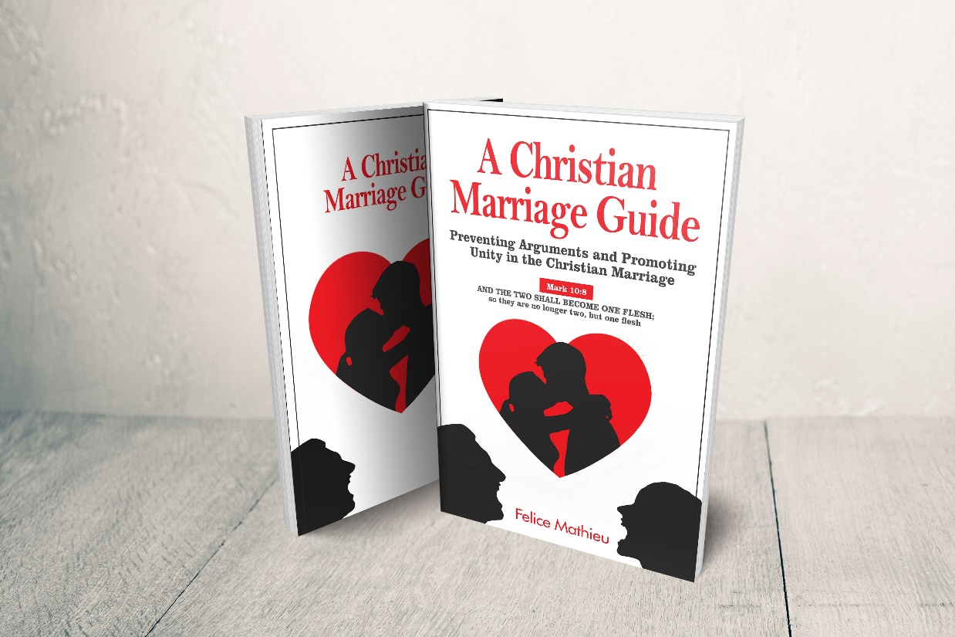

Communication in marriage is difficult. Who says it has to be complicated?

Learn the Christ-centered practical approach to communicating in your marriage. Based on over 20 years of research.

Whether you are newlyweds, have been happily married awhile, or are currently going through a rough patch in your marriage, the following statement is true, arguments WILL happen.
And pride, by far, ends more relationships than death does.

No person or relationship is perfect, and mediating these rosy expectations of love can be difficult. Every marriage has its problems, but what separates the "good" from the "bad" is how frequently, disrespectfully, or even selfishly these arguments happen.
But what prevents frequent arguments? True love?
As a counselor, I have studied interpersonal communication in marriage for over 20 years, and in this time, I discovered that the most successful marriages are founded on strong communication skills.
Jesus made communication in marriage simple with ONE verse:
Mark 10:8 NASB: "...AND THE TWO SHALL BECOME ONE FLESH; so they are no longer two, but one flesh."

With the right aids, you can get your marriage back on track, but improvement starts with you!
Order your copy NOW and take your first step for a better marriage!

"Firstly, this book touches on very important aspects of marriage, COMMUNICATION. In most cases, this is where all arguments or tensions emanate from. The author goes on to emphasize that HONEST TRUTH is always better than NOT SAYING THINGS AT ALL." - Idea Chitsaka (Zimbabwe), Outside Catering Manager

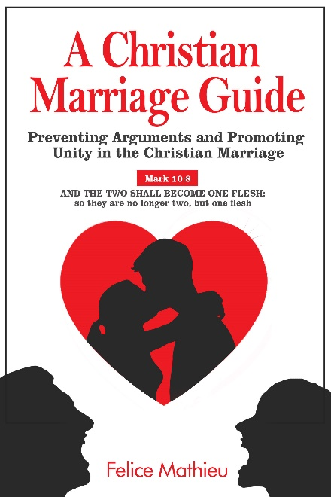
Achieve more unity in your marriage, and less arguments.

During my 20 years of research, I also took my observations into Spoken Word Poetry. Included in this book are biblical based poems that poetically express and share insights on what I have observed. If per chance you decide not to get this book, I highly encourage you to find marital aids that can help you with communication in marriage.
I have watched WAY too many spouses fail all because of a refusal to rely on anything but their own emotional intelligence. Pride, by far, ends more relationships than death does.

Get the book on many different platforms here: https://books2read.com/marriagesharing
This author’s mother died of HIV when he was 12 years old. Several months later his stepfather was murdered in Haiti. Several months following that his last living blood relative died of diabetes. By age 13 being the last known survivor of his last name, he became obsessively focused on understanding relationships. A journey of 20 years that compelled him to closely, and obsessively observe relationships, but more importantly, marriages. Learn what 20 years of research has revealed to him about the #1 problem in marriage. Communication. This book, founded on God’s Word, over 10 years’ worth of Spoken Word Poetry Performances, interviews with 100’s of spouses, panel discussions, coaching sessions, and workshops will quickly, and practically teach you to communicate effectively in your marriage.

Contact Information:

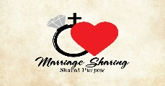

Felice Mathieu | Speaker Poet | Marriage Coach
Founder
contact@marriagesharing.com
Twitter
Facebook
Blog

