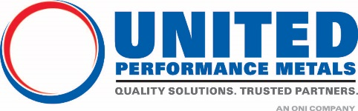
Contact: Kris White
Communications Specialist
kwhite@upmet.com
513-860-6373

UNITED PERFORMANCE METALS ACHIEVES ISO 13485:2016 APPROVAL IN CONNECTICUT SERVICE CENTER
South Windsor, CT – April 6, 2020 – United Performance Metals (UPM) has successfully achieved ISO 13485:2016 certification from NSF-ISR. This approval will allow the company’s South Windsor, Connecticut branch to provide both materials and processing services for the medical industry.

“Achieving this certification demonstrates our commitment to quality and service for medical OEM and machine shop sub-contractors in the Northeast, Mid-Atlantic, and other regions throughout the country,” remarked Dennis Rahill, Business Development Manager.

Mark Ruel, UPM Quality Lead in Connecticut added “Obtaining ISO 13485 certification validates United Performance Metals’ commitment within the markets we serve by delivering the highest level of quality and consistency to our customers.”
United Performance Metals South Windsor, CT branch now holds three (3) separate Quality Management Registration Systems; ISO 9001:2015, AS9100D and ISO 13485:2016.
United Performance Metals (UPM), an O’Neal Industries affiliate company, is a global distributor of high-performance specialty metals. UPM’s full line of high strength, high temperature, and corrosion resistant materials coupled with FIRSTCUT+® Processing Services provides quality solutions which support a variety of industries including aerospace, fastener, medical, power generation, oil and gas, semiconductor and many others. UPM is headquartered in Cincinnati, Ohio and maintains nine service centers worldwide. For more information, visit www.upmet.com.
O’Neal Industries (ONI) is the nation's largest family-owned network of metals service centers and component and tube manufacturing businesses. Composed of seven leading brands and generating sales of approximately $2.4 billion in 2019, ONI is based in Birmingham, Alabama, and has more than 80 specialized facilities throughout North America, Europe and Asia. For more information, visit www.onealind.com.

###

