-MEDIA RELEASE-

Aircraft Towing Systems’ Purchase of an Abandoned Boeing 727 Reveals Aviation History at Ardmore Industrial Airpark
By Kevan Goff-Parker, Corporate Communications director, ATS World Wide LLC.

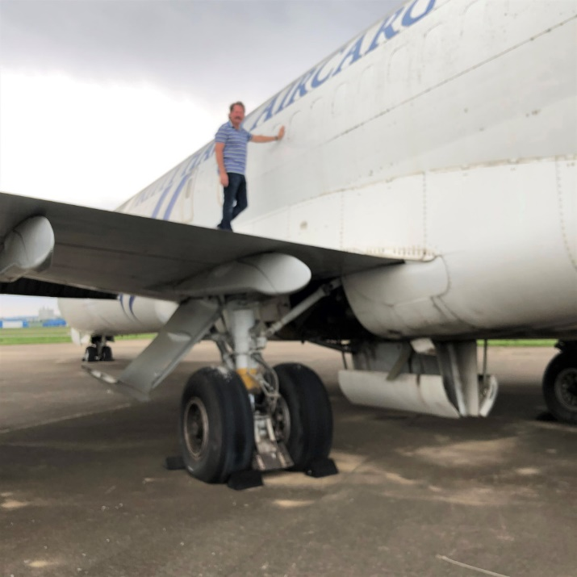
Aircraft Towing Systems World Wide LLC CEO/VP Vince Howie prepares to explore ATS’ Boeing 727. The jet was purchased at an auction held in late February by the City of Ardmore in Ardmore, Oklahoma. (Photos courtesy of ATS).
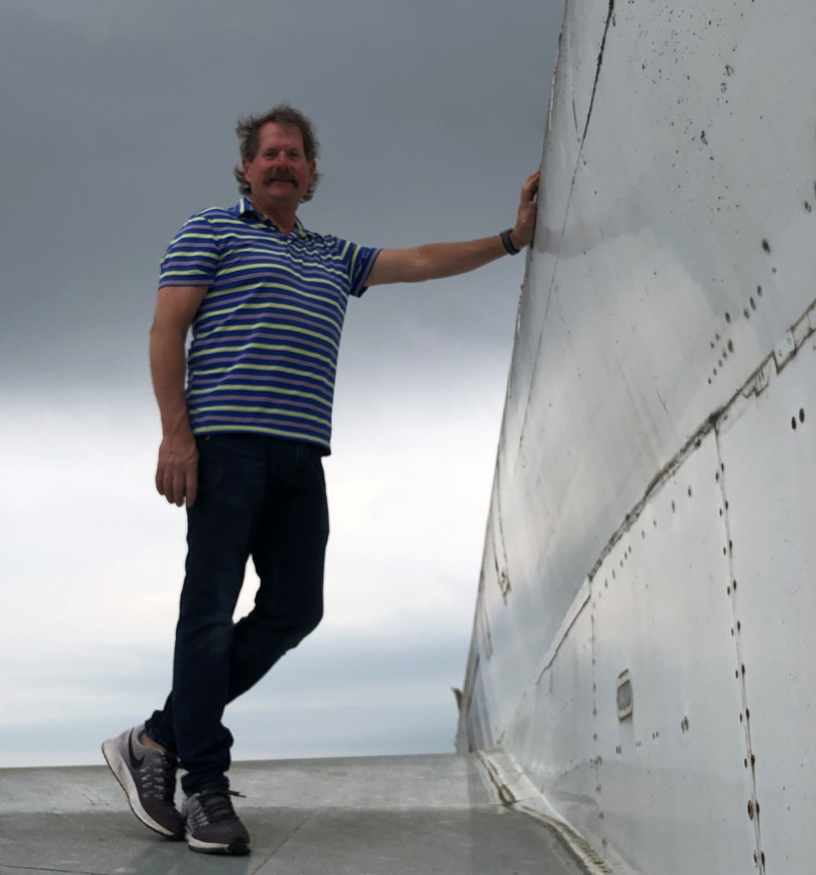
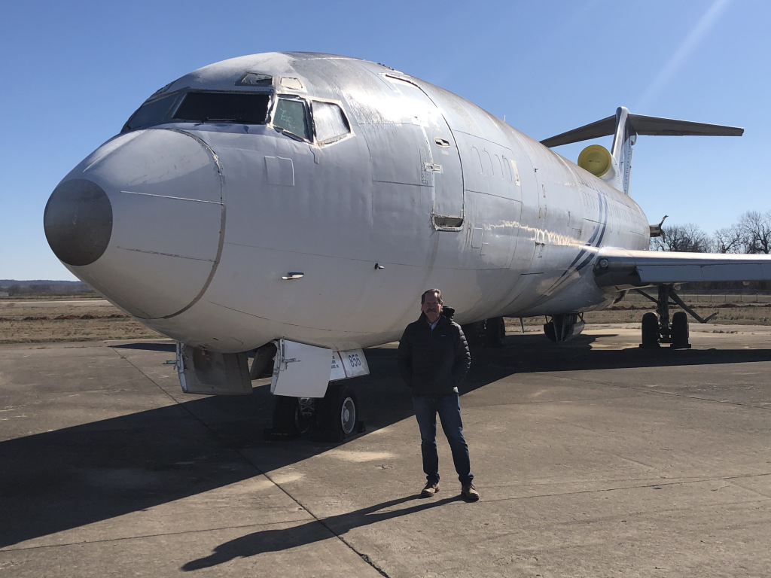Aircraft Towing Systems World Wide LLC CEO/Vice President Vince Howie stands before the formerly abandoned Boeing 727 that ATS WW LLC purchased in late February at the Ardmore Industrial Airpark in Ardmore, Oklahoma. Last week, he, one of his two daughters, Abby Pogorzelski, who, like her father, is also a part-owner of company, and Howie’s son-in-law, Bill Pogorzelski, all climbed aboard the 727 to discover the plane’s interior. They entered through the emergency access door because it was the only way available to the back of the plane. (Photos courtesy of Aircraft Towing Systems World Wide LLC).

ARDMORE, Oklahoma (04/28/2020) — Aircraft Towing Systems World Wide LLC CEO/Vice President Vince Howie recently climbed aboard the company’s newly purchased Boeing 727 – a jet that was abandoned nearly 13 years ago at the Ardmore Industrial Airpark in Ardmore, Oklahoma.
Accompanied to the airpark by his daughter and son-in-law, Abby and Bill Pogorzelski, Howie said he was finally able to gain entry to the back part of the plane through an emergency access door. When functional, one of the 727’s most distinctive features includes a built-in “airstair” that opens from the rear underbelly of the fuselage. Howie said the jet looked as if “the pilot had just landed the 727, turned off the engines and simply walked away” in 2007.
“When I stepped into the plane, the first thing I saw were two oxygen bottles and a fire extinguisher still strapped in their holders,” Howie said. “Everything looked as if it was ready for the next flight. We were all surprised because the good condition of the aircraft and how it acted as a time capsule from 2007.
“It was also amazing to find the auxiliary power unit (APU) still installed in the trijet aircraft. It was fully functional about 13 years ago when they parked the aircraft. If functional, the APU may allow us to power the brakes and steering for our testing purposes.”
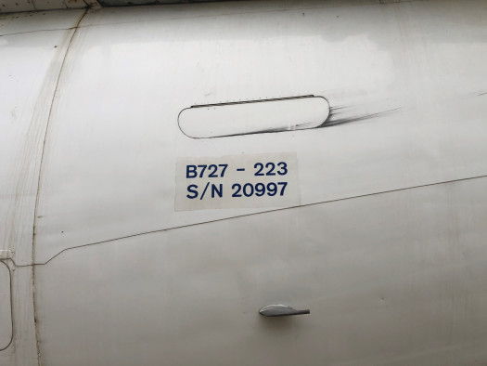
The Boeing 727’s make and model with serial number. (Photos courtesy of Aircraft Towing Systems World Wide LLC)
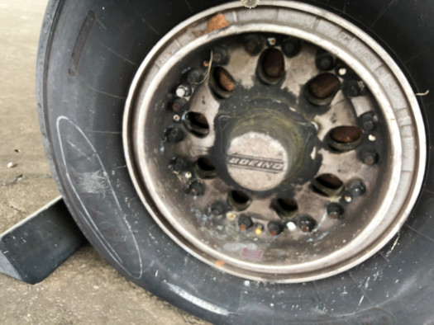
New wheels have been ordered to replace these 727 tires on the nose wheel. (Photos courtesy of Aircraft Towing Systems World Wide LLC).
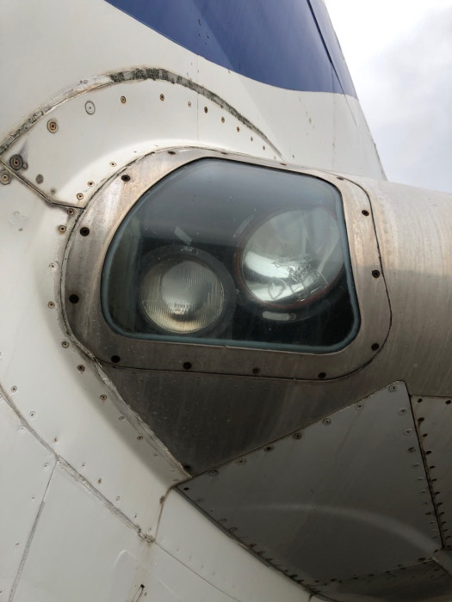
Aircraft landing lights. (Photos courtesy of Aircraft Towing Systems World Wide LLC).
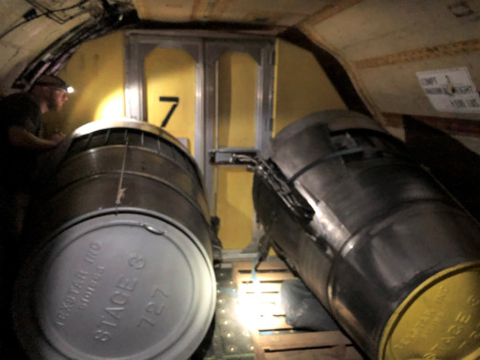

Two thrust reversers – used to slow down the 727-223 jet – are on the plane. (Photos courtesy of Aircraft Towing Systems World Wide LLC).
The narrow-bodied jet was created by The Boeing Company to satisfy airliners’ growing need during the early 1960s for a passenger jet that could be flown in and out of smaller cities with shorter runways. The APU was another Boeing innovation because it allowed air-conditioning and electrical systems to run without a ground-based power supply and without having to start one of the jet’s main engines. ATS’ particular 727-223 was once owned by Kitty Hawk Air Cargo based out of Texas, which went bankrupt in 2008.
Powered by an electric engine and featuring an underground rail channel system, the ATS prototype is designed to move aircraft to and from an airport’s runways to taxiways and gates — all without the use of an aircraft’s main engines. Anticipated benefits from ATS include improved safety, fuel savings, a reduction in airport accidents, decreased emissions, as well as increased airport efficiency, a longer jet-engine life, time management improvements, and a reduction in noise.
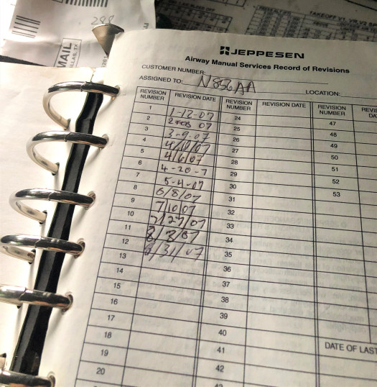
The Kitty Hawk Air Cargo’s final plane flight log featured above. It was last signed in August 31, 2007. (Photos courtesy of Aircraft Towing Systems World Wide LLC).

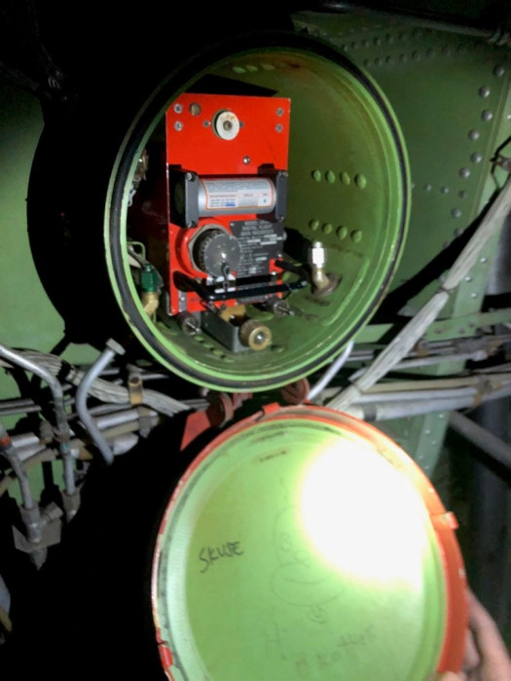
Flight data recorder. (Photos courtesy of Aircraft Towing Systems World Wide LLC).

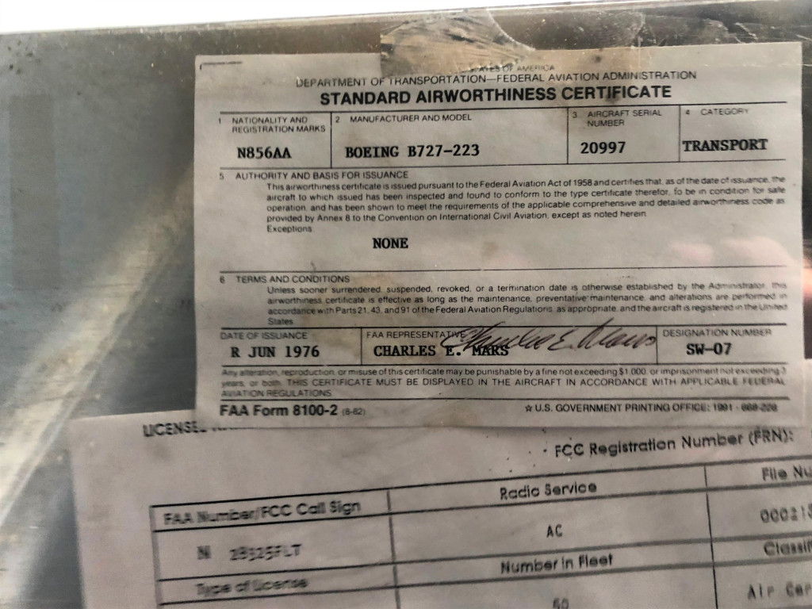
The Boeing 727’s standard airworthiness certificate. (Photos courtesy of Aircraft Towing Systems World Wide LLC).

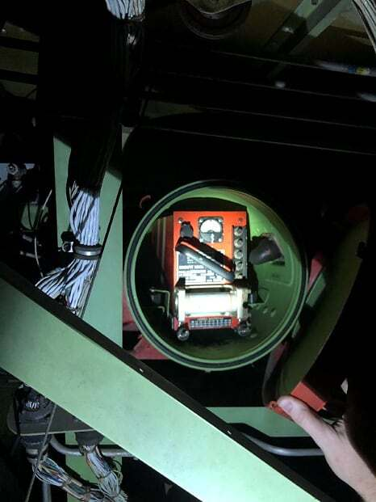
Voice cockpit recorder. (Photos courtesy of Aircraft Towing Systems World Wide LLC).

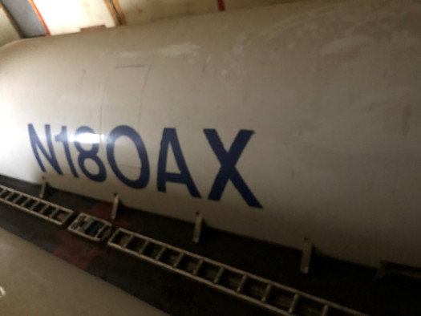
An engine cowl from a different 727 jet (lower right). (Photos courtesy of Aircraft Towing Systems World Wide LLC).
“Our jet will be used to demonstrate the effectiveness of Aircraft Towing Systems,” Howie said. “King Aerospace will also install the engine cowls we discovered inside, clean the aircraft and apply the ATS’ logos. If they can get the APU working, it will allow ATS to power the brakes and steering, which will make testing much safer and easier.”
“We also purchased two new front tires. King Aerospace will also move the jet onto the ATS ramp space where it will be used for the testing and demonstrations of our ATS prototype.”
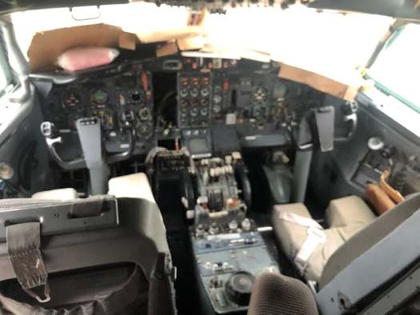
The cockpit had several aviation-related magazines published in 2007. (Photos courtesy of Aircraft Towing Systems World Wide LLC).
He said he first noticed the 727 at the Ardmore Industrial Airpark when he visited several years ago and thought he might eventually lease the jet as a test aircraft for the ATS prototype testing and demonstration.
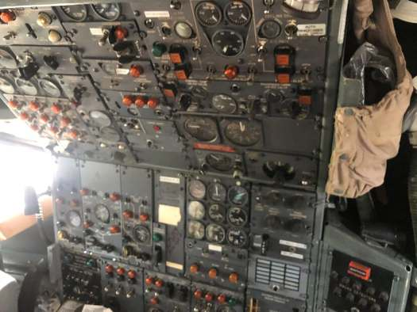
Flight engineer station. (Photos courtesy of Aircraft Towing Systems World Wide LLC).
“When I discovered it was abandoned, I asked if I might buy it,” Howie said. “The City of Ardmore then filed for an abandoned title and put it up for auction, so we bought it. We are excited about the future of our ATS prototype and the innovation it will bring to airports worldwide.
“We believe our strategic investment in this jet will be the perfect instrument to demonstrate how ATS works in the days ahead.”
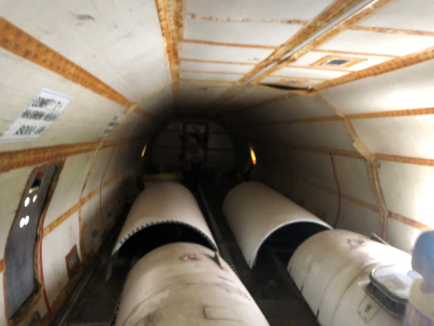
Two sets of jet engine cowls. (Photos courtesy of Aircraft Towing Systems World Wide LLC).
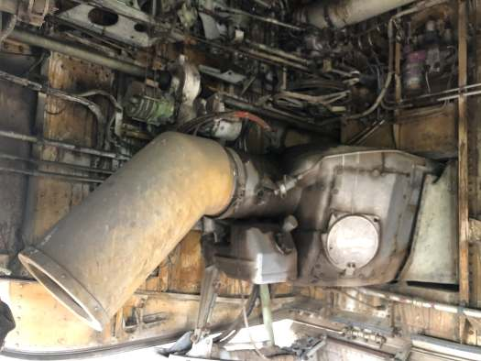
The intake and fuel control for the auxiliary power unit. (Photos courtesy of Aircraft Towing Systems World Wide LLC).

For more information about ATS WW LLC, please call Kevan Goff-Parker, director of Corporate Communications, ATS, at 405-514-3972, kevan.goff-parker@atswwco.com or contact Howie at 405-694-9861 or write him at vince.howie@atswwco.com. Website: https://www.aircrafttowingsystems.com
Media outlets may download photos with photo credit listed as “Photos courtesy of Aircraft Towing Systems World Wide LLC” at: https://www.dropbox.com/sh/9htgbn7odwx93i2/AACDGVaB8EOVx4FfgqyUje9da?dl=0

