Cogran Announces New Point of Sale Features
  - Innovative Point-of-Sale is Mobile and Sells Tickets, Passes, Handles Donations, and Sells Merchandise
Minneapolis, Minnesota: Cogran announces a completely redesigned, fully mobile Point-of-Sale interface for tickets/passes, merchandise sales, and donations. This is a significant new feature for Cogran’s recreation management vertical, allowing current clients to immediately add new POS features to their Cogran recreation management system.
“Cogran’s new POS means that Cogran clients have a no-registration option for making quick transactions,” said Katharine Miketic, VP of Sales. “Cogran’s new POS allows quick sale of products like pool passes. Cogran has always provided stellar recreation management with a fully mobile platform, but not every transaction requires a registration.”
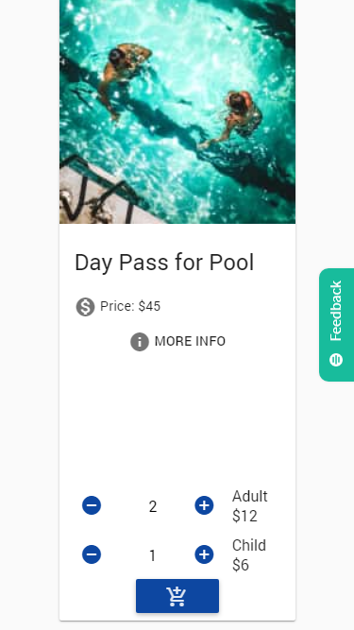
A long-planned feature, Cogran pushed development of this tool to meet the need for organized entry into pools and other summer recreation opportunities during this current pandemic. Cogran also forwarded the development of POS donations to allow supporters to make speedy gifts to support their chosen organizations. The donations can also be recurring.
Cogran also allows the quick sale of items such as shirts and snacks for quick checkout. Cogran’s mobile, cloud-based POS allows site visitors to make online transactions and for staff to handle in-person transactions in seconds. A scannable barcoded receipt is part of every sale for monitoring ticketed entry.

Positive Customer Impact
This feature come in response to customer request for a way to swiftly sell passes and take donations. The scan-in attendance feature will allow customers to manage pool capacity as well as sell tickets for events. The donation function of the new Cogran POS is designed to make it quick to run campaigns for support.

Key Takeaways
- New Cogran POS adds to Cogran Registration Management features
- POS for pass and ticket sales with multiple price categories and barcoded receipts
- Merchandise sales allow taxes, size selection, or no size selection
- Donations are easy with one-time or recurring gift options
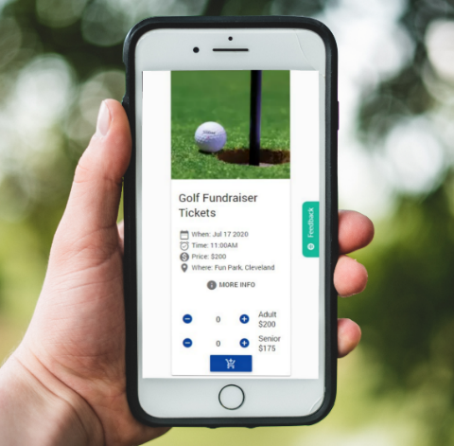
- Mobile POS

Product Availability
Like all of Cogran’s features, the Cogran POS is fully integrated into the Cogran System and is immediately available for current and pending customers. The POS is available at a setup fee starting at $699.
Cogran is a leader in the recreation management business. Cogran offers a wide range of tools designed to mission.
###

