Sundance Media Group Announces Drone Training Reseller Agreement with SYNNEX Corporation
Agreement Provides Certified Drone Training to Government Agencies and Organizations Across the U.S.
Las Vegas – June 3, 2020 – Sundance Media Group today announced an agreement with SYNNEX Corporation (NYSE: SNX), a leading business process services company, to provide certified drone training to government agencies and organizations across the U.S.
SMG specializes in assisting police, fire and private corporations seeking to stand up new small Unmanned Aircraft System drone programs or add sUAS workflows into their existing drone programs. SMG offers drone training programs across the U.S. as well as the filing of Certificates of Authorization and/or waivers with the U.S. Federal Aviation Administration. SMG also creates and assists in the implementation of Policy, Procedures and Operations manuals for ISO-compliant municipalities and organizations.
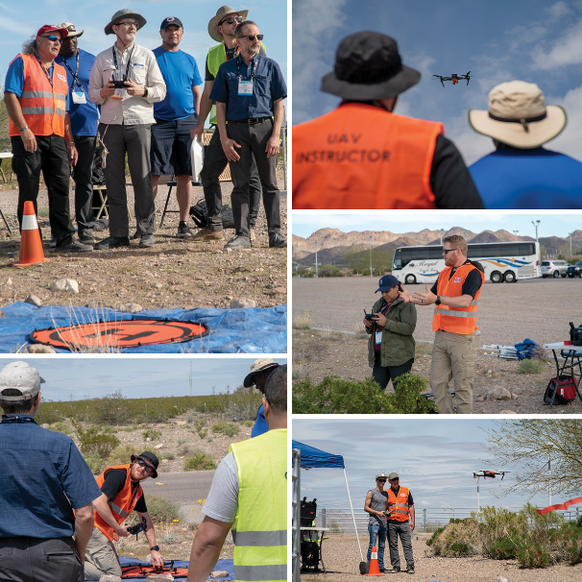
“Training is a vital component to a viable, safe and effective drone program. This agreement with Sundance Media Group enables us to offer a B2B turnkey solution within the unmanned aircraft industry,” said Ed Somers, Vice President, Public Sector and Vertical Markets, SYNNEX. “The addition of SMG safety-first training methodology services to our own product offerings elevates our complete technology solutions.”
SMG has a 19-year history working in aviation and crime scene investigation and has developed training missions for Major Incident Response Teams, CSI, traffic homicide, night-time forensic missions, and crowd overwatch with and without tethering components. Drones offer an aerial vantage point and are a significant force multiplier. Operations may be initiated faster with fewer persons involved. As a force multiplier, nothing compares to sUAS with regard to cost, safety, speed and capturing/recording /archiving information that may be passed up or down the chain of command.
SMG’s training, now available through SYNNEX, include 107 offerings from prep, introduction to practical flight and advanced applied to vertical-focused flight training and post-processing training.
"We look forward to bringing our standard of excellence for various segments within the UA industry to SYNNEX and its customers,” said Jennifer Pidgen, Chief Operating Officer of Sundance Media Group, now celebrating 26 years in training. “SYNNEX focuses on helping their business partners grow and the SMG culture is to ensure that every client gets white-glove services. We identify the clients’ specific sUAS needs and we build out our training programs to meet those needs to ensure they are successful in their adaptation of this new technology.”
About Sundance Media Group
Founded in 1994, Sundance Media Group (SMG) began as a training organization focused on cameras, codecs, and post-production technology. In 2004, the company began training in aviation technology, adding sUAS in 2011. In 2012, SMG produced the world's first UAS training conference at the NAB/P|PW Conference and is vendor neutral, where we collaborate with manufacturers, service providers, and software developer to find the best solution for our clients’ needs.
With instructors from Public Safety, Construction, Vertical Inspection, Real Estate, and Cinematography, SMG instructors may be found speaking at technical, aviation, and UAS conferences around the globe. For more information on SMG, please visit www.sundancemediagroup.com or via email at requests@sundancemediagroup.com
About SYNNEX Corporation
SYNNEX Corporation (NYSE: SNX) is a Fortune 200 corporation and a leading business process services company, providing a comprehensive range of distribution, logistics and integration services for the technology industry and providing outsourced services focused on customer engagement to a broad range of enterprises. SYNNEX distributes a broad range of information technology systems and products, and also provides systems design and integration solutions. Founded in 1980, SYNNEX Corporation operates in numerous countries throughout North and South America, Asia-Pacific and Europe. Additional information about SYNNEX may be found online at synnex.com.
SYNNEX, the SYNNEX Logo, and all other SYNNEX company, product and services names and slogans are trademarks or registered trademarks of SYNNEX Corporation. SYNNEX, the SYNNEX Logo, Reg. U.S. Pat. & Tm. Off. Other names and marks are the property of their respective owners.

