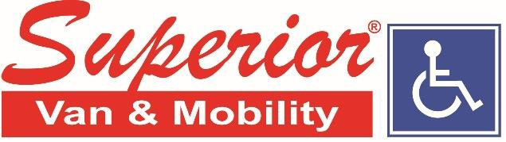
Corporate Headquarters - 1506 Lake Shore Court, Louisville, KY 40223

Contact: Patrick Brent, Director of Strategic Improvement
Company: Superior Van & Mobility
Direct: 269.753.4354
Email: pbrent@superiorvan.com

JULY 8TH, 2020 - FOR IMMEDIATE RELEASE

Superior Van & Mobility On the Move to Provide Affordable Accessible Vehicles in Eastern Arkansas
Superior Van & Mobility relocates Jonesboro, Arkansas location to larger, modern facility

JONESBORO, ARKANSAS – Superior Van & Mobility, the largest family-owned wheelchair-accessible vehicle dealer group in the United States, has relocated its Jonesboro store to a larger, more modern facility in order to better serve Arkansans seeking affordable new and used wheelchair vans and other adaptive driving and mobility aids. The continued expansion comes only months after Superior acquired the Jonesboro location as part of its acquisition of Arkansas-based Presidential Conversions, with additional locations in Fayetteville, and Little Rock. Superior currently has sixteen retail & service locations serving eight states.

Located at 2421 Sunny Meadow Dr, Ste D, Jonesboro, AR 72404, Superior Van & Mobility’s new facility offers sales and service on a full line of new & used wheelchair vans, handicap accessible vehicles, scooter & wheelchair lifts, and other adaptive driving aids. “We’re thrilled to introduce customers to our new Jonesboro location,” says Jeff Brummett, Superior’s Director of Acquisitions & Expansion. “The new facility is over twice the size of the original, and has a large, air-conditioned wheelchair-accessible showroom where customers can evaluate mobility solutions away from the heat and other elements. As eastern-Arkansas’ only Mobility dealer, it’s important we provide not only the best selection of affordable accessible vehicles and adaptive driving aids, but also give our clients the top-notch customer experience they’ve come to expect from Superior. This new facility is an exciting part of that ongoing mission”.

Serving eastern Arkansas, southeastern Missouri, and greater-Memphis, Tennessee, Superior’s Jonesboro location is open 8am – 5pm Monday-Friday, and on weekends by appointment. According to Sam Cook, owner and president of Superior, customers at the Jonesboro location can expect the same “no haggle” sales model, and a purchase experience that is focused on being “as simple and as stress-free for our customers as possible”. For questions, or to schedule a sales or service appointment, please call Randy Lairson, General Manager, at 870-933-7270, or visit www.SuperiorVan.com.

COVID-19 RELATED INFO:
All customers and public facing staff at Superior Van and Mobility locations are required to wear facemasks for face to face interactions, and practice social distancing as directed by the CDC and local/federal governments. Superior can provide masks to customers free-of-charge and can make special accommodations for those unable to wear a mask due to medical conditions or for those who prefer not to enter our facilities. Options include, upon request and availability, “touchless” pick-up and drop-off for service vehicles as well as “in-driveway” vehicle demonstrations at a customer’s home or workplace. Please contact your local Superior location for availability and details.

###

Superior Van & Mobility provides new and used wheelchair accessible vehicles, mobility seating options, hand controls, scooter and wheelchair lifts, and other driving aids, all of which meet or exceed Federal Motor Vehicle Safety Standards (FMVSS). Each Superior location is certified by the National Mobility Equipment Dealers Association (NMEDA) and supports and advocates with local community groups to promote disability awareness. Superior Van & Mobility’s sixteen sales and service centers are located throughout Indiana, Kentucky, Eastern Tennessee, Louisiana, Nebraska, Alabama, Florida, and Arkansas. For more information, visit www.SuperiorVan.com .

