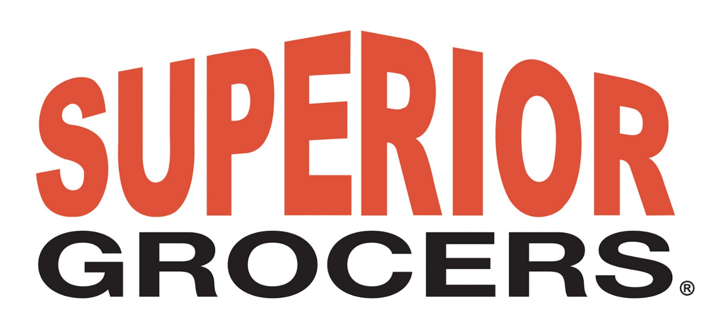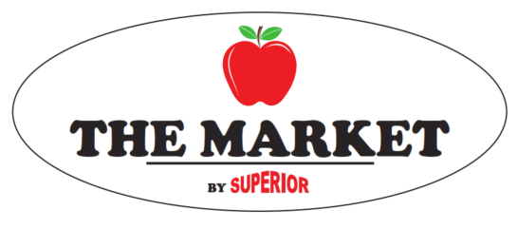

FOR IMMEDIATE RELEASE
SUPERIOR GROCERS REBRANDS LA MIRADA LOCATION TO “THE MARKET” BY SUPERIOR

Santa Fe Springs, CA– (July 9, 2020) – Superior Grocers, one of Southern California’s largest independent supermarket chains, rebranded a small format store under a new banner, The Market by Superior. Traditionally known for their large stores and displays, the retailer rebranded the 29,000 sq. ft. store at 12721 Valley View Ave. La Mirada, CA.
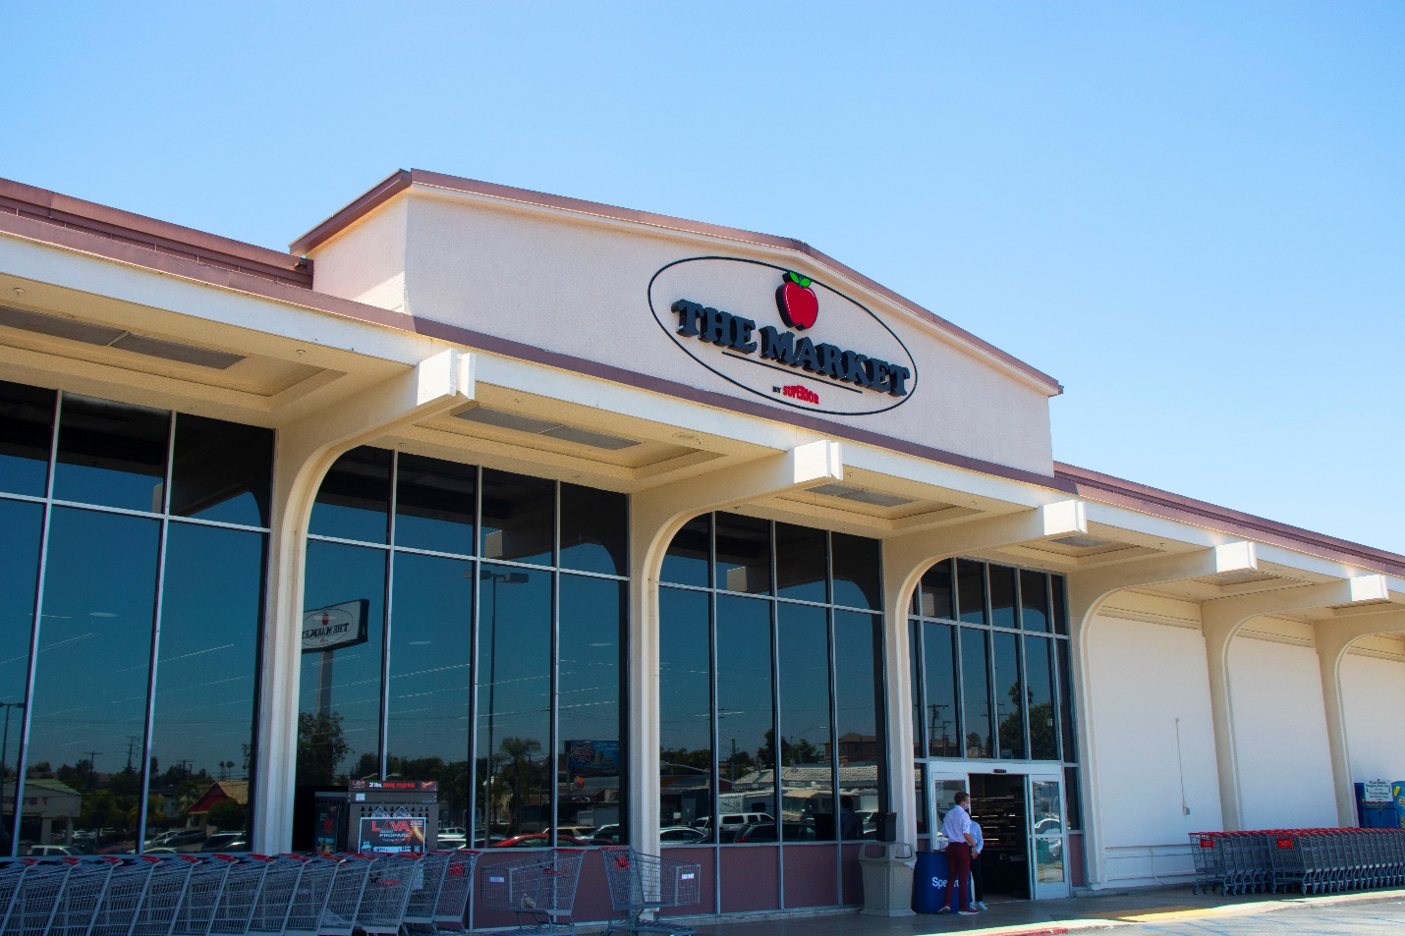

The Market has an enhanced itemization catered to the neighborhood. An expanded selection of Liquor, Beer, and Wine has been added. 5 Star Choice Beef and a wider assortment of Fresh Seafood is offered along with Organic Produce to compliment the vast variety of Fresh Fruits and Vegetables. A Full Service Bakery and Kitchen provides the convenience of a complete take home meal.

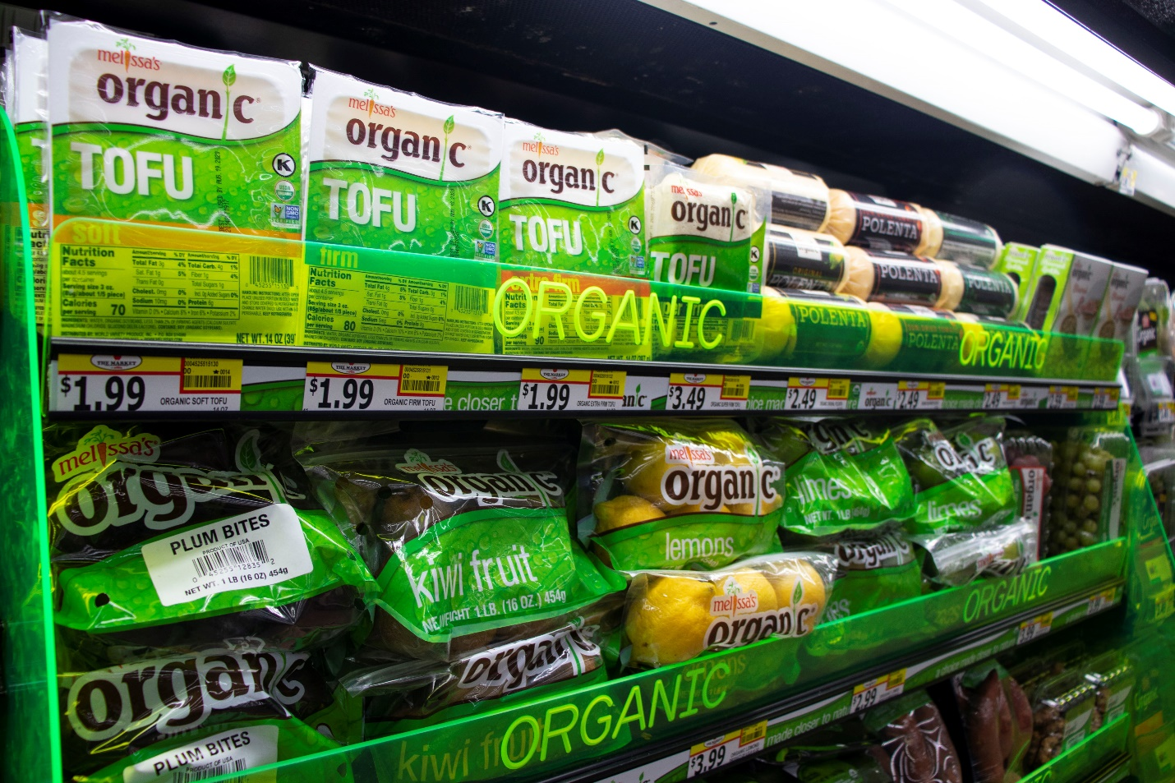

“We are very excited to open our second “The Market by Superior” in the City of La Mirada,” stated Richard Wardwell, President. “We are honored to serve the neighborhood with a great shopping experience and the same great customer service people have come to expect from Superior.”

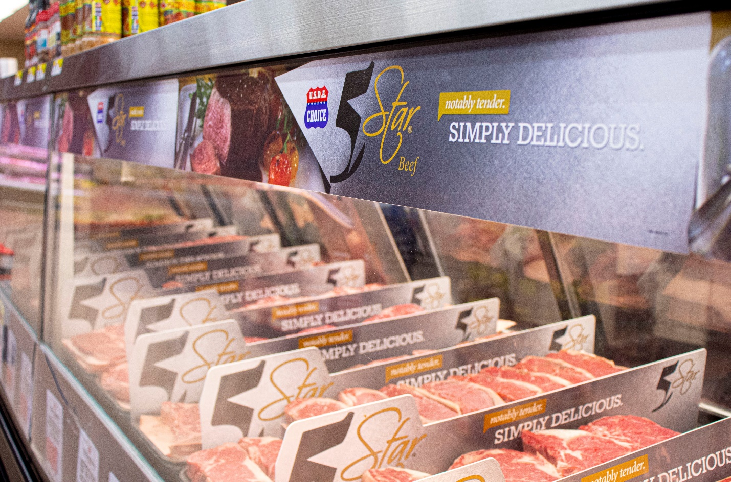
Additional services include Home Delivery and DMV Now Kiosk!

.

About Superior Grocers
Superior Grocers is one of the largest independently-owned chain of grocery stores in Southern California. Superior began its operations in 1981 with one store and has experienced steady growth for over 35 years. It now operates 46 stores throughout Southern California, and employs nearly 4,500 associates. Aside from its wide assortment of grocery, produce, meat, bakery, frozen, deli, international foods & general merchandise products, Superior stores also offer a variety of freshly prepared products in the Bakery, Meat & Seafood, Service Deli and Hot Foods departments.
It prides itself in providing Superior Quality, Superior Variety and Superior Value to the communities that it serves. Superior Grocers is a strong community partner and continually supports programs that help bring a positive impact to its customers, including education, health awareness efforts and many local youth organizations and non-profit groups. For more information about Superior Grocers, please visit www.superiorgrocers.com.

Contact:
Dale Nakata
Superior Grocers
dnakata@superiorgrocers.com

