Barb Jones  barb@thebloodprophecy.net  Thebloodprophecy.com | FOR IMMEDIATE RELEASE

The Prophecy Continues

Introducing the Third Installment in The Blood Prophecy Series

[VENICE, FL, August 17, 2020] The compelling story of a three-thousand-year-old prophecy set in modern-day Seattle continues with the third book; Queen’s Ascension. With the release of Queen’s Destiny back in 2014, a groundbreaking series of the beloved vampire genre was born. Now nearly six years later, author Barb Jones brings the long awaited and anticipated conclusion to The Blood Prophecy series.

Barb Jones has always strived to provide her readers with compelling plots and relatable characters; displaying the real potential of the genre by bringing back the true nature of vampires, werewolves, witches, gypsies and more. Queen’s Ascension involves all of the beloved characters, including some new faces, and the epic battle that has spanned a millennia.

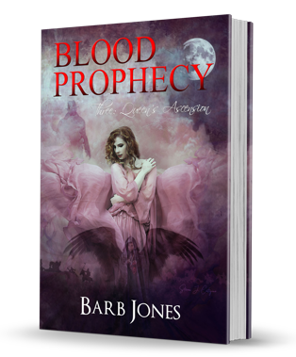
Bloodshed. Heartbreak. Revelation.
When the darkness was compelling and the heart knew no bounds, was there really a right choice? With Michael’s life hanging in the balance, Amber had a choice: save her star-fated love or keep on the crusade to unite the magical community. For Amber, her fate was sealed even before her birth and it was her destiny to fight the great battle ahead of her. But, when it came to her heart -- her friends, her great love -- Amber’s torn. Not only was she the Queen, but she was a human in every sense of the word. She was vulnerable. And so the very people -- Chloe and Michael -- that gave her strength, quickly became her weakness. It wasn’t her fault she loved too much, was it?

Nevertheless, the Tall Dark Man had set a plan in motion that could threaten the very existence of the Blood Prophecy. Would he gather his dark forces and succeed in destroying Amber once and for all? Or, would she assemble her powerful friends and save the world?

Barb Jones is a paranormal thriller author, IT professional, and the mother of two fantastic children. When people have asked her who she is, she's been quoted saying, "It can be hard to write at times, but never give up on what you're passionate about." She's a mother, first and foremost, and an author and supernatural enthusiast after.

Blood Prophecy Three: Queen’s Ascension, published by World Castle Publishing, is available on Amazon in ebook format and traditional paperback. More information can be found on Barb’s official website: www.thebloodprophecy.com and the series’ Facebook page. For tours, signings or other inquires please reach out to her assistant Jessica, at jessica@thebloodprophecy.net.

