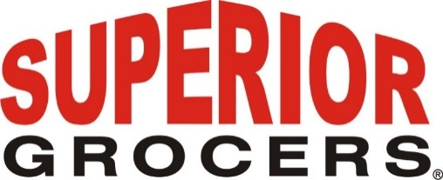

**Superior Grocers Opens New Location in Bakersfield**

**Santa Fe Springs, CA (August 5, 2020)**- Superior Grocers opens new Store in Bakersfield located at 1115 Union Ave. This is the second location in Bakersfield. A full service Supermarket featuring the largest selection of Produce in Bakersfield, a brand new “Beer Cave” offering the Coldest Beer in Bakersfield, Fresh Quality Meat, a large assortment of baked goods, and an array of ready to eat Hot Foods.

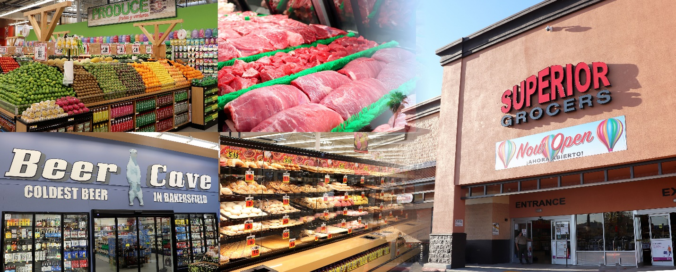

Because of Social Distancing, this Grand Opening was unlike previous openings, however, customers showed up in groves in anticipation of our store. “We appreciate the overwhelming welcome we received from the Bakersfield community. Following all the CDC guidelines, metering customers to maintain capacity limitations, Shop Safe, Mask requirement, and Social Distancing signs posted throughout the store. The safety of our customers and employees are our first priority.” Said Richard Wardwell, President.

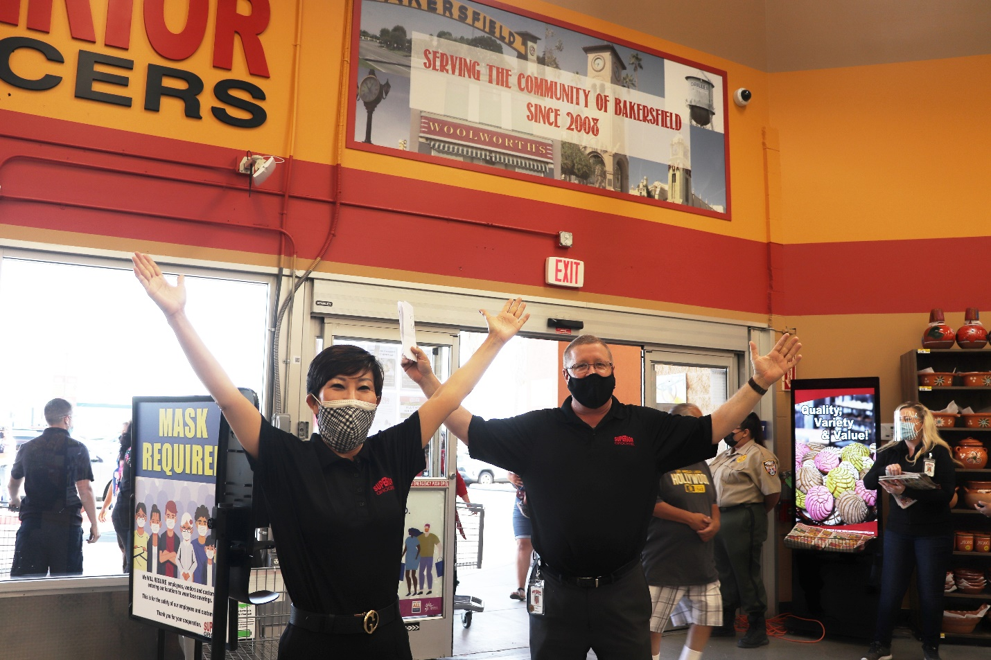

“Superior Grocers is always looking for ways to improve our customers’ shopping experience. We are happy to be able to better serve the community of Bakersfield with now two locations”, stated Mimi Song, CEO.

Superior Grocers is one of the largest independently-owned chains of grocery stores in Southern California. Our philosophy is to offer the highest quality products with exceptional customer service. You can always count on excellent Quality, Variety, & Value when you shop at Superior Grocers. We are dedicated to building a community of loyal customers, vendors and staff where food shopping is fun and the spirit and love of family guide our actions.

Superior Grocers is open daily 7:00A- 10:00P and has reserved the hours of 6:00A- 7:00A for Seniors 60+ and those with disabilities.

**@SUPERIORGROCERS**

Image result for facebook png Image result for instagram png

**Visit Our Website**

**Superiorgrocers.com**