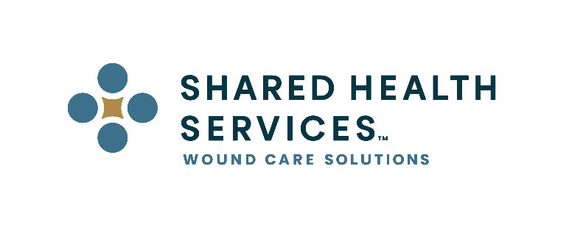
FOR IMMEDIATE RELEASE

Contact: Dan Greenlee, Executive VP
Phone Number: 1-800-474-0202
Email Address: dgreenlee@sharedhealthservices.com
Johnson City, TN – September 1, 2020 – Shared Health Services, a premier wound care management company, with a long history in the outpatient wound care industry, announced the launch of its new corporate brand identity, redesigned logo, and website. These changes come at a time when the company is evolving its service offerings to align with the rapidly changing healthcare landscape. “In the last year, Shared Health Services has successfully diversified and scaled its support focused wound care related offerings, while broadening our strategic alliances with key industry members,” said David Davis, CEO of Shared Health Services. “Our new website and brand identity better reflect our market-focused position and clearly demonstrates our commitment to the hospital partners and patients we serve”.

Designed to work smoothly across digital and physical channels, the new logo evokes a feeling of inclusiveness and collaboration, while inferring the traditional shape of the cross, a symbol of humanitarian activities, sacrifice and rejuvenation. The logo also resembles participants seated around a table representing the spirit of working together and developing solutions that work for all participants.

The redesigned website features easy-to-navigate pages and updated, simplified messaging. The visual design is structured to walk the user through the site, easily navigating to areas of interest. The Corporate Team page has been restructured to highlight Shared Health Services’ leadership and provide a view into the depth of experience held by our management team.

“While our name remains the same, our logo and website have changed significantly to better represent who Shared Health Services is and what we bring to market for our clients,” commented Dan Greenlee, Executive Vice President at Shared Health Services. “Our new identity is innovative, modern, and professional—words we would use to describe not only our image but also the solutions and support we provide to hospitals. It represents the culmination of thorough market analysis and refinement to ensure we provide the exact level of support hospitals require at a price point consistent with today’s reimbursement levels.”

About Shared Health Services:
Shared Health Services is a Premier wound management company helping hospitals save money by providing cost-effective, evidence-based wound care solutions and support. With industry leading expertise in wound care, hyperbaric medicine, reimbursement, and compliance, they provide the best-in-class support to help hospitals confidently navigate today’s evolving healthcare environment. Shared Health Services provides an à la carte approach to supporting wound care programs allowing hospitals the flexibility to tailor a suite of services specific to their needs, ensuring they are receiving the best value in wound care.

###

