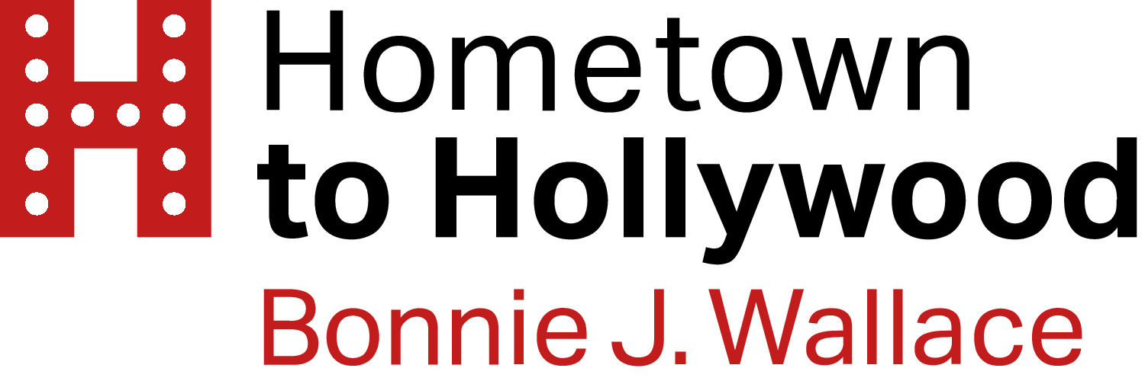

For Immediate Release Bonnie J. Wallace
September 24, 2020 bonnie@hometowntohollywood.com

- Bonnie J. Wallace’s Top Hollywood Acting Teachers: Inspiration & Advice for Actors, available October 6, 2020, offers readers an inside look at what the acting teachers to the stars know.

- The book contains exclusive interviews with 12 of the most successful acting teachers in Los Angeles, and details what they know about how to succeed in the Industry, how they train and coach their students, what guides their different approaches for actors, as well as their wisdom and advice.

- Perfect for aspiring actors as well as successful working actors looking to learn from the best, the real-world insights and secrets shared from these masters sheds light on what it really takes to become a successful actor, whether you are acting on stage or on film, in your hometown, in Hollywood, or anywhere else.

Los Angeles, California –

In a time when actors are struggling to book roles due to COVID’s affect on production, this new volume from the Hometown to Hollywood Interviews arrives to help guide both professional actors and aspiring actors with the wisdom of Hollywood’s top acting teachers. Filled with practical career advice as well as acting and audition techniques, Top Hollywood Acting Teachers provides genuine inspiration and education for actors of all ages.

The book features generous and intimate conversations with 12 of Hollywood’s most successful acting teachers: Zak Barnett, Diane Christiansen, Marnie Cooper, John D’Aquino, Patrick Day, Judy Kain, Anthony Meindl, Eric Morris, Lisa Picotte, Mae Ross, Scott Sedita, and Marcie Smolin

Each of these master teachers has been teaching for decades; each has mentored some of the biggest stars in film and TV, as well as many more successful working actors. All are well respected and bring something unique to the entertainment industry. Top Hollywood Acting Teachers shares their philosophies, insights, and advice in their own voices.

“This is not the art of pretending. This is the art of becoming.”
--Zak Barnett, founder of Zak Barnett Studios

“You need to get comfortable being uncomfortable.”
--Marnie Cooper, founder of Marnie Cooper School of Acting

“What I teach is so simple, it's just not easy.”
-- Anthony Meindl, founder of Anthony Meindl’s Actor Workshop

About the author:
Bonnie J. Wallace is the author of Young Hollywood Actors and The Hollywood Parents Guide, producer of the Hometown to Hollywood Podcast, an acting career consultant and mother of Emmy-Award winning actress and Columbia Music recording artist Dove Cameron.

Link to preorder on Amazon:
Top Hollywood Acting Teachers

Bonnie welcomes interview requests. Please reach out via email: bonnie@hometowntohollywood.com

###

Email: bonnie@hometowntohollywood.com
Website: HometowntoHollywood.com
Instagram: @bonniejwallace (over 50k followers)
Twitter: @bonniejwallace (nearly 9k followers
Facebook: @hometowntohollywood (1k followers)

