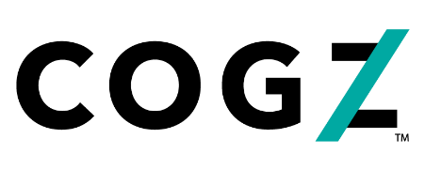
Press Release
For Immediate Release
Boost Engagement Launches Employee Engagement Solution and Platform for Smaller Companies

Employee engagement and recognition industry leader announces Cogz™ powered by Boost Engagement

Dayton, OH -- (September 22, 2020): Boost Engagement has launched its brand new patent pending engagement and recognition solution called Cogz™. Cogz™ was uniquely designed to build total workforce engagement for small and mid-sized organizations with a dual virtual and on-the-spot rewarding vehicle. Cogz combines the qualities of an online employee engagement program with a face-to-face rewarding approach and private organization-specific social newsfeed.

With the workforce changing from in-person to remote, it's more important than ever to ensure an organization's employees feel connected and engaged. The Cogz platform does just that by providing a tool to keep employees connected to the business and each other through an interactive private social news feed and rewards program. Employees can receive a Cogz award in-person if they're in the office, or virtually with an email to reach remote employees. With customizable reward values and vibrant token colors, employees can compete to show off their achievements and inspire others over time by creating their own "trophy" by stacking their magnetic Cogz tokens. Employees will establish their own accounts, allowing them to redeem from thousands of choices, including experiential, gift cards, products, charitable contributions, and travel in an online rewards store using their accumulated Cogz points.

"We are excited to launch our highly anticipated affordable solution into the market," said Anita Emoff, Chairman and Owner. "Industry research tells us only about a third of today’s workforce is engaged, which is a big challenge for organizations regardless of their size or industry. We heard similar feedback from our customers; most of them were looking for a tool to help solve their business challenges, improve engagement, and drive their culture. Cogz was specifically designed to make these kinds of impacts through social recognition and collaboration and specifically helps with a remote work environment".

Boost Engagement, LLC is the WBENC Women's Business Enterprise parent company of Boost Engagement and Shumsky brands. Boost specializes in driving employee engagement solutions as well as brand engagement through promotional products and eCommerce platforms for customers who span the globe. Learn more at culture.hr or call 800-466-2705.

