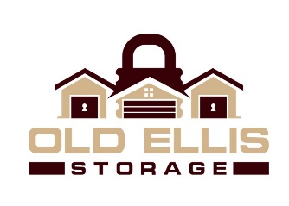
Old Ellis Storage
1150 Old Ellis Road
Roswell, GA 30076
678-393-0777
OldEllis@absolutemgmt.com

FOR IMMEDIATE RELEASE October 23, 2020

EXPANSION OF LOCAL SELF STORAGE FACILITY
Old Ellis Announces Growth, Expansion To New Facility in Roswell, GA
Roswell, GA–Old Ellis Storage has expanded. Local owners, Old Ellis Self Storage LLC, used construction company Griffco to complete the add-on of the state-of-the-art storage facility that can now be rented through our no-contact online rental process. The expansion adds an additional 500 units totaling an overall 78,000 of rentable square feet; offering both climate controlled units, non-climate controlled units, parking spaces and warehouse.

Sitting on the cross street of Old Ellis Road and Old Ellis Point, Old Ellis Storage’s new leasing office is now just a few steps away from its original address of 1205 Old Ellis Road.

Like always, Old Ellis Storage will accommodate the storage needs to nearby businesses such as Ozzi’s Automotive Inc, UPS Customer Center Roswell, InCommunity Roswell and Honeywell Enraf Americas.

Old Ellis Self Storage LLC have contracted with Absolute Storage Management (ASM) to provide professional self storage management. Old Ellis Storage is dedicated to offering a professional storage experience.

If you would like to speak to the local manager, please stop by the location at 1150 Old Ellis Rd. in Roswell, GA. or call local manager Jesse Prince at 678-393-0777.

Absolute Storage Management
Absolute Storage Management (ASM) is one of the largest private, third-party self-storage management company in the United States. Founded in 2002, ASM holds its headquarters in Memphis, TN with regional offices in Atlanta, GA; Charlotte, NC; Nashville, TN; and Jackson, MS. The company operates 140 properties in Alabama, Arkansas, Florida, Georgia, Illinois, Kansas, Kentucky, Louisiana, Mississippi, Missouri, North Carolina, Ohio, South Carolina, Tennessee, Texas, and Wisonsin.

For further information and news about Absolute Storage Management, please go to the ASM website at www.absolutemgmt.com or contact Jasmin Jones at jasmin.jones@absolutemgmt.com or call her at (678) 779-1978.

###

