Cellulose Ethers Market Size, Share, and Forecast 2019-2027

Cellulose Ethers Market Overview

The global cellulose ethers market valued USD 4,292.87 million in 2019 and is expected to grow at a CAGR of 4.83%. This rise in market value can be attributed to the increase in awareness regarding the benefits of cellulose ether and its derivatives increase in the number of oil drilling activities.

Cellulose ethers are polymers constructed from wood fibre or refined quick cotton fibre as the primary raw material, after chemical mix and through the reaction of etherifying marketers which includes chlorinated ethylene, chlorinated propylene, and oxidized ethylene.

Download Free Sample: https://www.datamintelligence.com/download-sample/cellulose-ethers-market

Cellulose ethers are finding applications in wide range of end user industries including construction, ceramic processing, adhesives, pharmaceuticals and healthcare, cosmetics and personal care, food and beverage, household products, textiles, and others.

Among these, construction is expected to remain the largest growing application for cellulose ethers while pharmaceuticals is expected to become the fastest growing market due to the worldwide rise in population and increase in the standards of living of consumers.

Carboxymethyl cellulose is the leading product segment and accounted for over 47% of the market share in the year 2019. It is most commonly used in different sectors including food ingredients, pharmaceuticals, cosmetics, adhesives, ceramics, detergents, and textiles.

In the context of geography, Asia-Pacific is projected to have the largest market share of 39% and dominate the cellulose ethers market from 2020 to 2027. A high economic growth rate, growing demand for applications (such as, mining, construction, drilling fluids in oilfields, pharmaceuticals, and others), cheap labor, and competitive manufacturing costs are the main factors driving the market for cellulose ethesr in the region.

China is the largest producer and consumer of cellulose ethers in the world. One third of the global cellulose ether global capacity is in China, mainly distributed in Shandong, Hebei, Chongqing, Jiangsu, Zhejiang, and Shanghai.

Market Dynamics

Market Drivers

The surging demand for cellulose ethers in food and beverage industry
In the food and beverage industry, cellulose ether is used as an extender of adhesive agent in the process of jam, sugar, fruit syrup, and pungent sauce. It is also used in various dessert preparations as it enables the tissue to be homogeneous and fine, thereby making the appearance of the dessert beautiful.
Various regulatory bodies are encouraging the use of cellulose ethers as food additives. For instance, hydroxypropyl methyl cellulose, hydroxy ethyl cellulose, and carboxymethyl cellulose are allowed as food additives in the United States, the European Union and many other countries.
In the European Union, it is emphasized that L-HPC and hydroxy ethyl cellulose can be used as licensed thickeners and gelling agents. Methyl Cellulose, Hydroxypropyl methyl cellulose, HPC, HEMC and carboxymethyl cellulose have completely passed identification of the FAO / WHO Joint Expert Committee on Food Additives, and the acceptable daily intake (ADI ) is determined as 25mg/kg.

Advantageous features of cellulose ethers are driving demand for this product in the world
Growing demand for cellulose ether products owing to their unique properties such as water solubility, binding, water retention, surface activity, emulsification, and PH stability is the key factor driving the cellulose ether market across the globe.

Market Restraints

Availability of substitutes
Low-priced guar gum, which is used as a substitute for cellulose ether is hindering the use of cellulose ethers in several industries including paints & coatings and food & beverages.
Growing awareness among consumers about health & nutrition has resulted in an increased interest in natural and organic products such as guar gum. Guar gum, as a natural ingredient, has several health benefits, such as reducing serum low-density lipoprotein (LDL) cholesterol and triglycerides and increasing glucose tolerance.

Volatility in raw material prices
A variety of raw materials such as cotton, recycled paper, wood cellulose, and sugarcane are used in making cellulose ether biopolymers in powder form.
Fluctuations in the prices of these raw materials, due to downstream demand and spot availability, Is expected to act as a challenge for cellulose ester manufacturers
The cellulose ethers market is also affected by high transport costs driven by rising fuel prices and higher manufacturing costs resulting from increasing energy costs. This also poses a risk to the cellulose ether manufacturers and is expected to bring down profit margins

COVID Impact on Cellulose Ethers Market

The global cellulose ethers market has witnessed a dual impact on the product demand in recent months owing to the lockdowns imposed in the majority of the countries due to the outbreak of COVID-19.

The uncertainty surrounding the situation resulted in consumers engaging in impulse buying and stockpiling groceries, essential products, handwash liquids, and hand sanitizers. The high demand for handwash liquids and hand sanitizers has contributed to the positive influence on the global cellulose ethers market.
There is a large demand of hand sanitizers globally, which has caused the raw material- Carbomer 940 continues to be out of stock and the prices soared. To cope with the shortage of Carbomer, in April 2020, Sidley Chemical Co., Ltd. introduced HPMC (Hydroxypropyl Methylcellulose) to be used as thickener for alcohol hand sanitizer after their research and experiments.

HPMC products performance can fully achieve the effect of Carbomer in thickening, suspending and transparency. Sidley Chem supplies two grades of HPMC-4000cps and 10000cps. According to different viscosity types, the application dosage can be adjusted to optimize production method and lower cost.

However, major companies such as ShinEtsu have reported that COVID-19 is likely to have significant impact on the group’s operating performance. The spread of virus resulted in a substantial downturn in demand for the company’s products and damaging the company’s business locations and supply chain.

On the other hand, there was possible supply chain disruption in the food and beverage segment as the suppliers are looking to increase the pharma-grade capacities to support the COVID 19 crisis.

Market Segmentation

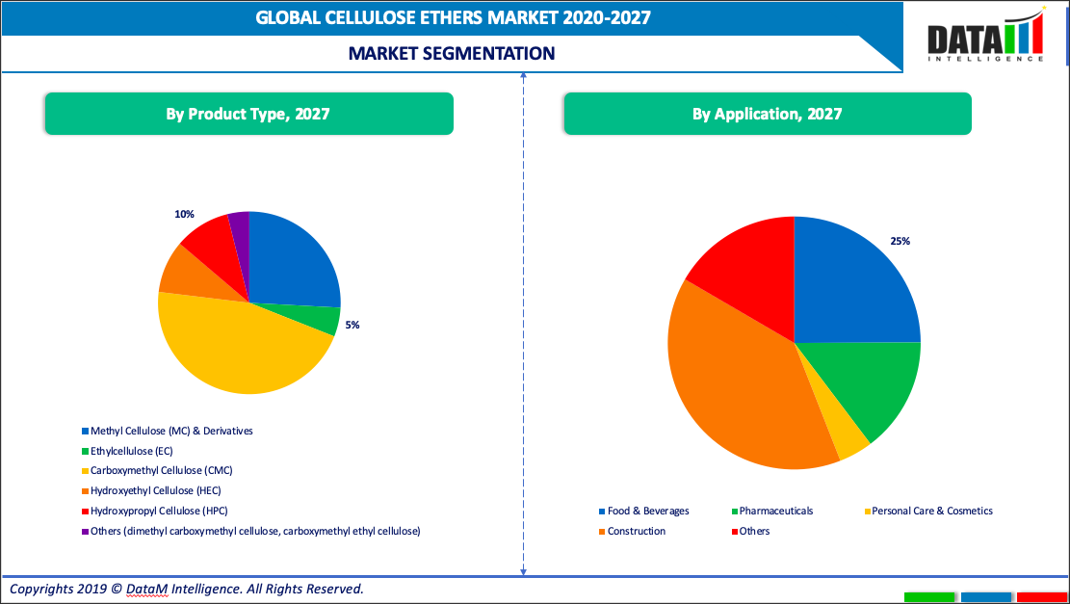

Owing to its applications in various end use industries, the market for methyl cellulose derivatives valued USD 1,113.93 million in 2019 is estimated to reach USD 1.496.15 million by 2027, growing at a CAGR of 4.65% during 2020-2027.

Methyl cellulose derivatives are majorly used as thickeners, binders, emulsifiers, and stabilizers in pharmaceutical & biomedical application. Methyl cellulose derivatives are extensively used in the production of medicines for the treatment of diseases such as Keratoconjunctivitis Sicca, constipation, diverticulosis, and irritable bowel syndrome. Moreover, owing to their excellent lubricating ability, methyl cellulose derivatives are also used in the treatment of dry eyes.
Awareness of healthy consumptions among people with decreased fats and capacity allergens will improve cellulose ether consumption in food & beverage industry in the forecast period.

The market value for cellulose ethers in the food and beverage industry is expected to witness a CAGR of 6.12% to grow from USD 935.76 million in 2019 to USD 1,443.37 million in 2027.

Cellulose ethers have huge value in pharmaceutical applications due to characteristics including high glass transition temperatures, high chemical and photochemical stability, solubility, limited crystallinity, hydrogen bonding capability, and low toxicity.

Geographical Analysis

The cellulose ethers market in U.S valued USD 499.20 million in 2019 and is estimated to reach USD 592.41 million in 2027, by growing at a CAGR of 3.07% during 2020-2027.
The food and beverage industry and pharmaceutical industries are one of the significant contributors to the cellulose ethers market in this region, especially in United States.
The food and beverage industry is an essential part of the US economy. Between agriculture, manufacturing, retail, and food service, the sector makes up roughly 5% of the country’s GDP and 10% of employment. Its sales total $1.4 trillion.
According to a report by the US Committee for Economic Development, the food and beverage industry consists of close to 27,000 organizations and employs almost 1.5 million people. While growth is relatively low, the market has been more stable than other US manufacturing industries, as demand for food remains steady.

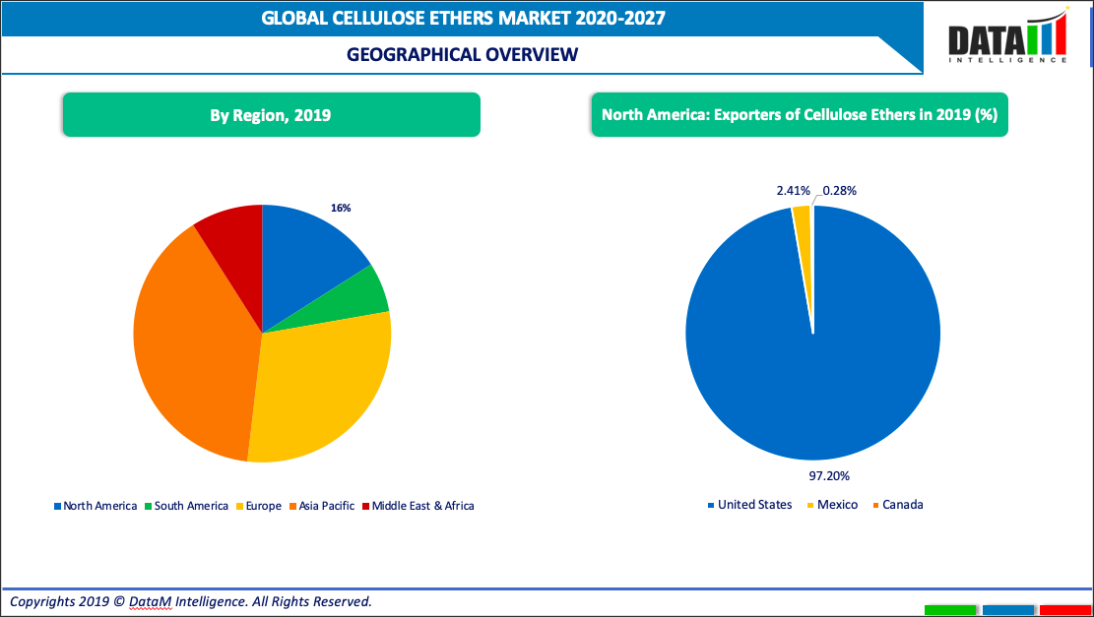

The cellulose ethers market in Asia Pacific region valued USD 1,679.70 million in 2019 and is estimated to reach USD 2,541.52 million in 2027, by growing at a CAGR of 6.47% during 2020-2027.
Asia Pacific is the largest market in cellulose ethers, with market segments like textile industry, cosmetics and pharmaceuticals growing in the coming years. Moreover, the increasing penetration of the manufacturing base in the Asian countries is expected to support the growth.
Chinese textiles exports witnessed an annual growth of 8.1% in 2018 over 2017. In terms of share in world textile exports, China remained a global leader, with a share of around 37%. With the increase in textile production, the market is expected to register a gradual growth in China.
The Indian textiles sector is one of the oldest industries in the Indian economy dating back several centuries. India's overall textile exports stood at USD 39.2 Million in FY18 and are expected to increase to USD 82.00 Million by 2021.

Competitive Landscape

- For instance, in June 2020, Nouryon has completed its acquisition of the carboxymethyl cellulose (CMC) business of J.M. Huber Corporation.
- In December 2018, Norton (the subsidiary of Akzo Nobel) launched Bermocoll EBM 3000, which enhances the performance of water-based multicolor paints used on building cover-ups to simulator the appearance of stone or marble.
- In April 2017, CP Kelco announced new production capabilities in Oklahoma plant for manufacturing KELCOGEL gellan gum which is used in used in a wide range of food, beverage, and other applications.
- Major players of the market are competing in terms of production capacitates of the cellulose ether plants and manufacturing units. They are also focusing on R&D investments.
- In December 2018, Dow expanded production capacity of methyl cellulose. In March 2018, DKS merge with lithium battery Mie-based unit Elexcel which is engaged in lithium battery development and manufacture.
- In November 2017, Rayonier Advanced Materials Inc acquired Tembec Inc. This lead to expansion of their cellulose business and increase their product offering. Both the companies worked under the name Rayonier Advanced Materials.

About Us:

DataM Intelligence was incorporated in the early weeks of 2017 as a Market Research and Consulting firm with just two people on board. Within a span of less than a year we have secured more than 100 unique customers from established organizations all over the world.

For more information:
Sai Kiran
Sales Manager at DataM Intelligence
Email: info@datamintelligence.com
Tel: +1 877 441 4866
Website: www.datamintelligence.com

