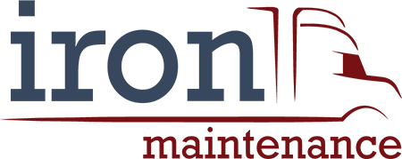

FOR IMMEDIATE RELEASE
Contact: Erni Armstrong
fsmginfo@freestylemg.com
(801) 364-3764, ext 106

Iron Maintenance Continues Rapid Expansion
Opens Its Seventh Location In Less Than A Year

SALT LAKE CITY, UTAH, December 4, 2020—Iron Maintenance, a leading provider of maintenance services for semi trucks, has opened a new location in Richmond, Virginia. This is the seventh service center that Iron Maintenance has launched in less than a year.

Iron Maintenance’s aggressive growth can be attributed to its ability to quickly and safely get truckers back on the road. The fast turnaround allows drivers to reduce the expected downtime for maintenance that can sometimes impact delivery schedules.

“We are a company of experienced truckers who know our audience extremely well. Our primary goal is to keep growing our family of satisfied customers by always anticipating their needs based on our own professional experience. We do that by offering them services -- like always free DOT truck inspections, wholesale prices and 30-minute oil changes without compromising quality or safety -- that no other semi truck maintenance service center offers,” said Justin Taylor, Senior Vice President. Added Duane Nicklow, Branch Manager of the Richmond, Virginia and Charlotte, North Carolina service centers, “We also make it very easy and convenient for our customers to get their truck serviced. Appointments aren’t necessary but for those who want to schedule one, online appointments can be made with a few clicks at www.irontruck.com.

With more locations slated to open in California in the next few months, Iron Maintenance is expected to grow its market share in a very specialized industry that provides the essential services for an indispensable component of the nation’s supply chain.

###

About Iron Maintenance
Iron Maintenance is a part of the Knight-Swift Transportation Holdings’ family of brands that includes Swift Transportation, Abilene Trucking and Knight Transportation.

