DAFEX’s AIT 3.0 is an all new MT5 upgraded edition AI trading platform!
AIT 3.0 is the harvest of years of hard work and accumulated experience by DAFEX’s research and development team. AIT 3.0 is considered one of the most wholesome and pioneering AI based trading platforms globally utilizing an all-automated approach to execute AI processing, along with its ability to systematically collect data and self-learn, and finally to automatically execute trading and data analysis. Today, AIT 3.0 even fully integrates with the upgraded MT5 platform, propelling the perfect union between blockchain technology and AI to new heights, creating a revolutionary new trading platform.
MetaTrader 5 (MT5) is MetaQuote’s new edition trading software that comes with years of accumulated research and MT4 community’s user feedback. With just a mobile phone or any computing device, you can easily monitor market conditions and strategize your daily trades. AIT 3.0’s integration with the new MT5 equips users with upgraded and more efficient set of analytical and trading functions. On top of that, MT5 runs on the highest security standards, ensuring all transactions made on the platform are fully encrypted, providing users a secure and safe environment to trade with AIT 3.0.

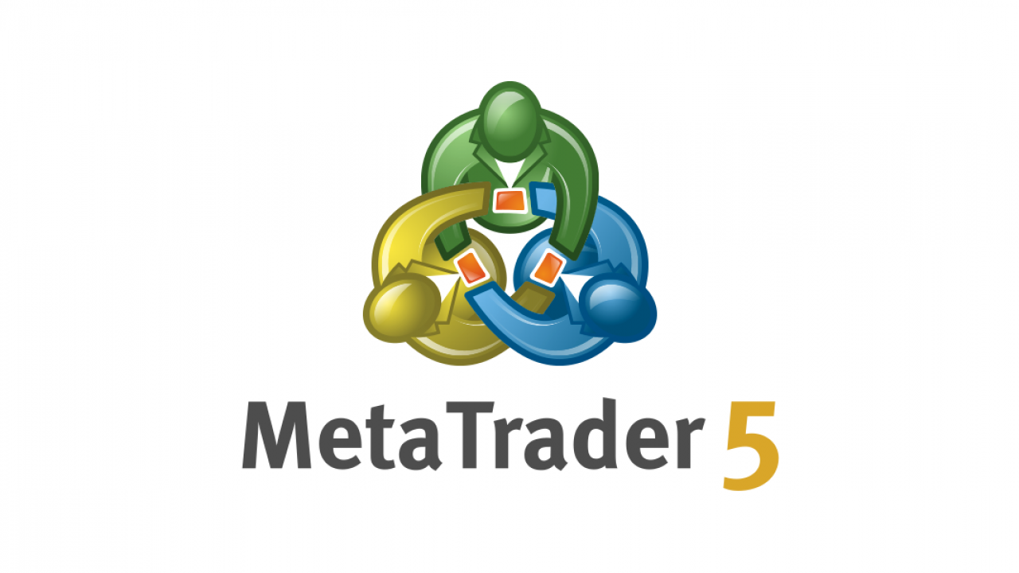
AIT 3.0 has matured after 3 years of self-learning. It’s thinking capabilities have exceed those of average humans in terms of making assumptions, knowledge, planning and memory with the ability to do all this in a matter of seconds. To put in perspective, it is like having 100 professional data analysts on the job making predictions on market sentiments whether it be cryptocurrencies, forex and various precious metals and making timely and reliable trading decisions on MT5.
MT5’s system is upgraded with many variations of charts, with 21 timeframes available enable comprehensive detailed analysis of all minor price movements. More than 38 technical indicators and 22 analytical tools, including 46 graphic objects, provide detailed analysis of quote dynamics. These tools give AIT 3.0 an additional competitive edge improving the overall user experience.
MT5 trading platform provides an internal trading report for investors to have an overview on trading history. In this report, users can trace initial and closing balances of all trading records. As of MT5, trading decisions cannot be modified, and the platform maintains all trading records as was input by traders which provides greater transparency and security for investors.

