SCORING RECORDS RELEASES THE
LOVE SARAH ORIGINAL MOTION PICTURE SOUNDTRACK

MUSIC BY ENIS ROTTHOFF

Featuring Original Song “For The Love Of You”
By Tony Momrelle & Emiliano Pari

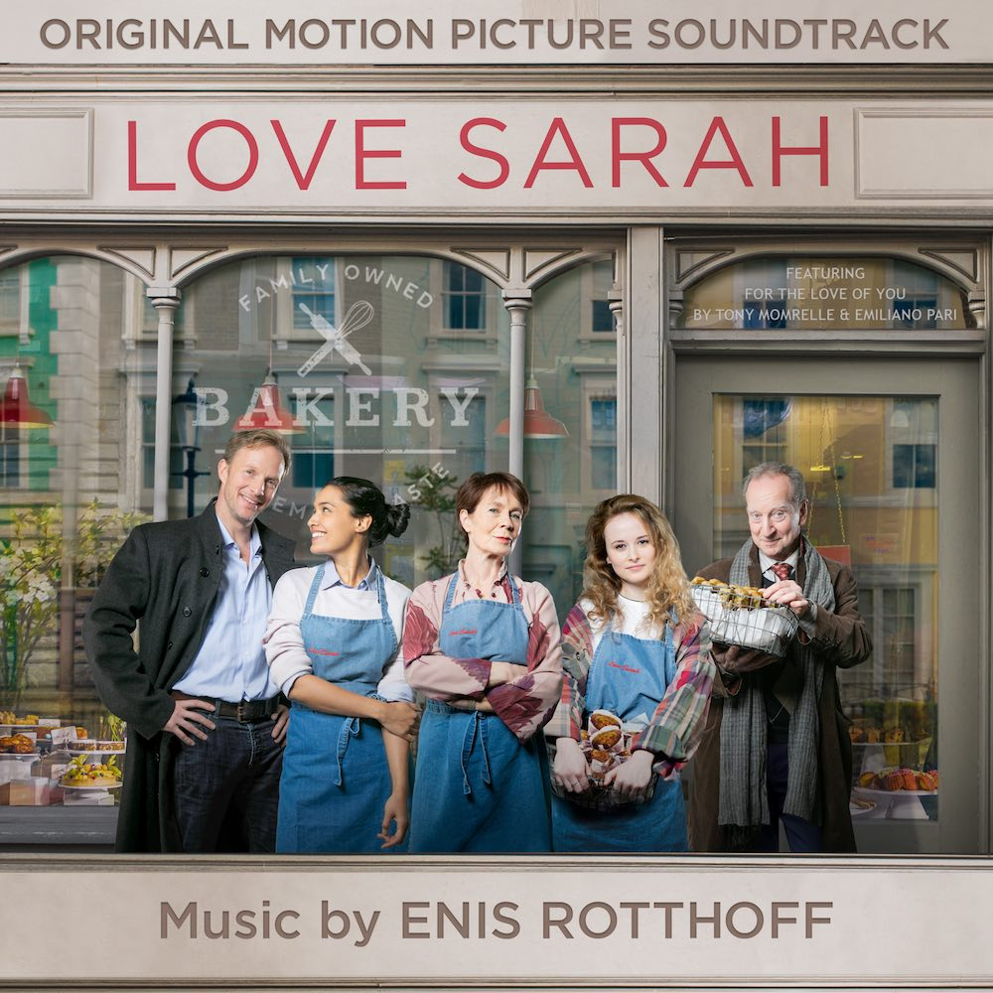

AVAILABLE DIGITALLY JANUARY 22, 2021

https://lnk.to/lovesarahsoundtrack

LOS ANGELES, CA (January 22, 2021) -- Today, Scoring Records released the LOVE SARAH ORIGINAL MOTION PICTURE SOUNDTRACK with music by ENIS ROTTHOFF (Guns Akimbo, The Sunlit Night, Wetlands).

Directed by Eliza Schroeder, Love Sarah was released in the United States on January 15 by Samuel Goldwyn Films on Digital platforms AppleTV, Amazon, Google Play, Vudu, and FandangoNow. The film follows a young woman who wishes to fulfill her mother's dream of opening her own bakery in Notting Hill, London. To do this, she enlists the help of an old friend and her grandma.

Rotthoff’s classical score injects electronic sounds with symphonic instruments to create a timeless, ethereal soundtrack. The album was recorded with the Budapest Art Orchestra and showcases a chamber string ensemble with flute, harp, piano, electric guitars, and percussion soloists. The soundtrack features the original song “For The Love Of You,'' written and performed by British R&B and Jazz singer Tony Momrelle together with his writing partner and pianist Emiliano Pari. Rotthoff created a string arrangement to complement the piece.

“The mouthwatering desserts in the film were the starting point for my inspiration,” stated Rotthoff. “I wanted to help our characters feel and cope with their loss of Sarah as well as provide hope and have the audience sense the magic of baking. The characters’ journey is both playful and positive while deep and reflective and this is what I wanted to capture with the music.”

Love Sarah stars Celia Imrie (The Best Exotic Marigold Hotel), Shannon Tarbet (Killing Ever), Shelley Conn (How Do You Know), Rupert Penry-Jones (MI-5), and Bill Paterson (Fleabag). The film screened at the 2020 San Diego Film Festival, Beijing International Film Festival, and the Glasgow Film Festival. It’s available in more than 50 countries worldwide and was #1 at the box office for two weeks in New Zealand.

Love Sarah Track List:

- Meet Sarah
- Opening The Bakery
- Lucky Me
- A Home Away From Home
- For The Love Of You
- The Final Dance
- The Magic Of Baking
- Winning Over Mimi
- Painful Reflections
- It Was Not Her I Was Looking For
- Sleeping In The Bakery
- Closing A Chapter
- Casting Call
- The World Has Come To Us
- A Bite Of Inspiration
- Let Us Find Out
- Earrings
- Running A Feature
- The First Day
- Reflection

To stream or purchase the Love Sarah Original Motion Picture Soundtrack, please visit: https://lnk.to/lovesarahsoundtrack

ABOUT ENIS ROTTHOFF
www.enisrotthoff.com
Enis Rotthoff’s passion for scoring films combined with his orchestral mastery and cutting edge electronic sounds has made him a leading voice for cinematic music in Germany and has contributed to his growing international reputation. Through his focus on close collaborations with the filmmakers, he is able to build true cinematic concepts providing a unique musical language for each film he scores.

Rotthoff has scored feature films in both the United States and in Europe. Rotthoff recently scored Jason Lei Howden’s Guns Akimbo, which premiered at the 2019 Toronto International Film Festival, starring Daniel Radcliffe, Samara Weaving, and Ned Dennehy; David Wnendt’s The Sunlit Night, which premiered at the 2019 Sundance Film Festival, starring Gillian Anderson, Jenny Slate, and Zach Galifianakis; and the Sundance Grand Jury Prize nominee Wetlands starring Carla Juri.

Rotthoff’s musical range includes works for small ensembles, electronic works, and big orchestral pieces that infuse both rare and electronic instruments. He has collaborated and recorded with some of the finest European orchestras and soloists such as trumpet player Till Broenner, cellist Johannes Moser and violinist Kolja Blacher.

Before studying and working with Academy Award-winning composer Jan A.P. Kaczmarek (Finding Neverland), Rotthoff earned a scholarship for young composers. He deepened his craft with studies of Film Music at the Film University Babelsberg and Audiovisual Communication at the University of Arts Berlin. In 2007, he was selected as a Sundance Composers Lab Fellow and in 2018 received the German Music Author’s prize for his work as a film composer. Rotthoff splits his time between Los Angeles and Berlin.

ABOUT SCORING RECORDS
www.scoringrecords.com
Scoring Records was founded in 2005 in Berlin, Germany since there were almost no dedicated Film Music labels at that time in Germany.
Recent releases include The Sunlit Night, Wetlands, Lassie-Eine abenteuerliche Reise, Look Who’s Back, and Measuring the World, all composed by Enis Rotthoff.

For licensing requests contact:
scoringrecords@gmail.com

###

Press Contact:
Gidget PR | Kelly Wilson
kelly@gidgetpr.com

