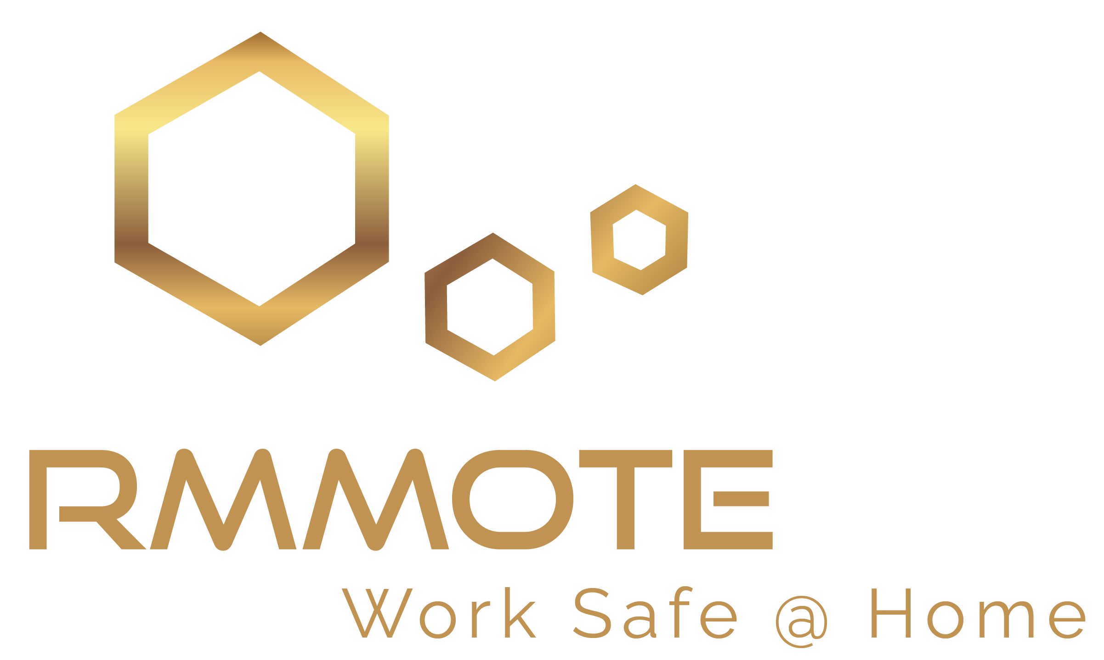

For Immediate Release Name: Carl Graham
Date 02/03/2021 401-206-0224
carl@rmmote.io

- Employers and their Work From Home staff may be at risk
- 38% is the number of employees at high risk
- Employers planning to return workers to the office, but who?

Austin, Texas – In a US Department of Labor weekly subscription newsletter for the week on November 13, 2020, it identified OSHA frequently cited standards violations indicating an increase in Subpart 1904 – Recording and Reporting Occupational Injuries and Illnesses. This may be a result of not having an offsite Work from home process or program in place.
A recent random survey of US employees working from home shows that most home workspaces do not meet the safety, productivity, or well-being standards expected in the typical office building. The responses show that 38% of these WFH employees are at high-risk for injury and/or reduced productivity, while the remaining are at medium to low risk. Of notable concern is 84% are working in spaces with fire hazards. The survey is designed to identify risks that have a high probability of resulting in injury and conditions that may affect your ability to do your best work. The survey should educate workers and identify employer risk for their remote workforce working from home.
As businesses move to reopen, employers are faced with who to bring back into the office. While some employees want to get back to the office environment, some are happy remaining at home. Identifying those employees at risk should be paramount in determining who to return to the office. Do you know which of your employees are at risk? Do you know who they are? Rmmote, Inc. provides organizations and employees a simple and thorough process to create a safe WFH environment. Our Work From Home Safe Place Analysis was designed to meet health and safety concerns associated with the majority of employees now working from home offices. Rmmote uses technology to ensure your employees' privacy. There are no in-home visits. If you would like to learn more about the survey or how to keep your WFH employees safe, contact info@rmmote.com. Or visit us at Rmmote.com

###

About us
Rmmote is committed to ensuring the safety of those employees who work from home. In response to the Covid-19 pandemic, many employers allowed their staff to establish work from home practices to protect them from exposure to the disease. Yet, these same employers may have unintentionally exposed their workers to unsafe working conditions. While the physical safety of your employees is ensured when working in the office, the population that works remotely does not have the same degree of protection. It is out of this concern Rmmote came into being.

The Firm
The leadership of Rmmote consists of a group of seasoned professionals with backgrounds and knowledge in Technology, Real Estate, Security, Facility Management, Architecture, Insurance, Health professionals, and Human Resources. These areas of expertise contribute to creating the safe office environments your employees have come to expect and the law mandates. It is this proficiency that makes Rmmote unique and capable of ensuring your workers' safety.

Vision
Our vision is to educate employers and promote awareness of workspace safety to ensure every employee’s home office space supports their well-being.

Our Mission
Rmmote’s mission is to ensure your employees are as safe at home as they are in the office environment. To minimize risk to their employees, COVID 19 prompted employers to support work from home policies. And while the risk of contracting the disease may be diminished by working from home, the risk of physical injury increases. The safety of an office building is ensured by dozens of workplace professionals trained to proactively develop and implement safety programs, plans, and audits. None of these measures are currently applied to the home office location. Rmmote identifies home office safety risks and corresponding corrective action.

