Kareem Mart Inc.
32816 Manor Park
Garden City, MI 48135

FOR IMMEDIATE RELEASE
Distributing department (313)651-4600
Date March 25, 2021

KAREEM MART RECALLS “Halva” BECAUSE OF POSSIBLE HEALTH RISKS
KAREEM MART of Garden City, MI, is recalling its 1lb and 2lb Kareem Chef brand “Halva”, “Halva with Pistachio”, and “Halva with Chocolate” food treats because they have the potential to be contaminated with salmonella, an organism which can cause serious and sometimes fatal infection in young children, frail or elderly people, and others with weakened immune systems. Healthy persons infected with salmonella often experience fever, diarrhea (which may be bloody), nausea, vomiting and abdominal pain. In rare circumstances, producing more severe illnesses infections.
The recalled “Halva” were distributed through Mediterranean food stores and wholesalers in Michigan, Illinois, Missouri, New York, Ohio, North Carolina and Pennsylvania. Between March 2020 to Feb 2021.
Please do not consume the product and immediately dispose of the product or return to 32816 Manor Park Garden City MI 48135. Or to the place of purchase. And send us a note to the email: recalls@kareemmart.com with the return receipt and product purchase date for a full refund.
The products come in 1lb and 2lb plastic tubs. There is only one lot distributed.
With Best Before 07-01-2022.
No illnesses have been reported to date in connection with the problem.
The potential for contamination was noted after routine testing from samples in the stores by the Michigan Department of Agriculture and Rural Development (MDARD).
Production of the product has been suspended while the FDA and the company continue their investigation as to the source of the problem.

Thank you.
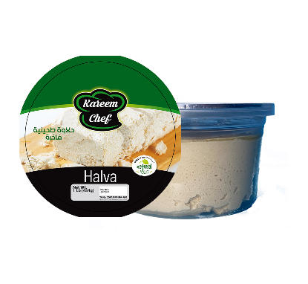
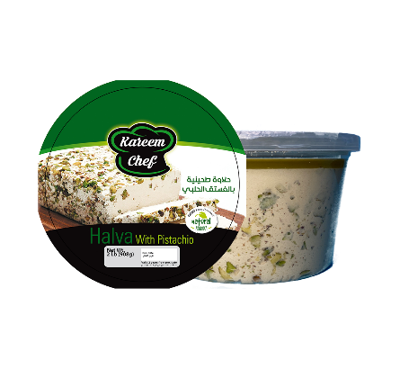
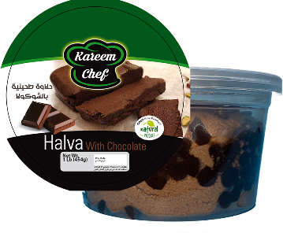
Pictures of the products:

