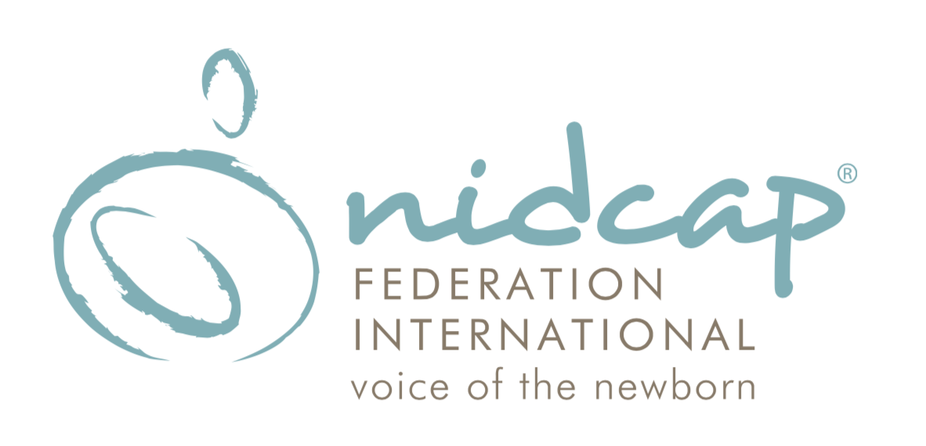 FOR IMMEDIATE RELEASE
Contact: Jennifer Degl
info@nidcap.org
845-406-1568

NICU Care with NIDCAP
Podcast Series
by
The NIDCAP Federation International

The NIDCAP Federation International proudly presents the new podcast series, NICU Care with NIDCAP.

Produced by The NIDCAP Federation International, alongside Jeff Bradbury of TeacherCast Educational Network and funded by Jennifer Degl of Speaking for Moms and Babies, Inc., NICU Care with NIDCAP is a series of one-on-one and group conversations.

In each episode, best practices are discussed to support the health and development of hospitalized newborns, infants and their families, and those that care for them, in intensive care nursery settings and beyond.

Season One includes:
- Episode 1: How Babies Communicate: featuring Dr. Heidelise Als
- Episode 2: NICU Family Partnerships: featuring Jennifer Degl, Dr. Melissa Johnson and Latoshia Rouse
- Episode 3: NIDCAP Goes Beyond the NICU: featuring Dr. James Helm
- Episode 4: Everyone Matters in the NICU: featuring Dr. Dorothy Vittner and Dr. gretchen Lawhon
- Episode 5: Everything Matters in the NICU: featuring Dr. gretchen Lawhon and Dr. Dorothy Vittner

Episodes 1-3 are now available for listening on our website, www.nidcap.org and you can also download them from your favorite podcast sites such as Apple Podcasts, Spotify, Google Podcasts, Amazon Music, and Overcast.

The remaining episodes in Season One will be posted throughout the spring.

Season Two will be released in 2022.

About The NIDCAP Federation International:
The NFI is a nonprofit, tax-exempt, 501(c)(3), membership and educational certifying organization founded in 2001 and the professional organization representing the NIDCAP community worldwide with more than 3000 clinicians, educators, researchers, families and students as its members.
The Newborn Individualized Developmental Care and Assessment Program (NIDCAP), developed by Heidelise Als, PhD and her colleagues, is a comprehensive approach to care that is developmentally supportive and individualized to the infant's goals and level of stability.
Based on detailed observations, NIDCAP was developed to create supportive, developmentally appropriate hospital environments for preterm and medically at-risk infants and their families.
About TeacherCast Educational Broadcasting Network:
The TeacherCast Educational Network features Podcasts, Reviews, and Professional Development with the world's leading educators and edtech companies. Jeff Bradbury, the creator of the TeacherCast Educational Network and host of "Ask the Tech Coach," the podcast that helps Technology Coaches create amazing digital learning programs is also a producer for many podcast series for companies such as Microsoft.

For more information please visit www.NIDCAP.org

Follow us on Facebook and Twitter @nidcap
Follow us on Instagram @nidcapfederationinternational

Improving the Future for Newborns and their Families

