Introducing Kiwi Cares Collections, a Children's book enterprise owned by 8-year-old philanthropist, Kiara (Kiwi) Smith.

Kiwi Cares Collections is a children's book enterprise owned by 8-year-old philanthropist, Kiara (Kiwi) Smith, and her team of like-minded family members inclusive of mum, Katrina Smith; Aunt, Patrice Payne; Grandmother, Maria Payne, and younger brother, Jackson Smith.
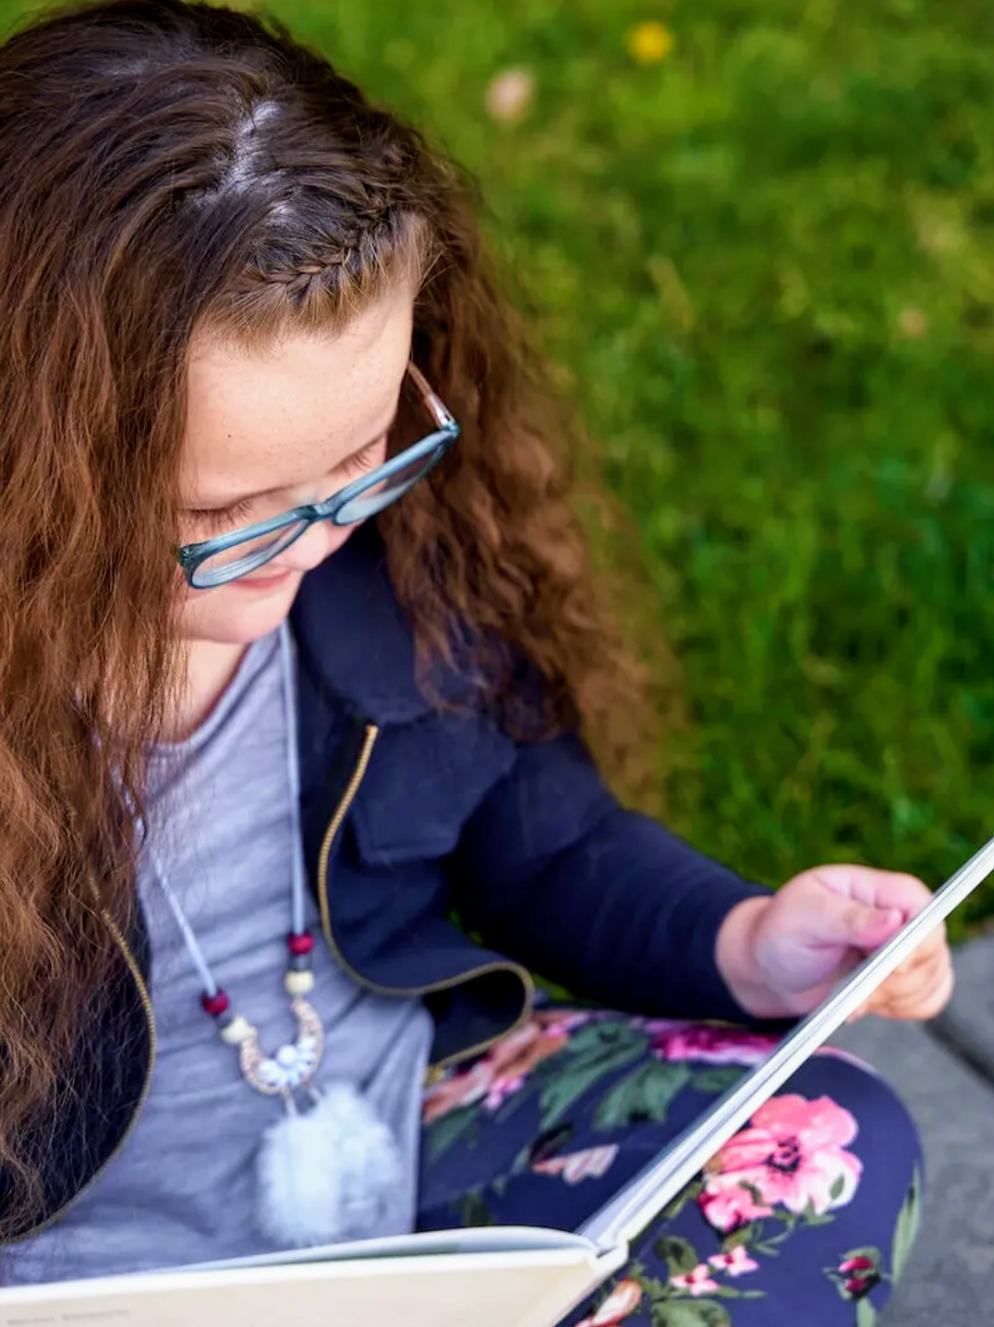
Kiwi's business, which was launched on April 2nd, her 8th birthday, is predicated on many reasons, chief among them being the need to share lessons she's learned while the profits are donated to Save the Children. Kiwi launched the business with three books and has sold 106 businesses to date via Amazon. Kiwi has direct ownership of creating the children’s books from start to finish. "At this time a child is being sponsored via Save The Children but our goal is to either sponsor more children, donate directly, or spread profits to numerous non-profits", explained Kiwi.
On May 11th, Kiwi Cares will be donating 80 books Olive Crest which is a local OC (Orange County, CA) non-profit for at risk youth.
Like most children in 2020, Kiwi’s world changed as she started distance learning full time in March 2020. In Fall 2020 she had transferred schools to the local public school and went through testing for a learning disability as she had struggled with reading and writing. By Winter 2020 she was diagnosed with a learning disability (dyslexia) and set with an IEP with the school that has been amazing in working with her.
In researching and learning about dyslexia, a new world of opportunities has opened with understanding the brain functions of those with dyslexia. Kiwi’s specific abilities with dyslexia is her immense creativity and viewpoint on seeing a bigger picture at such a young age. Reading and writing are still daily struggles for Kiwi but every day brings new opportunities to find joy in books, reading, and learning.
Speaking about her daughter, Katrina Smith said: "I and my daughter, Kiwi, have lots of conversations about world events, the pandemic, the virus, adaptation to a new normal, virtual learning, politics, racism, equality, self-love, confidence, and many more. We learned a lot of lessons over the last year and we will continue to learn more as Kiwi grows. Kiwi took a big interest in wanting to help others in need. She began asking a lot of questions about how she can help others, give back, volunteer, donate, etc, and as a mum, I wanted to foster this philanthropic mindset."
Kiwi Cares Collections has instilled a love of books in Kiwi as she has ownership for the ideation of the subject of the books, the story, illustration, and character choices. Kiwi decided that all of her books include lessons that she has learned so far and that the books are not only traditional books but also include engaging questions at the end regarding the book's topic as well as coloring pages and a word search with keywords from the book. Kiwi has had full ownership of not only the books, but the creation of the website, logo, and social media posts.

Media Contact
Website: kiwicarescollections.com
Facebook: Kiwi Cares Collections
Instagram: Kiwi Cares Collections
Email: kiwicarescollections@gmail.com

