**SPEAK UP FOR KIDS OF PALM BEACH COUNTY Announces Graduation Celebration- Annual Scholarship & ‘GIFTS FOR GRADS’ in partnership with LEADERSHIP PALM BEACH COUNTY ENGAGE CLASS OF 2021**

For Immediate Release:

**WEST PALM BEACH, FLORIDA (May 17, 2021)** – **Speak Up for Kids of Palm Beach County** has launched **GROWING GRADS,** a new community campaign aimed to CELEBRATE young adults who, despite involvement in the foster care system, are GRADUATING! In conjunction with the launch, **Speak Up For Kids** received invaluable support from the Leadership Palm Beach County Engage Class of 2021.

This year, **Speak Up for Kids** is celebrating **THIRTY-TWO** **GRADUATES** in Palm Beach County! As Class of 2021, these students cross the finish line as graduates - of high school, GED, college, and vocational school. Despite involvement in the foster care system, each of these young adults has reached this significant milestone in their education and deserves to be CELEBRATED.

**SCHOLARSHIP, GRADUATION CELEBRATION & GIFTS FOR GRADS:**

The 2021 Graduation Celebration- **GROWING GRADS** kicks off with the **Celebrating YOU*th* Scholarship** in which awards of $500 are available to high school graduates within the foster care system. With community support, **Speak Up for Kids** plans to grow the new scholarship fund in order to increase award amounts annually. Learn more by visiting the website <https://speakupforkidspbc.org/celebrating-youth>.

In lieu of an in-person 2021 Graduation Celebration Event, **Speak Up for Kids** pivoted to BRING THE PARTY to the grads despite COVID circumstances. Grads are celebrated with a personal delivery of a congratulatory yard sign and **GIFTS FOR GRADS** swag bag filled with community contributions including gift cards from **Speak Up**! Learn more by visiting the website <https://speakupforkidspbc.org/growinggrads>.

“For the teens we serve, normalcy and independent living skills are emphasized to ensure a bright future filled with lifelong connections and self-sufficiency,” says **Fiona Wade** at **Speak Up For Kids**. “We celebrate the successes of our young adults- especially the significant milestone of GRADUATION at each level in their education- whether high school diploma, GED, college degree, or trade certificate.”

Today in Palm Beach County, there are approximately 1600 children in our local foster care system. While several organizations are doing great work for segments of the foster care population, **Speak Up for Kids** is unique. As the nonprofit dedicated to the PBC Guardian ad Litem Program, **Speak Up** serves ALL of these children- from newborn to young adult.

*Each of these children has experienced abuse, abandonment, or neglect which has led to entanglement in a complex legal system. The Guardian ad Litem Program provides direct legal advocacy on behalf of the children involved in dependency court proceedings. Our Advocates are court-appointed to represent the best interest of the children - in doing so we support the physical, emotional, and educational needs of each individual child.*

“We are profoundly honored and humbled to celebrate our graduates this year! Our triumphant students have risen above their circumstances and worked hard to break the cycle of abuse and neglect through education and empowerment,” says **Coleen LaCosta**, **Executive Director** of **Speak Up For Kids.**

When asked why the graduation campaign is so important to the community, **LaCosta** says**, “GROWING GRADS** captures the true spirit and commitment **Speak Up for Kids** has made to our youth. This community campaign not only celebrates our kids at this exciting time in their lives, but it also pulls together resources to ensure each young adult has the support needed to achieve their dreams. We could not be more thrilled to receive support from the Engage Class of LPBC to help us with this project!”

**Speak Up for Kids of Palm Beach County** champions advocacy for the 1600+ abused, abandoned, and neglected children in Palm Beach County by ensuring the Volunteer Child Advocates of the Guardian ad Litem Program have the resources they need to support the children’s well-being, therapeutic and educational needs, normalcy activities, clothing and shoes, birthdays, school supplies, and more!

In the words of one **Guardian ad Litem Volunteer Child Advocate**, “**Speak Up for Kids** supplies the little extras that mean so much to a child that has been removed from his family and feels totally alone. I have gone to them for the extra gift of the high school graduation ring, or scholarship money to send a young girl to a very special conference in Washington. When we have a child who would benefit by having riding lessons, art lessons, music lessons, or even the musical instrument that is not available by any other means. **Speak Up for Kids** works continually raising enough money to make sure that the children who have been abused, neglected, or abandoned have what they need.”

Learn more by visiting the website <https://speakupforkidspbc.org> or emailing [info@SpeakUpForKidsPBC.org](mailto:info@SPeakUpForKidsPBC.org)

Donations to the **GROWING GRADS** campaign support our graduation celebrations + recognition of our incredibly deserving 2021 graduates! ***Because every grad deserves to be celebrated!*** <https://speakupforkidspbc.org/growinggrads>

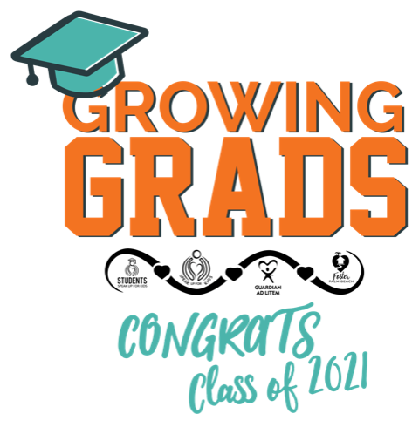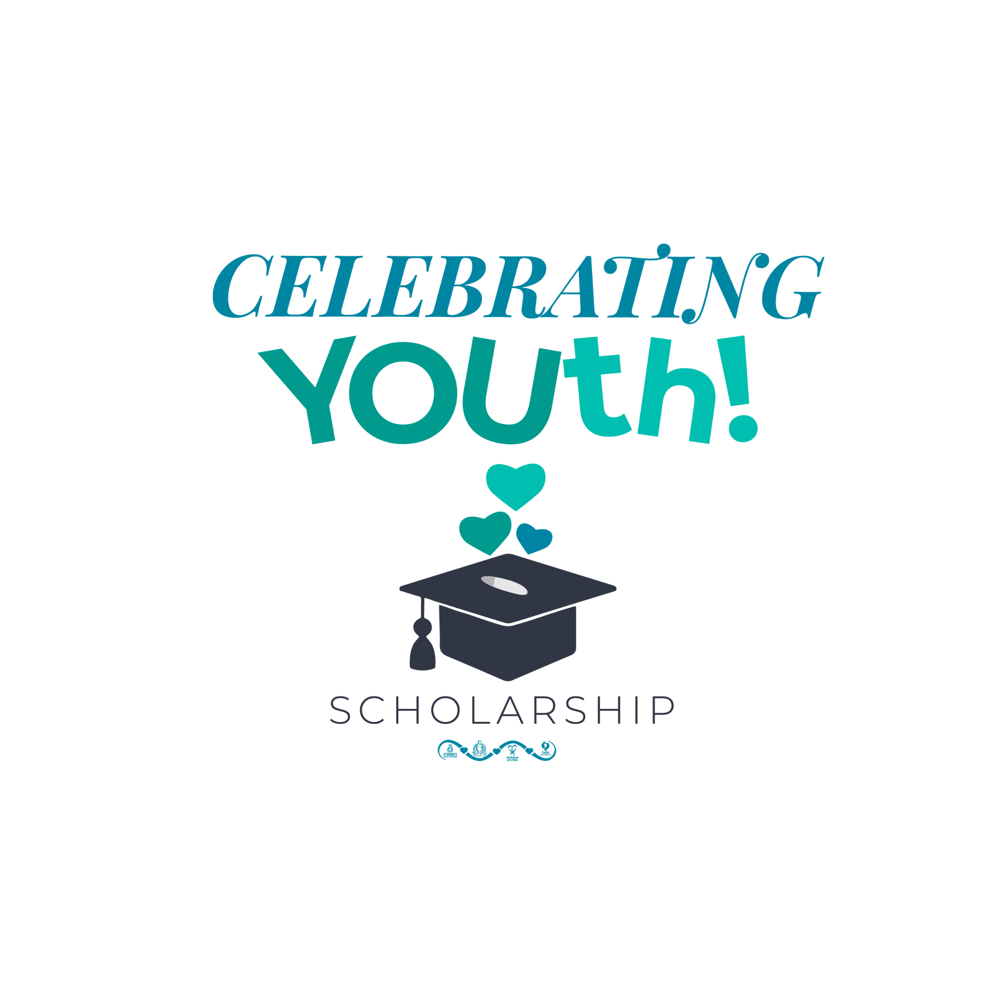

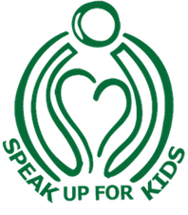

**About Speak Up for Kids of Palm Beach County**

Speak Up for Kids of Palm Beach County, Inc. is the exclusive 501(c)(3) fundraising arm for the Guardian ad Litem Program of Palm Beach County, Florida. We champion best-interest child advocacy through the recruitment, training, and retention of court-appointed volunteer child advocates. These “guardian angels” are committed solely to each child’s emotional, educational, and physical well-being throughout dependency court proceedings as the only 100% objective voice. Through effective advocacy the cycles of abuse, violence, and crime are being broken one child at a time, and children’s futures are being rewritten. [www.speakupforkidspbc.org](http://www.speakupforkidspbc.org)

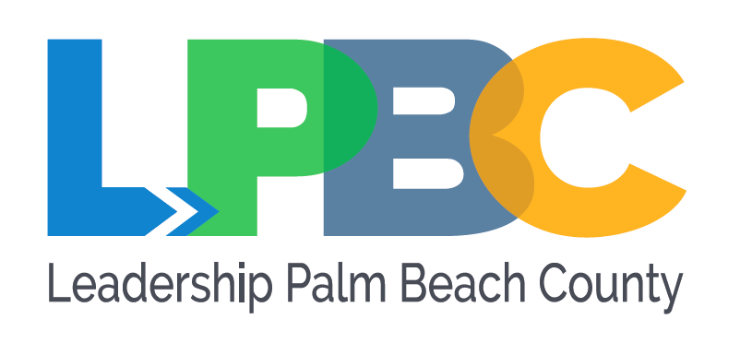

**About Leadership Palm Beach County, Engage Forward**

Since 1983, our flagship Leadership Program, now referred to as Leadership Engage, has existed to unite and educate our county’s most promising leaders. Engage Forward, formerly called Civic Engagement Projects, empowers class members from the Engage program to take active roles in the community through this partnership with local nonprofit agencies. Engage Forward connects nonprofit organizations with this year’s Engage Program class members to actively collaborate on finding solutions to issues facing an organization or the community. The impact of these class projects has historically been significant and of lasting benefit to the participating organizations. [www.leadershippbc.org/Engage-Forward](https://www.leadershippbc.org/Engage-Forward)

***A special thank you to the Leadership Engage Class of 2021 Members***

***dedicated to Speak Up for Kids of Palm Beach County***

**Todd J. Bonlarron,***Palm Beach County*

**Dr. Julie Botel,***City of Riviera Beach*

**Gina Chiello,** *Cummins Cederberg, Inc.*

**Dr. Tunjarnika (Nika) Coleman,** *Palm Beach State College*

**Jennifer Ethridge,***Education Foundation of Palm Beach County*

**Teneka James-Feaman,***West Palm Beach Downtown Development Authority*

**Poonam Kalkat,** *City of West Palm Beach Department of Public Utilities*

**Ricky Petty,***Pathways to Prosperity*

**Jordan Smith*,*** *Memorial Presbyterian Church*

**Christine Sylvian,** *Path to College*

**Patrick Thompson,***Cary Stamp & Company*

