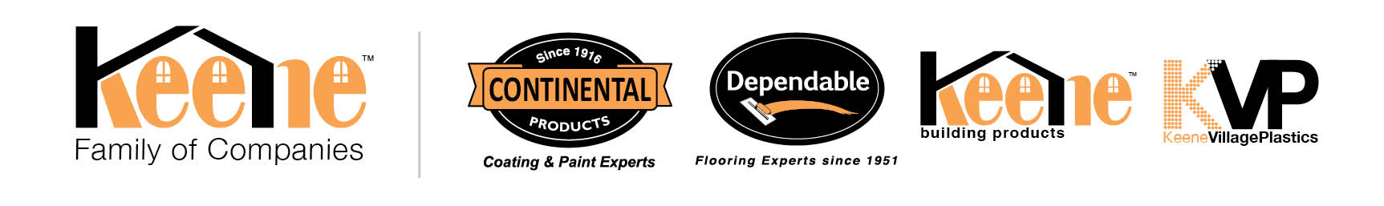

Announcement

FOR IMMEDIATE RELEASE

Jill Bresnahan
Keene Family of Companies
877.514.5336
440.605.1120
jpb@keenebuilding.com
www.keenebuilding.com

Keene Family of Companies Welcomes New Director, Business Development

Cleveland, Ohio—May 28, 2021 – Keene Family of Companies is proud to announce and welcome Richard Muller to the sales organization.

Rich joins Keene Building Products as the Director, New Business Development. Born and raised in New York with a Bachelor of Business Administration from Iona College and a Master of Business Administration from Pace University, he began his professional career holding various manufacturing and finance positions with a Fortune 500 company. Muller was instrumental in the startup a gypsum underlayment business and was promoted to Director of Sales, Specialty Products Division. He was instrumental in the success of many major brands in the flooring industry. He also has experience in structured strand products for both walls and flooring applications.

Now, Richard has the responsibility to provide guidance in supporting, promoting, and selling GSL of a gypsum underlayment business, QUIET QURL sound mat, Driwall Building Envelope, and other products including Dependable Floor Prep.

Currently, Richard lives in Fredericksburg, Virginia with his wife, Linda. They enjoy golfing together in their spare time. Rich will be focusing on the East Coast and growing the range of customers for all the brands in the KEENE Family of Companies.

Keene Building Products is an American manufacturer of 3-dimensional products for the building envelope, noise control, and roofing markets. Dependable Floorprep.com is a manufacturer of specialty cement products for flooring.

For further information call 877.514.5336, email at info@keenebuilding.com, or visit website keenebuilding.com.
# # #

