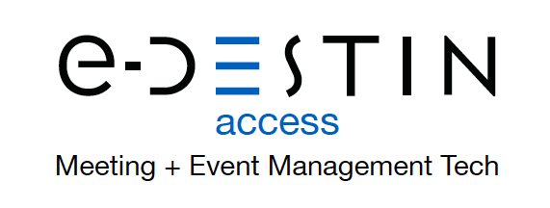

FOR IMMEDIATE RELEASE Media Contact:
Anita Beaubien
800.605.5597 ext. 102
anita@e-destinaccess.com

e-Destinaccess Launches Time-Saving, Revenue-Generating
Digital Meeting and Event Planning Platform

(TUCSON, AZ, June 17, 2021) e-Destinaccess, Inc. is pleased to announce the launch of the one-of-a-kind, end-to-end solution for planners of every experience level to manage all aspects of meetings and events for organizations of any size. With the rollout of DestinDIY, planners can improve their efficiency by up to 70%, saving time with a single-source digital tool designed to manage both group and individual bookings while also capturing revenue from shared commissions.

DestinDIY has the flexibility to fully integrate multiple services—including HotelPlanner, Flyus, Carey International, Tiqets and Quickbooks—to deliver a truly turnkey platform. Planners can
create custom, dynamic event experiences with the ability to book group/individual rooms, air, exclusive Covid-19 at-home airport pickup and drop off service, airport transfers and local activities.

To manage the process, DestinDIY provides a user-friendly planner dashboard that includes electronic proposal, contract generation, electronic signature, online registration, transportation scheduling, electronic departure notices and daily itineraries functions. In addition, financial forecasting and cost reports, including program spreadsheets and final invoicing, are all available in real time.

With a built in CRM, communication with suppliers and attendees is effortlessly straightforward. Each attendee has an easy-to-use personal dashboard—which they can access from any device—providing a centralized location for their important documents, including vouchers, itineraries and other key details. DestinDIY also provides SMS or email communication accessible from the planner and attendees’ dashboards.

With DestinDIY, CVBs and Conferences can create cash-back opportunities by providing their attendees the ability to book their own room, air, home airport pickups and drop offs, airport transfers and local activities, with all bookings providing commissions.

DestinDIY is the only full-service solution on the market for planners to provide comprehensive meeting and event management functionality and generate revenue via cash-back earnings on all bookings
###

ABOUT e-DESTIN
Co-founded by proven destination management pros Wayne and Anita Beaubien as e-DestinACCESS Inc., is a meeting and event management technology provider that provides easy-to-use tools delivering end-to-end solutions that put planners in full power of their budget and ROI. e-Destin’s industry-leading products, developed in partnership with technology experts, are used to organize every facet of a group gathering, run insightful reports and access of-the-moment details any time, on any device. All booked services are guaranteed and e-Destin’s proprietary single-entry platform ensures mistake-free outcomes. Gains from significant time and cost savings allow planners to focus on the big picture while strengthening local economies.

