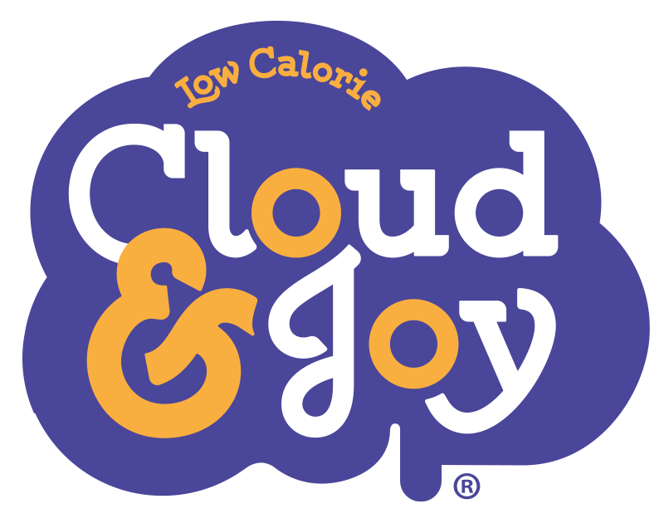

Cloud & Joy Newsroom
cloudandjoy.prowly.com

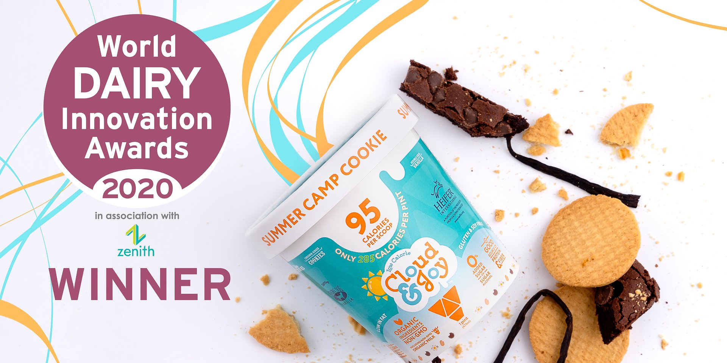

Cloud & Joy Wins Best Dairy Dessert at the World Dairy Innovation Awards 2021

2021-06-24

Miami, FL – June 24, 2021 – Cloud &amp; Joy took the win for Best Frozen Dairy Dessert in FoodBev Media's annual dairy product accolades.

Cloud &amp; Joy low calorie healthy lifestyle ice cream dessert today announced that the company was selected as a winner in the category of Best Frozen Dairy Dessert in Food Bev Media’s 2021 World Dairy Innovation Awards.

The awards held in association with the Global Dairy Congress and were announced during a special, virtual ceremony in association with Zenith Global. The judging panel considered 222 entries from 25 countries across 20 categories.

Judges cited Cloud &amp; Joy's "clean and ambitious ingredient panel and nutritional attributes" as a key factor in their taking home the honor.

Cloud &amp; joy’s motto is: Everything You Want. Nothing You Don't:Good Taste. Good for Your Body. Good for the World. The frozen dairy dessert supports this with a clean ingredient product that – in addition to low-calorie – is low sugar (with no added sugars in most flavors), sugar-alcohol free, low fat, low saturated fat and cholesterol, gluten-free. It is also reduced net carb, soy free, corn-syrup free, kosher, non-GMO organic ingredient, and ethically and responsibly sourced. A portion of the profits from each pint made is donated to NGO Heifer International to support their mission to end world hunger.

This speaks volumes for the ambitious developments that are being made when it comes to innovation in the dairy industry, and it is fantastic to see both household names and small challengers alike from every continent.
Lily Benham, FoodBev Media's awards marketing executive

According to awards judge Donna Berry (owner of “Dairy &amp; Food Communications”), product nutrition, pleasure and sustainability were key differentiators. Focus on health and wellbeing, conscious consumption and local sourcing along with innovation were key criteria according to judge Tolga Sezer, CEO of Al Safi Danone.

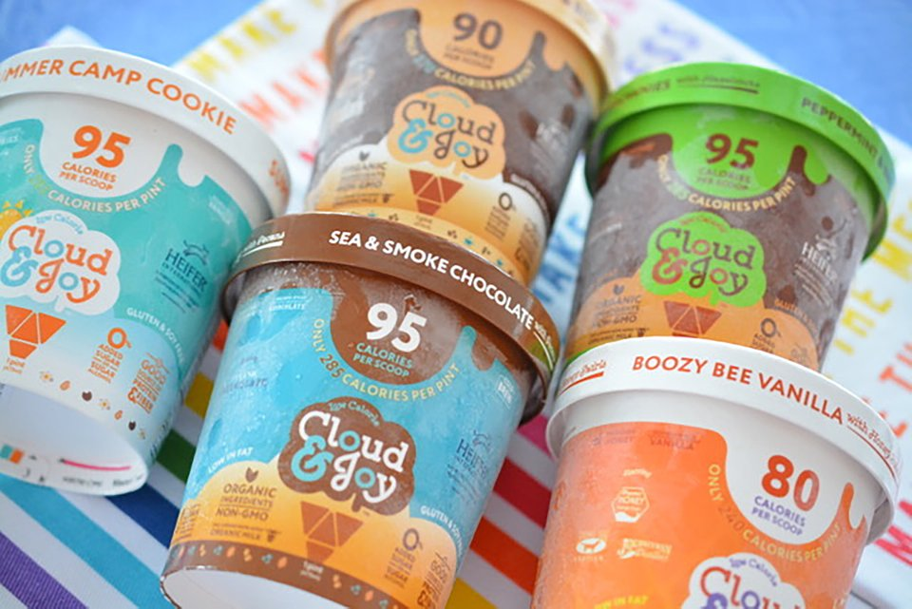
Cloud & Joy Frozen Dessert Product Line-up (Photo Credit: Liz Horne (@sweet_things_by_lizzie_)

“Being recognized as a winner and innovator in such a competitive category is a real honor,” said Selina Tepoot, the product creator and co-founder of Cloud &amp; Joy, “Ian [Selina’s husband and co-founder] had an accident that left him immobile for over 6 months and he couldn’t have sugar during recovery. This inspired us to create a better healthy ice cream that actually tasted like indulgent ice cream.”

According to Selina, it took over a year, much frustration and getting the science right to create a product that lived up to their standards. They set rules for themselves: no shortcuts, ingredients hidden under natural flavors, or ingredients that were harshly processed or unpronounceable. Another priority was to create bold, elevated flavors which led to flavors with names such as "Sea &amp; Smoke Chocolate", "Boozy Bee Vanilla" and "Cafecito Coffee &amp; Biscuits."

For small, emerging products like Cloud &amp; Joy in the frozen dairy space, recognition as disruptors can be vital in gaining awareness among buyers in a competitive market dominated by large brands.

“…This speaks volumes for the ambitious developments that are being made when it comes to innovation in the dairy industry, and it is fantastic to see both household names and small challengers alike from every continent” said Lily Benham, Food Bev Media’s awards marketing executive

For a full list of winners in each category, check FoodBev Media's "World Dairy Innovation Awards 2021: Winners revealed" article here and you can view the awards on YouTube here.

About Cloud &amp; JoyCloud &amp; Joy™ was formed by a wife and husband duo with a vision to disrupt the ‘lite ice cream’ business by creating the cleanest-label, socially responsible scoop with the best nutrition profile while maintaining delicious creamy taste. It is a minority owned and majority women-led company. Cloud &amp; Joy donates a portion of every pint produced to NGO Heifer International to support their mission to end world hunger.

For more information about Cloud &amp; Joy, visit CloudandJoy.com or check out our social media channels: Instagram, LinkedIn and Facebook

Contact Information: Ian Tepoot (ian@cloudandjoy.com)

 | Selina-Photo-WinnerPic.jpg | Download
 | WDI-Photo Pix-Winner.jpg | Download
PDF | PRESS RELEASE WDIA 2021.pdf | Download
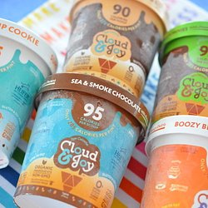 | Variety-LizHorne.JPG | Download
 | Selina-Founderpic01.jpg | Download

