FOR IMMEDIATE RELEASE  Monday, July 14, 2021 | Contact: Cleota G. Brown, President  Hawaii Fetal Alcohol Spectrum Disorders Action Group  hawaiifasdactiongroup@gmail.com  PH 808-258-5874
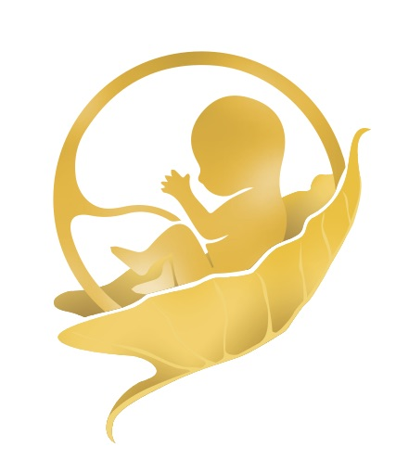

New Legislation Will Help Children and Adults Living with FASD, the
Nation’s Most Common and Preventable Developmental Disability

SENATORS LISA MURKOWSKI AND AMY KLOBUCHAR AND
REPRESENTATIVES BETTY McCOLLUM AND DON YOUNG INTRODUCE THE
FETAL ALCOHOL SPECTRUM DISORDERS RESPECT ACT

Honolulu, HI July 12, 2021 – The U.S. Senate and House have introduced matching bills to authorize comprehensive Fetal Alcohol Spectrum Disorders (FASD) support services, public health prevention, and research programs across agencies within the U.S. Departments of Health and Human Services, Education, and Justice.
The Advancing FASD Research, Services, and Prevention Act, (S. 2238, H.R. 4151), known as the FASD ReSPect Act, is cosponsored by Senators Lisa Murkowski (R-AK) and Amy Klobuchar (D-MN) and Representatives Betty McCollum (D-MN) and Don Young (R-AK), all dedicated champions of maternal and child health and support for individuals living with disabilities and addiction. Their home states of Alaska and Minnesota now lead the way in statewide efforts to respond to FASD.
FASD describes the range of lifelong physical, mental, and behavioral impairments that can occur in an individual prenatally exposed to alcohol. As reported in JAMA: The Journal of the American Medical Association, FASD affects as many as 1 in 20 school-age children in the U.S., and, according to a 2019 Centers for Disease Control and Prevention Mortality and Morbidity Weekly Report, 1 in 9 pregnancies are exposed to alcohol. The estimated annual cost for each individual with FASD, including heath care, special education, residential care, lost productivity, and juvenile and criminal justice expenses, is $30,945, for a total annual cost to society of $205 billion.

FASD affects every sector of Hawaii’s society and the costs to society are immeasurable. 94% of those affected by FASD have mental health issues; 95% cannot live independently; 80% have employment difficulties; 70% have trouble in school; 60% have trouble with the Law; 50% of adults abuse drugs and alcohol; and 45% have legal problems with sexual behaviors. These are all social determinants that can contribute and lead to homelessness and imprisonment. A major contributing factor to these statistics is many service providers are uninformed on the complexities of FASD which lead to a missed diagnosis.

“It is rare that we come across a brain disorder that is 100% preventable and that we have the ability to reduce these shocking mental health, addiction, homelessness and imprisonment statistics, through training, awareness, diagnosis, treatment, and prevention. It’s also shocking that many states including Hawaii have NO funding for informed FASD diagnosis, treatment and services.” Cleo Brown, President, Hawaii FASD Action Group HawaiiFASD

For more information on the importance of the FASD Respect Act and why Hawaii’s support is needed now, please refer to the attached information sheet. Whether you are a concerned citizen, business or legislator, you can make your voice heard by supporting the Fetal Alcohol Spectrum Disorders Respect Act. Visit The Respect Act for more information and links to express your support online. A few minutes of your time will help us make FASD, Invisible No More.

Hawaii Fetal Alcohol Spectrum Disorders Action Group is a member of the National Organization on Fetal Alcohol Syndrome (NOFAS) Affiliate Network, a coalition of 33 FASD organizations working to disseminate information, provide referrals, and integrate FASD resources into local services. Susan Elsworth, Executive Director of Indiana NOFAS and the affiliate network coordinator, believes attention and investment for FASD is long overdue, “Families living with FASD seeking help are too often met with ignorance. They deserve medical and behavioral care and education and justice systems that recognize and meet their needs. The affiliates are on the front lines. They are prepared now to partner with state agencies, clinical networks, and service providers to prevent FASD and support families. Passage of this legislation will bring hope to our communities and meaningful resources that will improve their lives.”
Our Mission is to raise awareness through education, advocacy, and research on the impact of Fetal Alcohol Spectrum Disorders (FASD) on individuals, their families, and the communities of Hawai’i. Our Long Term Vision – is to ensure Fetal Alcohol Spectrum Disorder (FASD) is Invisible no more.
Our programs include 1) parent, caregiver, and service provider support groups, and 2) education and training for those who are treating, caring, and supporting the needs of Hawaii’s FASD families and children.
We are soon to launch an FASD assessment training program to ensure accurate diagnoses of FASD, and we continue to develop systems of care to identify and support individuals with an FASD.
To learn more about the FASD ReSPect Act visit the NOFAS Policy Center or contact NOFAS Policy Coordinator Jennifer Wisdahl or contact Hawaii FASD Action Group.
###

