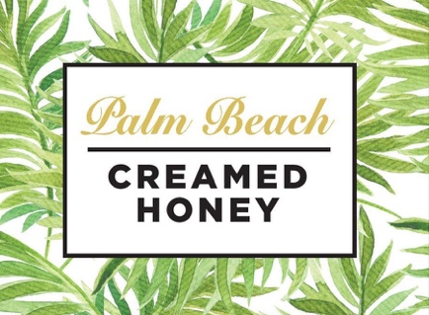

Palm Beach Creamed Honey
Kosher Certified for Rosh Hashanah

Palm Beach, FL – August 17, 2021: The small batch, small business beekeepers at Palm Beach Creamed Honey welcomed Rabbi Yehuda Goldman to their honey farm for their annual kosher certification inspection. Rabbi Goldman, is the CEO of the internationally renowned
EarthKosher. He conducts a 7-step certification process onsite to verify that the production facility and the product meet stringent kosher standards.

“With Rosh Hashanah around the corner, it was important for us to maintain our certification, and we are pleased to report we passed the two-hour inspection with flying colors,” said Sierra Malnove, head beekeeper. Palm Beach Creamed Honey is the only kosher-certified creamed honey producer in Palm Beach County. Malnove, is a leader in Florida’s sustainable, bee keeping industry. She and her partner, Al Salopek have a 13-acre honey farm in the Palm Beaches with 900 hives, and a “honey house”.

Apples dipped in honey are an honored tradition for the Jewish New Year celebration. Rosh Hashanah will be celebrated September 6 -8 in millions of homes across the country. It symbolizes the wish for a “sweet new year”. Palm Beach Creamed Honey is pure, raw honey
that is creamed in a state-of-the-art facility with high-tech equipment, giving honey a smooth, creamy texture. Palm Beach Creamed Honey is available on Amazon, with free 2-day shipping for Prime members.

Media Contact: Enid Atwater, The Atwater Agency – epalmbeach@gmail.com, 561.762.2141

