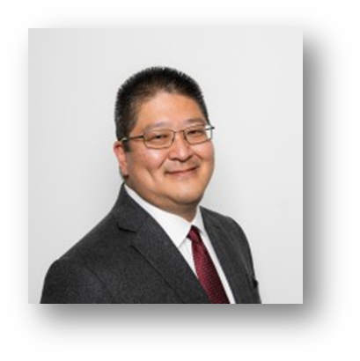

**Superior Grocers Announces New Chief Operating Officer- Steve Fujimoto**

**Santa Fe Springs, CA (August 3, 2021)**- Superior Grocers has named Steve Fujimoto, Chief Operating Officer, effective Aug. 16th. In Steve’s new role, he will report directly to Richard Wardwell, President.

Steve Fujimoto was Vice President of Retail Operations for the Portland Division of Albertsons in the northwest. He led the operations of 141 stores in addition to the extensive support team to drive top sales and earnings performance in the company. Steve takes a vision and makes it a reality through sound strategy development and execution. He intuitively sees the threads of opportunity that wind through an organization, brings them together into a coherent whole, helps others extend their thinking, and drives material business advantage.   He is an inspirational leader who tells stories that inspire action while at the same time is grounded in financial information that levers the business.

*“We are fortunate and grateful to have Steve join our team and look forward to his valuable contributions to our growth and success. Steve brings a wealth of knowledge and experience to help elevate our Operations, Merchandising & Marketing teams”, said Richard Wardwell, President.*

Steve is distinguished by his ability to build solid teams by identifying and developing talent. He has a contagious enthusiasm and passionate belief in people that inspires them to become prouder, stronger, and more valuable contributors to their organization. He has also led innovative initiatives to build top-performing teams with management “bench strength” and staying power.

Steve’s background is broad-based with 39 years in the industry holding leadership positions in Finance, Warehouse and Distribution, Marketing and Merchandising and Operations. His ability to be process driven is based in his knowledge of the Six Sigma & Lean methodology where his is a certified Six Sigma Black Belt and Master Black Belt.

Steve holds a BS in Finance from California State University Long Beach. He is also a graduate of the University of Southern California Food Industry Management Program and is graduating in December with his MS in business from USC.

Steve also serves on several Association boards including the Northwest Grocery Association (NWGA) where he is Treasurer and Secretary, and the Western Association of Food Chains (WAFC).

**@SUPERIORGROCERS**

Image result for facebook png Image result for instagram png

**Visit Our Website**

**Superiorgrocers.com**