

Springdale, Arkansas – August 6, 2021 – [**Paschal Air, Plumbing & Electric**](http://gopaschal.com/)**,** the leading provider of home comfort services and replacements in NW Arkansas & SW Missouri, is proud to be named as one of the Best Places to Work in Arkansas. This eighth annual program was created by [**Arkansas Business**](https://www.arkansasbusiness.com/)and [**Best Companies Group**](https://www.bestcompaniesgroup.com/).

This survey and awards program was designed to identify, recognize and honor the best employers in Arkansas, benefiting the state’s economy, workforce and businesses. The list is made up of 50 companies from all over the state, & Paschal Air, Plumbing & Electric has been named one of this year’s Best Places to Work in Arkansas.

Paschal was named as a top employer due to several factors including workplace standards, growth potential, job satisfaction, philosophy, and diversity. “You can’t offer world-class service without world-class people. The thing that I am most proud of in our growing organization is the caliber of talent and the winning nature of this team.   We are truly honored and humbled to be chosen as one of Arkansas’ Best Places to work in 2021 and we look forward to growing our workforce in providing more Arkansan’s the opportunity to join the Paschal Family.” – Charley Boyce, President

Paschal Air, Plumbing & Electric was founded in 1968, and for over 50 years has provided homes & businesses with professional heating and cooling, plumbing, and electrical services & solutions. The company employs almost 200 individuals in the trades, and has locations in Springdale, AR, Fort Smith, AR & Carthage, MO.

The deciding factors came down to survey answers provided by anonymous employees of Paschal. These insights painted a clear picture of why the company was listed as a top employer in the state.

The core values at Paschal encompass just a few reasons why the company was selected as one of the top places to work in Arkansas. These values include:

* Service to our community
* Our team is our family
* Passionately loyal to our customers
* Pride in our craftsmanship
* Accountability for our actions
* Transparency in everything we do
* Empowering & educating our customers
* Continual growth for our team
* Doing what is right, not what is easy

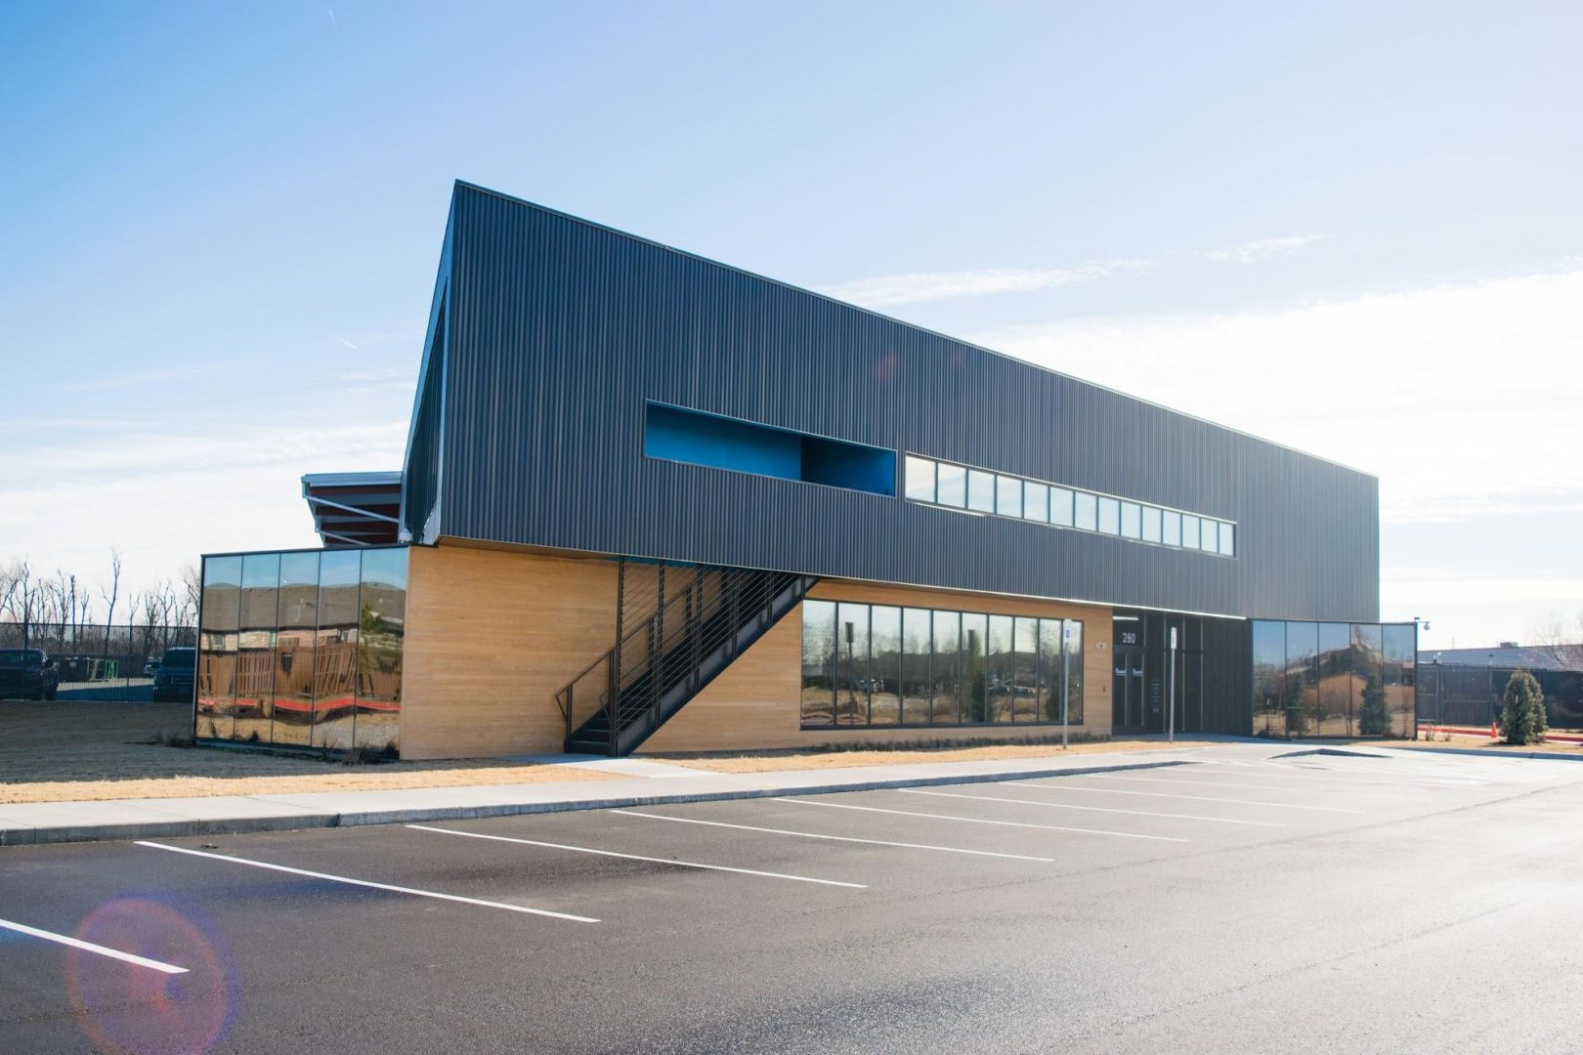

Paschal Air Plumbing & Electric is dedicated to providing unrivaled customer service and top-notch workmanship to all of the communities that we have served for over 50 years.  Now with 3 locations serving SW Missouri, NW Arkansas, and the Arkansas River Valley, Paschal is committed to serving with honesty and integrity by providing each and every customer an unforgettable and unmatched experience that goes above & beyond expectations.

Contact Information: Jade Rundle – Community Outreach

Ph: 479-751-0195

[**jrundle@gopaschal.com**](mailto:jrundle@gopaschal.com)

**Paschal Air Plumbing & Electric**

[**www.gopaschal.com**](http://www.gopaschal.com/)

