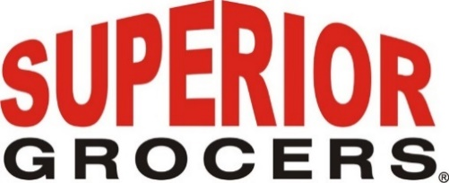

Superior Grocers Gives Back to our
Future Generation

It was the first time that students were welcomed back to in-person teaching since the start of pandemic. Students arrived with bright smiles excited to return to campus along with a special surprise.

Superior Grocers partnered with the Rialto Unified School District and provided Backpacks filled with school supplies to the students of Boyd and Preston Elementary School. With over 1,200 Backpacks donated to RUSD, students were thrilled to select from the many different colors of backpacks provided.

“As many of the student’s head back to school this year it is important that they are provided with all the necessary tools to succeed,” said Miguel Alarcon, Regional VP of Superior Grocers. “Seeing how happy they are being back at school and their faces when they see that they’re getting a new backpack brings a big smile to our faces.”

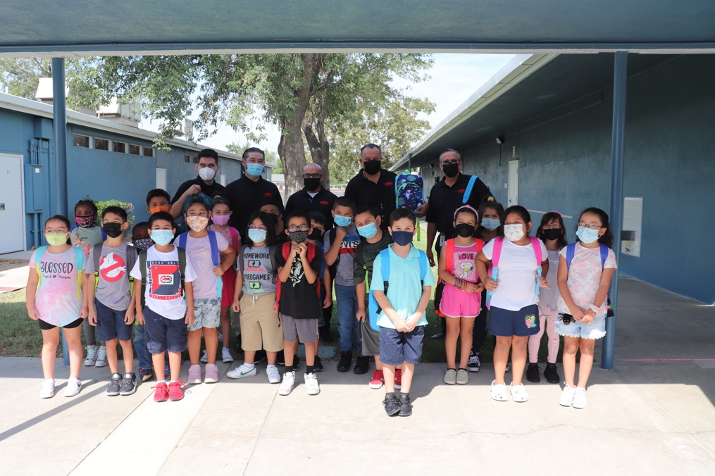
Preston Elementary students along with the Superior Grocers team pose for a photo with their new backpacks.

