PRESS RELEASE

BILT Prepares for Exponential Growth;
Tech Innovator Hires Ops Leader from Brink’s

GRAPEVINE, TX, September 9, 2021– Ahead of imminent expansion, BILT Incorporated, creators of the BILT app, announced today it has hired Michael Rosales as a senior program manager. Rosales will be responsible for developing operational processes and managing complex projects at the Software as a Service (SaaS) company, specifically as it expands within the federal space.

“Michael inhales complexity and exhales order,” says BILT President & COO Ahmed Qureshi. “He has tremendous operational experience.” Rosales says he found BILT on Inc. magazine’s 2020 list of the 500 fastest-growing private companies in America and realized it was just minutes from his home.

The BILT app provides official assembly and installation instructions for thousands of products from hundreds of brands. Users follow voice, text, and animated prompts with play/pause control. The 3D images can be manipulated, rotated, and viewed from any angle. Millions of users register products, save warranties, upload receipts, and leave ratings & reviews in BILT. It is proven to increase NPS & star ratings, registrations, and brand loyalty while reducing returns, calls to customer support, setup time & errors.

“BILT gives clarity to inconsistent and painful processes,” says Rosales. “Its potential for growth is limitless.” He says he was specifically attracted to the team’s outward mindset and mission to create a customer experience so empowering it turns users into brand ambassadors.

At Brink’s, Rosales was part of the Global Product Technology team, creating and expanding the global footprint of a new cash management solution. Prior to Brink’s, Rosales focused his project management career on software implementation, including working for Kronos and Ultimate Software. He holds an MBA from Ball State University, a BS in business management from the University of Wisconsin–Parkside, and a Project Management Professional (PMP) certification from the Project Management Institute.

Contact:
Juliette Qureshi
Sr. Director, PR & Corp Comms
Juliette@BILTcorp.com
703-554-3020

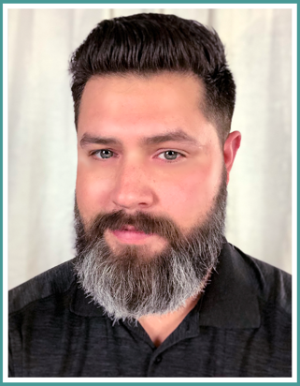

Summary:
Michael Rosales is joining BILT Incorporated as a senior program manager ahead of explosive growth at the customer experience innovator.

