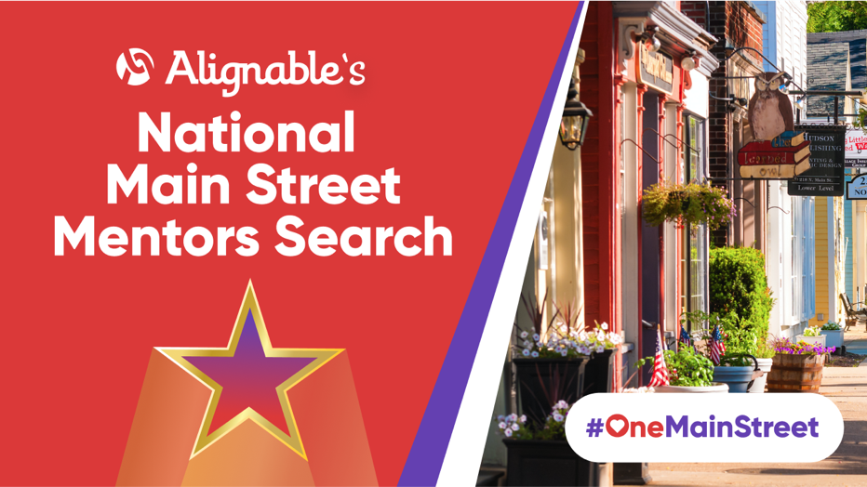

Cameron Marie Needham of Needham Solutions, LLC Wins Mason’s
Alignable Main Street Mentors Search For 2021

Cameron Marie Needham Emerges As Hometown Champion In National Contest Celebrating Business Superstars Helping Local Communities Recover

BOSTON, MA: September 2, 2021 -- The largest online referral network for small businesses, Alignable.com is announcing the results of its North American search for business leaders who’ve gone above and beyond guiding peers, Main Street economies, and entire communities toward recovery.

Today, Alignable’s network is honoring Cameron Marie Needham of Needham SolutionsLLC as Mason’s 2021 Main Street Mentor Of The Year!

Alignable’s latest contest generated an incredible 132,000+ votes and recommendations supporting altruistic, collaborative business superstars. This is the first year Alignable has hosted its new National Main Street Mentors Search and the participation levels were astronomical.

“No Business Left Behind”

“Based on what we’ve heard from thousands of voters, the rallying cry ‘No business left behind’ is driving many of our local business leaders as they redouble efforts to help communities against new threats,” said Eric Groves, Alignable’s Co-Founder and CEO. “And their countless supporters really cheered them on during this contest, demonstrating unparalleled gratitude for their often-unsung business champions.”

Alignable’s National Main Street Mentors Search ran from June 28th to August 24, 2021. In all, nearly 2,000 local businesspeople emerged victorious across North America.

This Is Really Mason’s Award

“No matter what happens in Mason’s business community (and surrounding areas), many of us look out for each other and offer advice or a helping hand,” said Cameron Marie Needham. “So it’s really more appropriate to accept this award on behalf of the small business community of Mason, MI (and surrounding small town business communities), as all of us play a role in keeping our local economy going. That said, I’m very grateful for my peers’ support and send it right back to all of them, too. We’re #onemainstreet, and we stand strong together.”

Needham Solutions and other 2021 Local Main Street Mentors in communities across the U.S. and Canada have received badges on their Alignable profiles, recognizing their contributions. In past years, the awareness generated through similar contests has helped drive additional connections, prospects, and new business for many winners.

Rev Up Business For The Rest Of 2021

“We’ve heard from countless members that they made many new connections during this contest, and had the chance to rekindle older business relationships, too,” added Alignable’s Co-Founder and President Venkat Krishnamurthy.

To arrange interviews with Cameron Marie Needham and/or an Alignable representative, please contact Alignable’s Head Of News & PR Chuck Casto at chuck@alignable.com. He also can offer JPEGs and other visuals, recommendations supporting winners, and additional information.

About Needham Solutions LLC

At Needham Solutions, we are just that, your solutions to all things marketing, design, and promotions. From email marketing and website design to graphic design and social media management, from promotional products and printing services to copywriting/content development to strategy and marketing technology implementation, and so much more.
*All services are 'buffet-style' - just pick and choose what you need help with.
We pride ourselves on being the TRUE full-service team at a fraction of the cost of agencies (and we can do more than them)!

About Alignable

Alignable.com is the largest online referral network for small businesses in the U.S. and Canada. With 6.5 million+ members across 35,000+ local communities, Alignable is the network where small business owners drive leads and prospects, generate referrals, land new business, build trusted relationships, and share great advice.

Cameron Marie Needham – headshot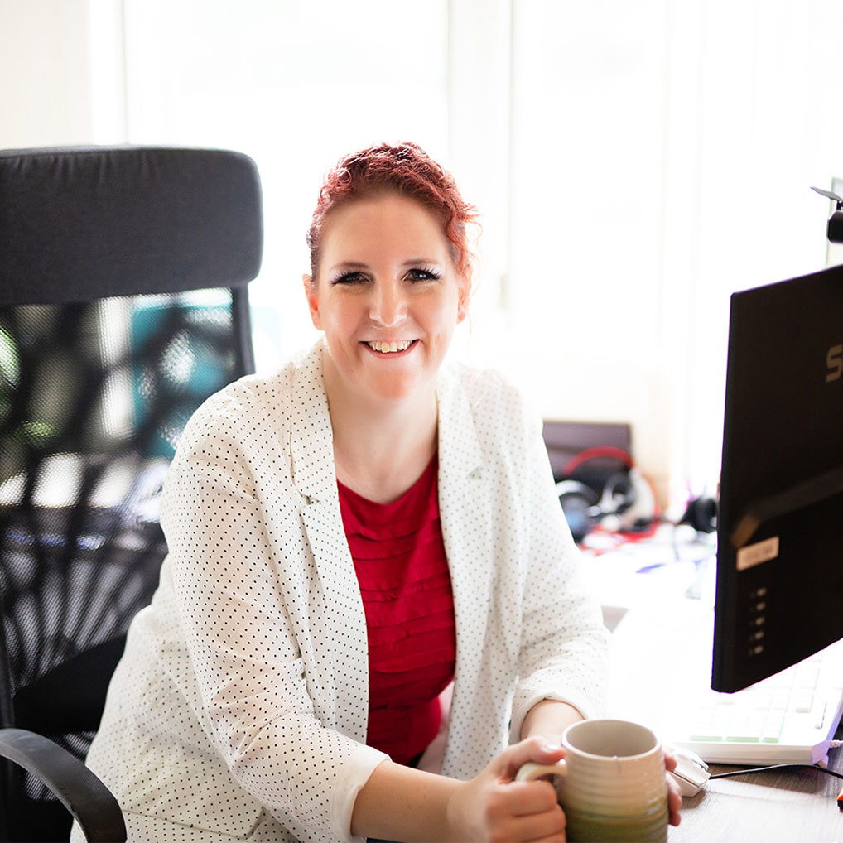

Award Badge

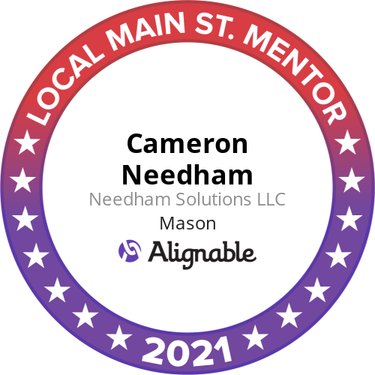

Needham Solutions LLC – Logo
