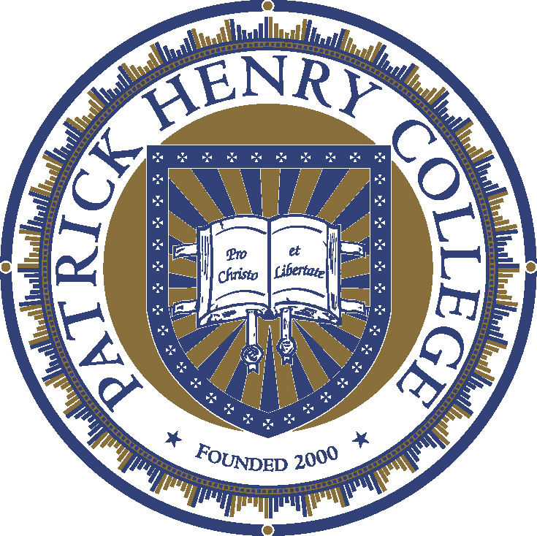

PATRICK HENRY COLLEGE IS AWARDED CANDIDACY FOR ACCREDITATION BY THE SOUTHERN ASSOCIATION OF COLLEGES & SCHOOLS (SACS)

Purcellville, VA, September 20, 2021 — The Commission on Colleges of the Southern Association of Colleges & Schools (SACS-COC) has granted Candidacy status to Patrick Henry College.
As an institutional, regional accreditor recognized by the U.S. Department of Education, SACS-COC accredits nearly 800 institutions primarily in the southern region of the US. The action taken by the SACS-COC Board of Trustees indicates that Patrick Henry College has demonstrated compliance with the accreditation requirements addressed in the Application for Membership and that this compliance has been verified by a Candidacy Committee.
“Candidacy with SACS-COC is an important milestone for all of the families who, over the past 20 years, believed in the personal and national consequences of rigorous learning for Christ and for Liberty. So much trust and so many talents and sacrifices made this vision a reality,” said Rodney Showalter, Vice President of Institutional Effectiveness & Planning.
The College is now in the process of working towards membership with SACS-COC as an accredited institution, including hosting an Accreditation Committee as soon as 2022. Patrick Henry College continues to be accredited by the Transnational Association of Christian Colleges & Schools (TRACS), who is also recognized as an institutional accreditor by the U.S. Department of Education.
Jack W. Haye, PHC’s president says, “Patrick Henry College will have a unique opportunity over the next few years to be a significant voice in the national conversation. Our culture is rapidly changing. As a result, there is a great need for young leaders who understand what it means to live integrated lives in which both faith and reason inform all aspects of their experiences. It’s a big task that will require conviction, tenacity and creativity.”
Patrick Henry College does not accept any federal or state funding; one of only 18 U.S. institutions of higher education to hold this distinction. PHC is committed to robust classical liberal arts training as a Christian mission with a biblical worldview. Graduates are known for in their ability to think logically, communicate persuasively, and represent the cause of Christ faithfully. Visit www.phc.edu/about to learn more about the one-of-a-kind academic program at Patrick Henry College.
###
Primary Contact: Stephen C. Allen, Assistant VP and Director of Communication
540.441.8722 | Email: scallen@phc.edu
Patrick Henry College | 10 Patrick Henry Circle | Purcellville, VA 20132 | phc.edu

