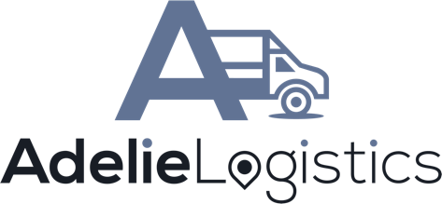

PRESS RELEASE

Adelie Logistics Equipment and Event Rental Software to Release E-Commerce Integrations For Both WooCommerce And Shopify

Adelie Logistics LLC announced, today, their plan to release additional features to their software this Fall. These plans include two new plugins that give rental companies using Adelie software, the ability to offer their rental products to customers directly online via their own website. In addition to the new features, the company says they plan to release even more robust improvements to their web app beginning early 2022.

A leading provider of rental software for the equipment and event rental space, Adelie Logistics is a SaaS company that touts its QuickBooks integration approach to 3rd party software in the rental space. By developing with a "How does this affect my accounting and billing software?" first approach, they have been able to help companies increase efficiency and accuracy in their rental processes.

Some select rental companies have been chosen to test/implement the e-commerce integration with Adelie before its release. Leslie from PSR Events in Clarksville Tennessee says, "The website and Adelie has helped us become a completely paperless office. We couldn't be more pleased with it." Others have offered similar sentiment.

This release comes at a time in the industry where more and more customers are requiring online solutions to booking rentals in advance of their needs. Since 2019 and the beginning of the COVID 19 pandemic, the event rental industry has experienced significant loss of revenue due to lockdowns and social distancing measures. As more and more restrictions are lifted, the demand for gathering in social events has never been higher. However, reservations are still top of mind and thus, those looking to book rentals are opting to do so from their mobile devices or a computer as opposed to doing business in person.

"Our primary focus is to provide rental operations with the tools and digital solutions that enable them to better serve their customers and more efficiently operate their business," says Adelie founder, Jon Burgoyne. "As situations change in the industry, we take it upon ourselves to adapt our solutions to the needs of our customers. We feel that providing a complete solution for e-commerce integration with our software comes at just the right time for everyone to benefit from this much needed enhancement to our product."

Contact:
Joe Mangum
Sr. Directory, PR & Corp Comms
Joe@adelielogistics.com
(480) 712-0279

Summary:
Adelie Logistics LLC, a SaaS company servicing the equipment and event rental space, has announced their intention to release feature enhancements this fall that will allow all users the ability to connect their rental inventory with either Shopify or WooCommerce shopping carts. Accordingly, rental companies will be able to provide their customers with their own dedicated rental marketplace right on their current WordPress or Shopify site without having to leave the company's custom domain.

